Lesson Plan: Writing Effective Resumes

Jason Kurland
Lunenburg High School
2011-2012 School Year
jkurland@lunenburgonline.com

Grade: 10, 11, or 12

Topic of the Lesson:

To educate students on how to write effective resumes.

Focus Question:

Do students have the knowledge and skills necessary to write an effective resume?

Goal of the Lesson: (long description moved to TPO and cut/pasted into appropriate places)
- Individual objectives: Students will learn the resume writing process and write personal resumes.
- Group objective: Students will collaborate effectively while learning the skills

Minimum Time Required: 50 minutes

Materials:

- Informational handouts from the Career Service Office of Quinsigamond Community College (attached).
- Sample resume(s)
- Sample disorganized resume
- Poster/Bulletin board to enhance and reinforce learning (optional).

National ASCA standards:

Standard A: Students will acquire the attitudes, knowledge and skills
that contribute to effective learning in school and across the life
span.

A:A3 Achieve School Success

- A:A3.1 Take responsibility for their actions
- A:A3.2 Demonstrate the ability to work independently, as well as the
Ability to work cooperatively with other students
- A:A3.4 Demonstrate dependability, productivity and initiative

Standard B: Students will complete school with the academic
preparation essential to choose from a wide range of substantial
post-secondary options, including college.

A:B1 Improve Learning

- A:B1.1 Demonstrate the motivation to achieve individual potential
- A:B1.2 Learn and apply critical-thinking skills
- A:B1.4 Seek information and support from faculty, staff, family and
peers
- A:B1.7 Become a self-directed and independent learner

A:B2 Plan to Achieve Goals

- A:B2.2 Use assessment results in educational planning
- A:B2.5 Use problem-solving and decision-making skills to assess
progress toward educational goals
- A:B2.7 Identify post-secondary options consistent with interests,
achievement, aptitude and abilities

MA Curriculum Frameworks:

- English Language Arts (ELA) Guiding Principles: Literacy in all forms of media
- ELA General Standard: Gather information from a variety of sources, analyze and evaluate the quality of the information obtained, and use it to answer one’s own questions
- Mathematics Guiding Principle: Technology is an essential tool in a mathematics education
- Health Guiding Principles: Work in a positive manner with families, school staff, peers and community members to create a safe and supportive environment where individual similarities and differences are acknowledged.

MA CDE Benchmarks:

Academic Technical Development

- A1-1: Flexible, higher order thinking skills
- A1-2: Technical and technological skills
- A1-3: Skills in locating and using information resources for research
- A2-3: Organizational skills for career and life management
- A2-5: Technical literacy for career and life management (including completing the FAFSA online)

Workplace Readiness Development

- W1-1: Skills in the planning process.
- W1-5 Skills in establishing and modifying career management tools
- W2-3: Skills to both utilize and evaluate career information, resources, and experts in career planning
- W3-4: Knowledge and skills necessary for employment, retention and advancement.
- W3-5: Knowledge of the transferability of skills and its value.

Professional/Social Development

- PS1-3: Attitudes and skills, personal responsibility and self-determination
- PS2-1: Skills in interacting positively with others at home, at school, at work, and in the community.
- PS3-2: Knowledge and skills for evaluating and responding to social and economic influences at home , school , work, and in the community.
Teacher Performance Objectives
(Note: This lesson requires that the counselor is already familiar with how to write and structure a resume including teaching define what a resume is, learn and identify action words, incorporate action words to describe a student’s experience, and take a disorganized sample resume and organize it into a coherent resume structure.)

- The counselor will teach a four step resume writing process:
- After the lesson, students will be asked to work on their individual resumes and schedule an appointment with the counselor to review for edits.

Student Performance Objectives: reorganized with suggestions

Cognitive
- Students will identify the definition and purpose of a resume.
- Students will be able to identify at least five action words from the Action Words List.
- Student will list five components of a resume.
.
Affective suggestions for this category….
- Students will collaborate effectively while learning the skills (captured from goals blurb
- Students will recognize the need for having a well-written resume (suggestion)

Performance
- Students will be able to use the action words to describe an experience for a resume.
- Students will be able to take a disorganized sample resume and organize it into a proper resume structure

Modifications for Differently-Abled Students:

The school counselor will attempt to accommodate the learning needs of all students when presenting the lesson. If particular students have extreme difficulty in understanding the information, the school counselor will offer additional assistance for these students as one-on-one individually scheduled appointments.

Description of the Activity:Structure of the Lesson:

- First, the school counselor will pass out a Pre-Assessment Questionnaire to each student to complete. The questions are designed to test students’ knowledge and ability in each of the student performance objectives. The counselor will explain that the purpose of the pre assessment is to determine the student’s current familiarity with certain aspects of writing effective resumes.

- After collecting the Pre-Assessment Questionnaire, the school counselor will start a class discussion by asking the group to define the word “resume” and explain the purpose of a resume. The counselor will also ask the students if they know of certain information that should always be included in a resume and certain information that should never be included.

- The counselor will ask each student to identify at least five action words that could be used on an effective resume and write them down. The counselor will then ask the group to share what they wrote and write the group’s responses on a board.

- The counselor will then pass out to each student the Action Words List and ask the students to find how many of the action words they wrote are on this list. The counselor can give a prize to the student who had identified the most words. A prize can also be given to students who identified effective action words that are not on the Action Words List.

- The counselor will then ask for one student to list their school, work, and volunteer experiences including activities they have done or are presently doing. The counselor will write a list on a board. Then the counselor will ask the group if they can use certain action words from their list or the Action Words List to describe the student’s experience. In order to help engage the students in this activity, the counselor could divide the students into two teams and the team that uses the most action words to describe the student’s experience would receive a prize.

- For the next activity, the counselor will show the students a sample resume that is structured in a proper order. Then the counselor will show the students another sample resume that is completely disorganized and ask the students to organize that resume into a proper structure using the organized sample resume as a guide. In order to help engage the students in this activity, the counselor could divide the students into two teams and the team that can organize the resume structure first would receive a prize.

- The counselor will then distribute a post-assessment questionnaire to compare pre and post responses and determine if the student’s gained knowledge from the lesson. The counselor should encourage the students to work on their own resume and make a follow-up appointment to have the resume critiqued and edited.

Reflection:

The school counselor will evaluate the pre and post questionnaires to compare the number of correct responses. An increase in the number of correct responses will indicate whether the students gained knowledge and ability in each of the five student performance objectives. Modifications to the lesson may be necessary if the counselor believes the students were not actively engaged or if the data shows that they did not increase their knowledge of writing effective resumes. If the counselor believes that certain students had difficulty understanding and following through with the lesson, individual meetings with these students should be offered to provide additional assistance.

Pre and Post Assessment Questionnaire:

- What is the correct definition of a resume? Please circle one.

- A full description of a person’s life and accomplishments.

- A brief written account of one’s personal, educational, and professional qualifications and experience.

- A persuasive essay used for job applications.

- Please list three important uses for a resume:

- Please list five resume action words:

- Please describe one experience or qualification you would use on a resume using one of your resume action words:

- Which of the following are parts of a resume? Circle all that apply:

- Conclusion

- Education

- Social Security Number

- Objective

- Family Background

- Experience

- Skill Set

- Recommendations

- Contact Information

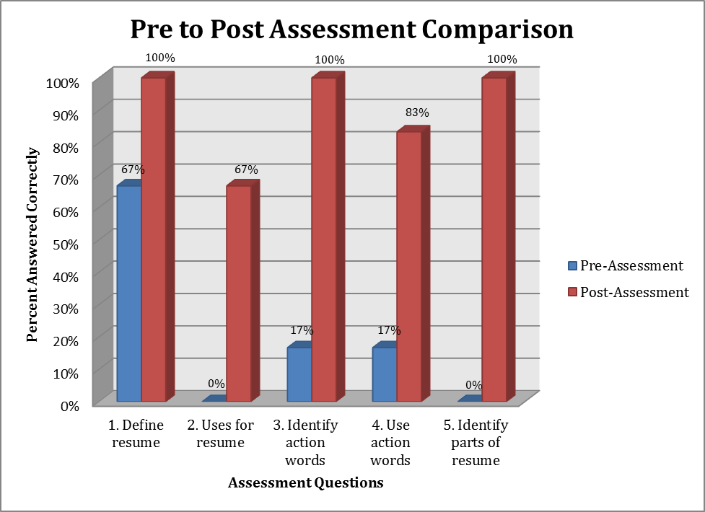

Lesson Data and Results:

The graph above was derived from data collected after administering this lesson to an eleventh grade class at Lunenburg High School during the 2011-2012 school year. For this particular lesson, the students appeared engaged both individually and as a group. The students appeared to put forth their best effort in answering the pre and post assessment questionnaires. The graph shows a comparison of the percentage of correct responses from pre to post assessment for each question. For question 1, there was an increase from 67 percent pre assessment to 100 percent post assessment (33 percent). For question 2, there was an increase from 0 percent pre assessment to 67 percent post assessment (67 percent). For question 3, there was an increase from 17 percent pre assessment to 100 percent post assessment (83 percent). For question 4, there was an increase of 17 percent pre assessment to 83 percent post assessment (66 percent). For question 5, there was an increase from 0% pre assessment to 100 percent post assessment. This data clearly shows that this lesson was effective in increasing students’ knowledge and ability in each of the five student performance objectives.
Resources:

- Massachusetts Model for Comprehensive School Counseling Programs/October 2006.

- Amercian School Counselor Association (2004). ASCA National Standards for Students. Alexandria, VA: Author.

- Information handouts from the Career Service Office of Quinsigamond Community College.

Informational Handouts:



