S
Unit: Career Development Grade Level: 8 Lesson #: 2

Essential Question for enduring understanding: Do students know how to: apply for a part time job, have a successful job interview, complete a job application, and know the labor laws?

Topic of Lesson: Applying for part time jobs: Laws, Application and Interviewing

Focus Question: What do I need to know about applying for a part time job?

Materials Needed: Time Needed: 45 mins
-Computer and access to internet
-LCD
-Speakers
-Power point
-Copies of application

Curriculum Links:
National: ASCA Mindsets and Behaviors for Student Success:
Mindset: 2 (Self-confidence and ability to succeed)
6 (positive attitude towards working and learning)
Behavior: 4 (applying self-motivation and self-direction to learning)
Social Skills: 9 (demonstrate social maturity and behavior appropriate to the situation
and environment)
State:
MA Career Development Education (CDE) Benchmarks:
A4-3 Skills in maximizing education and workplace achievement for employability, work satisfaction, and optimal earning potential.
W 2-2 Knowledge of how and where to access career and labor market information
W3-2 Knowledge of concepts of career pathway development, labor, market demand, and job retention
PS1-1 Skills in developing and maintaining a clear and positive self-concept

MA Curriculum Frameworks:
Science and Technology Engineering Guiding Principle: W-13 Address students’ prior knowledge and misconceptions (to challenge inaccurate belief and redirect student learning along more product routes)
History and Social Studies General Economics Skill: W1-2, W1-4 Explain how people or communities examine and weigh the benefits of each alternative when making a choice and that opportunity costs are those benefits that are given up once one alternative is chosen.
ELA Guiding Principles: A1-2 Literacy in all forms of media Gather information from a variety of sources, analyze and evaluate the quality of the information obtained, and use it to answer their own questions.
District/School Framingham Public School School Counselor’s Mission statement:
Through our comprehensive developmental school counseling program, students will acquire skills addressing their academic, personal/social, and career/technical development. Our goal is for students to develop self-awareness of their abilities and interests in order to explore secondary options and career pathways. Our department is committed to supporting a safe and conducive learning environment.
Walsh Middle School Mission Statement:
The community of Walsh Middle School is committed to the academic, social, physical, and emotional development of every student. This commitment is supported by a philosophy based on differentiation, participation, high expectations, cooperation, and respect for all.

Planning Reflection:
- I will teach my students job interview skills such as: how to applying for a job, how to have a successful interview, and how to successfully complete a job application. Students will also gain knowledge by learning the labor laws in Massachusetts.
- The baseline I need to know is how many students understand the job process and how many of them have applied to Keefe Technical School. If students have already applied to Keefe then they are familiar with filling out an application.
- The measures I will take on my pre and post data are: the completed job application, feedback from Keefe Technical School regarding the preparation of our students for their interview, and the feedback from our school secretary (who monitors the work permits) regarding the proper completion of a work permit.
- I will assess student learning by the feedback the completion of the mock application as well as the feedback, the pre and post questions and feedback from Keefe Tech and our school secretary.

Counselor/Teacher Performance Objectives:
During the lesson, the teacher will educate the students on the following: how to have a successful interview, how to complete an application of any kind, and what a job permit is.

Student Performance Objectives:
Cognitive: By the end of the lesson, the students will be able to
- Identify 3 important components of a job hunt (application, interview, laws)

Affective: By the end of the lesson, the students will
- Be familiarized with the Child Labor Laws and requirements associated with work permits.
- Know where to obtain a work permit.
- To complete an application, prepare for an interview and request a reference

Behavioral/Performance: By the end of the lesson, the students will be able to
- Complete a mock application
- Be prepare for and participate in an interview

Pre Assessment:
The teacher will take a quick poll of the classroom. He/she will ask
- How many students feel confident about their upcoming interview with Keefe or with a future employer?
- How many students feel confident in completing an application?
- How many students know what a job permit is and where to get one?

Post Assessment: The above questions will also be asked again

Description of the Activity/Structure of the Lesson:
1. Students will arrive to their homeroom for the lesson.
2. The teacher will explain to the students that they will be continuing the career and readiness unit.
3. The teacher will ask the pre assessment questions (noted above)
4. The teacher will begin the power point presentation.
5. Teacher will hand out mock application and ask students to complete it
6. Teacher will ask post assessment questions.

Modifications for Differently Abled Students
Since our social competences lessons are taught in homerooms, teachers are aware of the needs of their students. Therefore, the ELD and SPED students have already been identified.
To support all students, this lesson has been accommodated by having a multi model approach. It has visuals (such as, power point and videos with in the power point) and a hands on activity, such as a mock interview application. Prior to having the students complete the mock application, the teacher will preview the questions with the whole class and then walk around to each individual student for additional support.

Overall, the students were invested and interested in the lesson.
- 19/20 students completed the application
- 18/20 students reported that they feel confident about an interview and 100% of the class became aware of a job permit and where to obtain on.
- The feedback from Keefe Tech interviewers supports/reported that this lesson assisted our students in being prepared for their interview.

See post data below:

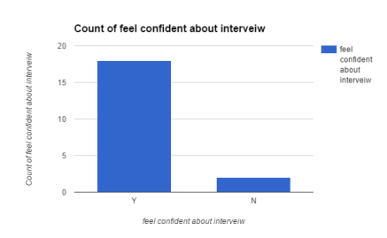

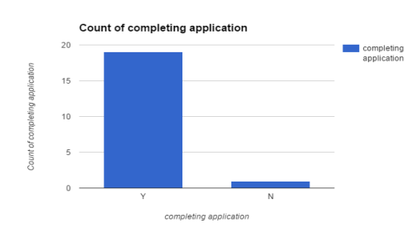
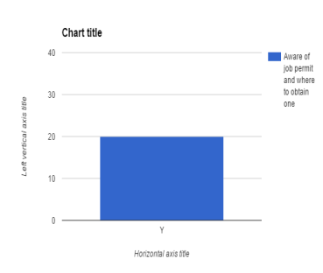

Reflection:
The lesson went quite well. From the pre data: 2 confident in job interview, 2 have completed an application, and only 1 knew information regarding a work permit, to the post data (shown above). It felt rushed due to the limit amount of time we have for our social competencies class. For next time, it would be great to incorporate a role play of a mock interview. This would allow student to practice prior to a job interview or their Keefe tech interview.

Cite Resources:

Commonwealth of Massachusetts, executive office of labor and workforce, department of labor standards.
http://www.mass.gov/lwd/docs/dos/youth-employment/youth-application.pdf
About. Com -job interviewing for tips for teens
http://video.about.com/jobsearch/Job-Interview-Tips-for-Teens.htm
McDonald’s- application

Supplemental Material:
See attachments (power point/application)

