JOB HUNTING TIPS
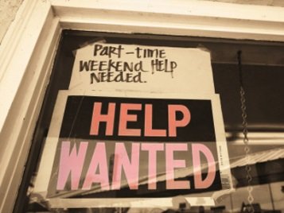
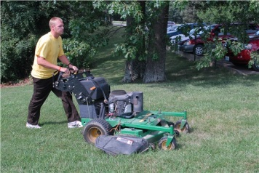

 

- Don’t wait for someone to knock on your door and offer you a job!
Good things don’t always just happen. Successful people go out and make them happen. Recruiters, counselors, neighbors, family, etc. may give you a little help, but it is NOT their responsibility to find you a job. Start searching – be proactive!

- Create a resume and keep it updated.
Add any work, volunteer and leadership experiences, as well as any awards, co-curricular and other items that will spice up your resume. When you are young and don’t have much work experience yet, it’s ok to include school successes! Make it neat, make it organized, and make sure all those pesky typos are outta there!

- Use as many sources as possible to locate job options.
This includes internet job sites (Monster, Indeed, Craigslist, CareerBuilder, etc.), newspaper ads, and bulletin boards. But, it also means you could walk around the mall, drive around town, and ask family, friends, neighbors and community members! There are so many different ways to begin searching. Don’t forget your teachers, counselors, and other school leaders!

- Fill out application completely.
Plain and simple. Don’t rush it! And again, make sure all spelling and information is correct.

- Identify, seek permission, and obtain contact information for references.
Think about who will speak highly of you – teachers, community leaders, etc. Employers typically look for three to four references, so try to get as many as you can. Contact them my email, phone, or in person and ask if they would be willing to be a reference. If they say yes, congrats! You are one step closer to a job.

- Do NOT take rejection personally.
Look at any lost job as a learning experience and one more chance to practice your interviewing skills. If you get the opportunity, you might even ask the employer why they chose not to hire so you can be even better prepared for the next one that comes along. Be polite and gracious, you never want to burn bridges! One day, your paths may cross again…

- Adjust your attitude!
You ALWAYS want to convey a positive attitude to a prospective employer. Be friendly, confident, and have good manners. Don’t forget to shake hands and make eye contact!

- Look for a job where you think you will be happy!
Sometimes you have to spend a great deal of time at work, so finding a job that makes you happy will make it a more enjoyable experience. Be open to new ideas and great opportunities, but don’t force yourself into something you know you will hate.

- Prepare for your interviews!!
You can bet your competitors have rehearsed for their interviews, so you should too! Study up on the company and position to which you are applying. Important things to know include: what the company does, who’s in charge (CEO, Manager, etc.), what skills they look for in their employees, where they are located (and if they have multiple locations), the work culture and environment, and any important information being said about that company in the media. Also, think about the kinds of questions you may be asked and how you will answer these questions. (Practice questions given below!)

- Doing well at an interview is a lot like taking a test.
The same sorts of rules apply. Before and interview, you want to get a good night’s sleep, study the material on which you will be asked questions, eat a good breakfast, be on time to the interview, bring any materials you may need, etc.

- Always dress for success!
Even if the job you're applying for involves wearing a uniform or working behind the scenes, the way you dress for an interview tells your potential employer that you take the job seriously. If you're a guy, wear a nice pair of pants and a shirt (a tie usually isn't necessary for a summer job, although it never hurts to wear one!). The same goes for girls — wear something simple and avoid short skirts or skimpy tops. Keep it classy! Whether you’re a guy or girl, sneakers, sandals, shorts, t-shirts, sweatshirts, and jeans don’t make good interview attire. You never get a second chance at a first impression!

Types of questions you should be prepared to answer in an interview:

- Why did you apply for this job?
- What do you know about this job or company?
- Why did you choose this position?
- Why should this employer hire you?
- What would you do if (filled in with a work-related crisis)?
- What are you strengths/weaknesses?
- How would you describe yourself?
- What accomplishment gave you the greatest satisfaction?
- Why did you leave your past job?
- What are your goals?
- What do you hope to be doing in 5 years?
- What courses did you like best or least in school and why?
- What are your interests outside of work?

