Linking Common Application and Naviance Family Connection Accounts
UNIT: College Application Process  Title/Topic of Lesson: Using Common App & Naviance  Lesson #1  Grade Level: 12  Time Needed: 48 minutes  FOCUS QUESTION: Do all students know how to set up their Common App account, link it to Naviance, and request transcripts and letters of recommendation electronically? | MATERIALS NEEDED:  - Computers with internet connection
CURRICULUM LINKS:

American School Counselor Association National Standards:
A:A2.1, A:B1.1, A:B1.4, A:B2.4, A:B2.7, A:C1.6
C:A1.1, C:A1.5, C:A1.7, C:A2.9, C:B1.3, C:B1.6, C:B2.2, C:C1.1
PS:A1.10, PS:B1.9, PS:B1.10, PS:C1.6

National Common Core:
CCSS.ELA-Literacy.CCRA.R.7 Integrate and evaluate content presented in diverse media and formats, including visually and quantitatively, as well as in words.

CCSS.ELA-Literacy.CCRA.W.6 Use technology, including the Internet, to produce and publish writing and to interact and collaborate with others.

MA State Frameworks:
ELA General Standard: Gather information from a variety of sources, analyze and evaluate the quality of the information obtained, and use it to answer [one’s] own questions. (A1-3)

Science and Technology Engineering Broad Concepts: (2) Appropriate materials, tools, and machines extend our ability to solve problems and invent. (A1-2)

Arts Core Concept: Understand the value of reflection and critical judgment in creative work. (A4-1, A4-2)

MA CDE Benchmarks:
A1-3, A2-3, A4-1
W1-1, W1-4, W3-5
PS1-3

District/School Links (Strategic Plan):
2.3 Improve the use of technology to communicate with the community
3.3 Create and implement a robust, effective communication network to market and inform
4.6 Increase student achievement in all grades

PLANNING REFLECTION:
- Students will set up their Common App and Naviance accounts and acquire the skills to be able to request transcripts and letters of recommendation and complete college applications through the Common App.
- Information collected from the pre and post assessment will measure student’s understanding of this process, and data collected from Naviance about the number of students who successfully set up their accounts during the lesson will be analyzed.

COUNSELOR/TEACHER PERFORMANCE OBJECTIVES:
The counselor will clearly describe and demonstrate how to create a Common Application account, how to activate student’s Naviance accounts, and how to link the two accounts for document submission. The counselor will show students how to request letters of recommendation and transcripts and apply to colleges using the Common App.

STUDENT PERFORMANCE OBJECTIVES
Cognitive:  1. Students will identify which teachers they will ask to submit recommendations on their behalf.  2. Students will learn about 2 on-line resources that will assist them with college planning. | Affective:  1. Students will feel more confident and prepared to carry out their postsecondary plan by demonstrating competence to use the presented on-line applications. | Behavioral/Performance:  1. Students will create Common App and Naviance accounts and link them.  2. Students will request letters of recommendation from teachers.  3. Students will evaluate the requirements for postsecondary options.
PRE-ASSESSMENT  Number of students participating in lesson = 47  Pre-Assessment Responses (Perception data)  - YES=32, NO=5, SORT OF=10  - YES=1, NO=42, SORT OF=4  - YES=0, NO=45, SORT OF=2  - YES=5, NO=35, SORT OF=7  - Average Response = 4.72  # of students with linked Common App and Naviance Accounts = 1 (Baseline data) |  | POST-ASSESSMENT  Pre-Assessment Responses (Perception data)  - YES=46, NO=0, SORT OF=1  - YES=43, NO=0, SORT OF=4  - YES=39, NO=2, SORT OF=6  - YES=35, NO=4, SORT OF=8  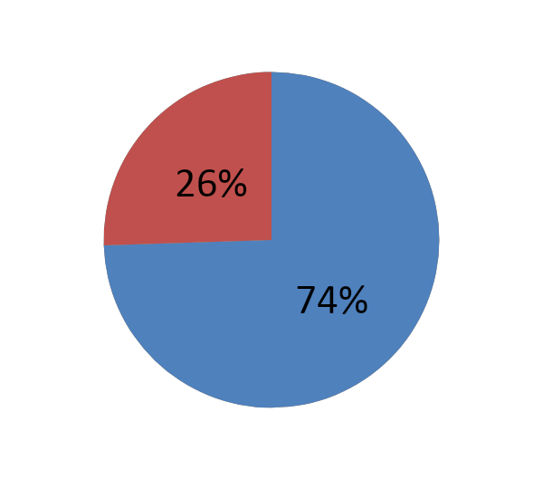  - Average Response = 7.12  Results Data  # of students with linked Common App and Naviance Accounts = 35 (out of 47 = 74%)
DESCRIPTION OF THE ACTIVITY/SEQUENCE OF THE LESSON
- Students will complete the pre-assessment online.
- Students will be asked how many of them are planning on applying to 4-year colleges and universities, and they will be divided into 2 groups.
- Students who identify that they plan on applying to 4-year colleges and universities will be seated at computers together and asked to log in. Students who identify that they do not plan on applying to 4-year colleges will be seated together and take part in a different lesson.
- The group of students who identify that they plan on applying to 4-year colleges will create Common Application and Naviance accounts if they have not already done so. They will then be shown how to complete the following tasks:
- Link their Common App account to Naviance
- If time allows, the students will also complete some or all of the following
- Update their game plan survey and student self-assessment
- Request transcripts and letters of recommendation
- Look up college information in Naviance
- Access the college visit schedule and sign up for appointments
- Students will complete the post assessment online.
MODIFICATIONS FOR DIFFERENTLY ABLED STUDENTS: The counselors will attempt to accommodate the learning needs of all students when presenting the lesson. If particular students have difficulty in understanding the information, additional assistance will be provided through individual appointments. | LEARNING STYLES ADDRESSED:  Enough counselors and teachers will be available to address the individual learning styles of each student. Instructions on how to complete the lesson will be handed out, a video will be available online for students to view with instruction, and they will also be explained verbally.
Data Analysis and Summary:
35 of the 47 (74.5%) students who participated in this lesson were able to set up and link their Common App and Naviance accounts during the lesson. 8 of the students who were unable to complete linking their accounts indicated in the post-assessment that they know how to do it. Completing this lesson early in the school year for seniors gave students more confidence (4.72 out of 10 on the pre-assessment to 7.12 out of 10 on the post-assessment) about their ability to carry out the postsecondary plan. The process of completing this lesson took longer than expected for some students, and in the future more time should be allotted to have all students be able to complete the task.
REFLECTION  The process for linking Common App and Naviance takes more time than anticipated. Students must fill out the lengthy Education Section on the Common App, add one college to their colleges list, and waive their FERPA rights before creating the link. This process takes up most of the class period. | RESOURCES  American School Counselor Association (2004). ASCA National Standards for Students. Alexandria, VA: Author.  Massachusetts Model for Comprehensive School Counseling Programs/October 2006.  The Common Application. https://www.commonapp.org/.  LMHS Naviance Family Connection. http://connection.naviance.com/leemhs.  Lee Middle and High School Strategic Plan (2011-2016).
SUPPLEMENTAL MATERIAL: Pre and Post Assessment (Administered online, questions attached)

Pre/Post Assessment

- Do you know what the Common Application is?

YES NO SORT OF

- Do you know how to set up a Common Application account and link it to your Naviance account?

YES NO SORT OF

- Do you know how to request transcripts and letters of recommendation?

YES NO SORT OF

- Do you know how to apply to college using the Common App?

YES NO SORT OF

- On a scale of 1-10, how certain are you that you know what the next steps are to make your postsecondary plans a reality?

1 2 3 4 5 6 7 8 9 10

