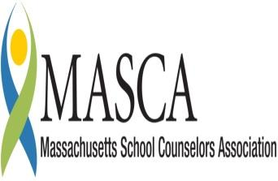 | Massachusetts Accountability Report Card  A continuous improvement document for school counseling outcomes  M.A.R.C. Jr.  2011 - 2012

1st LT Charles W. Whitcomb Middle School
Principal Mary Murphy
25 Union Street Marlborough, Massachusetts 01752
(508) 460-3502 Fax (508) 460-3547 http://www.mps-edu.org/
DISTRICT: Marlborough Public Schools GRADE LEVELS: 5 - 8 ENROLLMENT: 1400 SCHOOL YEAR: Traditional

School Guidance Program Mission

The mission of the 1LT Charles W. Whitcomb School is to provide quality instruction to our diverse population so every student can establish a pattern of lifelong learning based upon the tenets of wellness, knowledge, creativity and skills.

Whitcomb’s fifth-grade guidance program is comprehensive and developmental in scope and sequence. Lessons are designed to also include instruction and reinforcement of established grade curriculum frameworks, including ELA, Health and Wellness, and in this instance, Computer Technology.

College and Career Unit: Resume Building
It is never too early for students to begin thinking about college and careers, and how focusing on their current studies can actually prepare them for future success. During Academic Advising, our guidance staff delivered a 3-lesson unit in career and college readiness to 100% of all 16 fifth-grade classes (406 students).

Additionally, students received online resume building instruction and support for students during computer classes. Lessons encouraged exploration of individual talents and skills, hopes and dreams and finally, developing individual resumes in accordance with

Students were encouraged to think about how their talents and skills could translate into careers that would bring personal fulfillment, financial security, as well as a positive impact on their society. Student responses were contemplative and positive.

Student Results

National Curriculum Links:
- C:A2.6 Learn how to write a résumé
- C:A2.7 Develop a positive attitude toward work and learning.
- C:B1.2 Identify personal skills, interests and abilities and relate them to current career choice.

Traits and Interests Lead to College and Careers

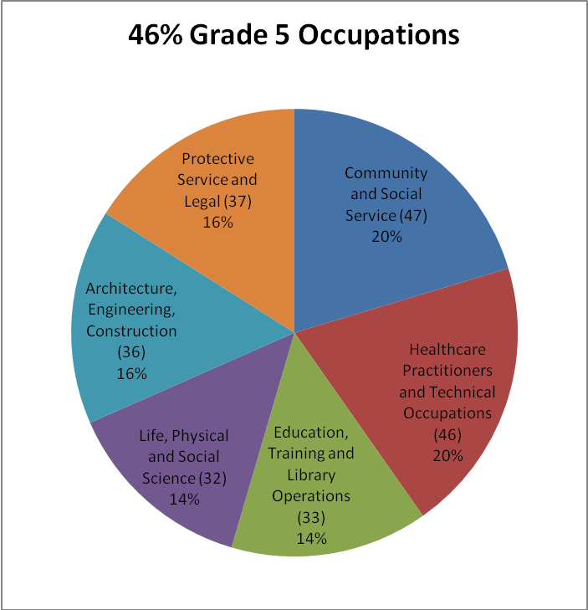

U.S. Bureau of Labor Statistics Categories
Division of Occupational Employment Statistics

Arts, Design, Entertainment, Sports and Media

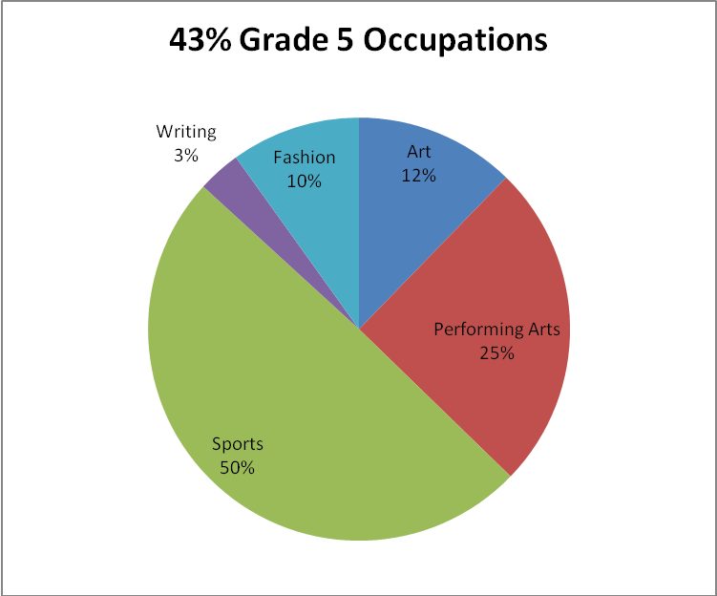

Grade 5 students quite possibly have the most interest in Arts, Design, Entertainment, Sports and Media fields as a result of their of their participation in age-appropriate, extracurricular activities.

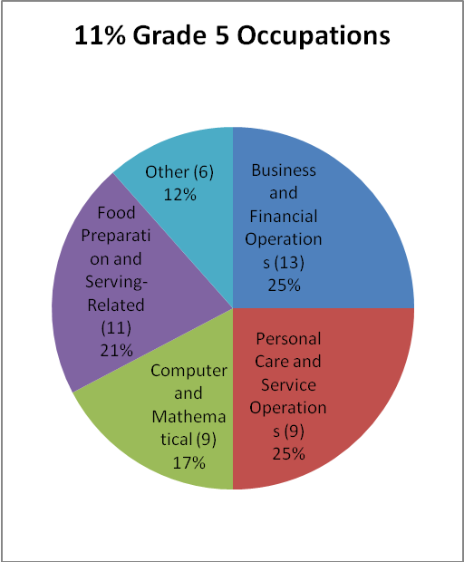

Integrating a contextual model of career development for young students that exposes them to a wider variety of experiences in the humanities, math and sciences can help them better understand the connection between school work and a personally satisfying, future career.

Focus for Improvement

Marlborough Public Schools continues to build its curriculum to offer more cultural, technical, literary and mathematical experiences and learning opportunities. It is expected that student achievement will be further reflected in broadened student career aspirations.

Our culturally-rich, civic-minded city is also home to a thriving business community. As students develop connections to their community, relationships with local businesses and civic leaders will enable them to experience a variety of careers and professions.

Welcoming Changes, Recognizing Opportunities

Now more than ever, teaching students to expect and embrace change is as important to their success as knowledge and skill. Successfully adapting and flourishing during change is integral to one's career success as is knowledge, ability and drive. Today, an effective career planning program must also offer specific instruction in functional adaptability, resiliency, and how to cultivate and sustain relationships in a multicultural society.

Student Support Personnel Team

Our student support personnel team is comprised of the following professionals:

Principal
Mary Murphy

Assistant Principals
Kalliope Pantazopoulos Grade 5
Bethany Pritchard, Grade 6
Richard Lacina, Grade 7
Wayne Labbe, Grade 8

School Adjustment Counselors
Loretta Braverman, Grades 5, 6
Michelle Stakutis, Grades 7, 8

School Guidance Counselors
Kelli Anne Jardim, Grade 5
Laura Henderson, Grade 6
Shelly Kennedy-Leonard, Grade 7
Lilian Kane, Grade 8

School Guidance Counselor Practicum Students
Gabriela DiGiandomenico, Assumption College
Joan D’Onofrio, Fitchburg State University

