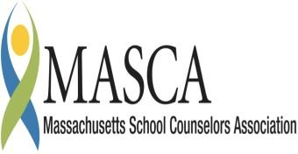 | Massachusetts Accountability Report Card  A continuous improvement document for school counseling outcomes  M.A.R.C. Jr.  2012-2013 School Year
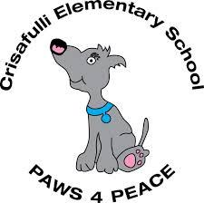 | Crisafulli Elementary School  13 Robinson Road, Westford, MA 01886  | ph: (978) 392-4483  | fax: (978) 392-8581  http://cs.westfordk12.us  DISTRICT: Westford  GRADE LEVELS: 3-5/ENROLLMENT: 525  SCHOOL YEAR: Traditional  PRINCIPAL: Sharon Kennelly

Principal’s Comments

We are continuing with our Code of Conduct, PAWS 4 Peace. Each day we are asking our students to 'PAWS' as they come in to school to remember that we strive to be a peaceful community. Each day we ask that they remember the Power of their words, be Accepting of others, be Willing to help others and demonstrate Self-Control. We will continue to reinforce and learn about PAWS 4 Peace with our students during Community Meetings, at classroom meetings and during the classroom guidance lessons.
Our guidance counselor meets regularly with students, staff and administrators to discuss the use of PAWS at Crisafulli and to develop plans to assist those who may need extra support. PAWS is also incorporated into the School Improvement Plan and the students and staff take a survey in the fall and spring to determine their knowledge of PAWS.
The goal of PAWS is to provide a consistent and meaningful language throughout the school to ensure students feel safe and comfortable in our school environment.
Sharon I. Kennelly,
John A. Crisafulli Elementary School

School Counseling Team

The Westford Public School is committed to student success. The school counselor is responsible for teaching and reinforcing safety in the school, positive social and emotional behaviors, and conflict resolution. If students act appropriately in social situations, there will be a decrease in reported conflict referrals at Crisafulli. Our goal is to utilize this series of lessons to prevent negative student interactions.
Crisafulli uses lessons developed by a team of guidance counselors. The guidance counselor at Crisafulli modifies the lessons to cater to the needs of
the students at Crisafulli. The Guidance Curriculum lessons include positive social interactions/friendships, perspective taking, calming down strategies, and how to apologize. The guidance lessons that we have focused on are a series of lessons that were given to each 4th grade class. The guidance lessons for the fourth grade include lessons on perspective taking, self-control, calming down strategies and apologizing. We have incorporated the PAWS 4 Peace code of conduct in each of the lessons given. The students learned how their words affect others, how to be accepting of others opinions, how to help others, and how to use self-control.
The lesson goals for this unit were:
- Lesson # 1 was for the students to learn the vocabulary words perspective and impulse control.
- Lesson #2 was for the students to learn calming down strategies and how to apologize by role playing.
- Lesson # 3 was focused on students identifying and role playing respectful perspective taking, self-regulation, calming down strategies and apologizing.

Student Results

Students successfully learned what the words perspective and impulse control mean. When given a scenario the students were able to correctly role-play how to take another’s perspective, and how to apologize. At the end of the three lessons, the students took a short assessment to show their knowledge of identifying other’s feelings, identifying acceptable reason’s for others feelings, how to use calming down strategies when upset, and how to apologize. Graph 3 is evidence that the students understand the concepts, and now have the skills to resolve a conflict in an appropriate way.

Graph 1: Knowledge of Vocabulary
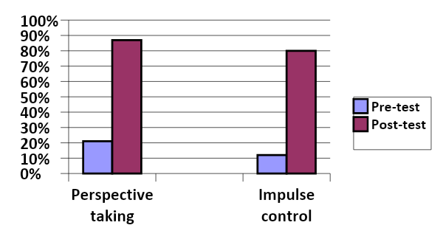
This graph shows that the students did not know what the perspective taking and impulse control meant before the lessons. After the lessons, the students knew the definitions of the vocabulary and how the words related to conflict.

Graph 2: Role plays
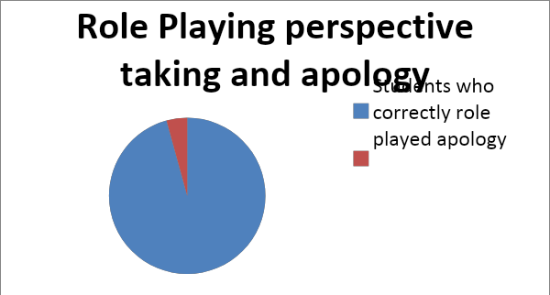
This graph shows that 96% of the students were able to correctly role play perspective taking and how to apologize.

Graph 3: Identifying feelings, calming down strategies, and apologies
Sara Leef | School counselor-  10 years of experience
Danielle Lemire | School counseling intern
Katie Meyler | 4th Grade Teacher
Briana Baker | 4th Grade Teacher
Amy Noonan | 4th Grade Teacher
Melissa Donegan | 4th Grade Teacher
Lenore Kost | 4th Grade Teacher
Lisa Boyle | 4th Grade Teacher
Sara Fox | School Nurse
Sharon Kennelly | Principal
Michelle Kane | Assistant Principal
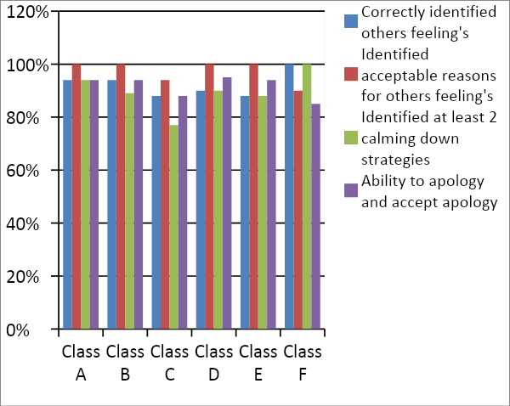
This graph shows that the students now have the skills to resolve a conflict by taking another person’s perspective, using self-control, and calming down strategies. If there is a conflict, they are able to successfully apologize and accept another person’s apology.
These lessons target the personal and social domains of the Massachusetts Career Development Educations Benchmarks, specifically PS2-1: Skills in interacting positively with others at home, at school, and in the community, and PS-2: Skills in problem-solving and conflict resolution at home, at school and in the community.

Focus for Improvement
In the future, the students should fill out a survey in the beginning of the year to report how many times they get into conflicts with their friends or peers, and if they know how to resolve their conflicts. At the end of the year, the students should take the same survey. Also, the principal should record conflicts that have disciplinary action in the beginning as opposed to the end of the year.
In order for the students to understand the concepts, they should role play in every lesson. The students enjoy showing teachers what they have learned by role playing, and it is a great way for the students to learn. If the students practice, they will be more likely to use the strategies they have learned in real life scenarios. Therefore, the school will continue to be a safe place with the improvement of less conflict.

Student Support Personnel Team
Mission and Philosophy
The Crisafulli community is committed to developing lifelong learners who are confident, caring, curious, and respectful citizens. We work hard to create a rich learning environment where all students can grow academically, socially, and emotionally. It is a strong home/school connection that ensures our students' success. Each day we are asking our community members to 'PAWS' as they come in to school to remember that we strive to be a peaceful community by paying attention to the Power of our words, being Accepting of others, being Willing to help others, and demonstrating Self-control.

