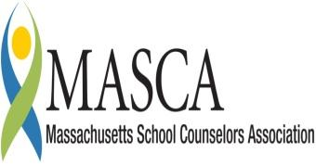 | Massachusetts Accountability Report Card  A continuous improvement document for school counseling outcomes  M.A.R.C. Jr.  2012-2013School Year

Everett Public Schools
121 Vine St.
Everett, MA 02149
(617) 394-2400 FAX: (617) 394-2408
http://www.everett.k12.ma.us
DISTRICT: Everett Public Schools
GRADE LEVELS: K-12 ENROLLMENT: 6,844
SCHOOL YEAR: Traditional
SUPERINTENDENT OF SCHOOLS: Frederick F. Foresteire

Superintendent’s Comments

The Everett Public Schools is committed to the academic and social development and success of all students PreK-12. Thus a safe learning environment for all students is and must be maintained. Over the past years, my focus has been to ensure that any reported incidents of bullying are managed readily and efficiently. To that end, the Committee on Bullying has been established.

The Everett Public Schools Policy on Bullying, approved by the Department of Elementary and Secondary Education, was enacted; and, through the work of the Committee, continues to be updated as necessary. Through further work, the Committee has overseen the development of the curriculum by grade level K-12 and is in alignment with the Massachusetts Aggression Reduction Center recommended Curriculum on Bullying. The Committee has also elected to utilize the Open Circle Curriculum available to the children of grades K-5. In order to implement both of these programs with fidelity, staff have attended core trainings, and coaches have been trained to lead groups of children in each building as they raise awareness on all matters of bullying.

Because of this concerted effort, over the past three years, I am happy to report, the reports of bullying have decreased.

Frederick F. Foresteire
Superintendent of Schools

Student Results

Under the new Massachusetts Anti-Bullying Law Chapter 92 of the Acts of 2010, students are encouraged to report any acts of bullying incidents to teachers, administrators and school support personnel. In 2010, Everett Public Schools implemented a district wide bullying initiative. Staff and students have received training on how to report incidents of bullying in order to ensure that all students’ level of safety, comfort and overall wellbeing is maintained.

The bullying curriculum was developed using the CDE Benchmarks found in the Mass Model. The Everett Public Schools reports that there was a
decrease in the number of bullying reports/incidents from the 2010 school year to the 2012-13 school year. The district went from 49 reports in the first half of 2010 down to 18 in the first half of 2011. For the 2012-2013 entire school year, there were 16 bullying reports made district wide. The total number of reports decreased by two however, the time span increased by six months.

The bullying curriculum targeted the Social and Personal Domain of the MA Model, specifically within the PS2-2 benchmark of the MA Model, which directly relates to building skills in problem-solving and conflict resolution at home, at school, at work and in the community.

The guidance department has worked hard to implement the MARC curriculum and has trained all of the K-5 counselors in Open Circle. The number of reports at each of the K-8 schools has either maintained the same number of reports or decreased from the previous year. The high school is the only school in the district to see an increase in the number of reports with an increase of three in comparison to the beginning of the previous year.

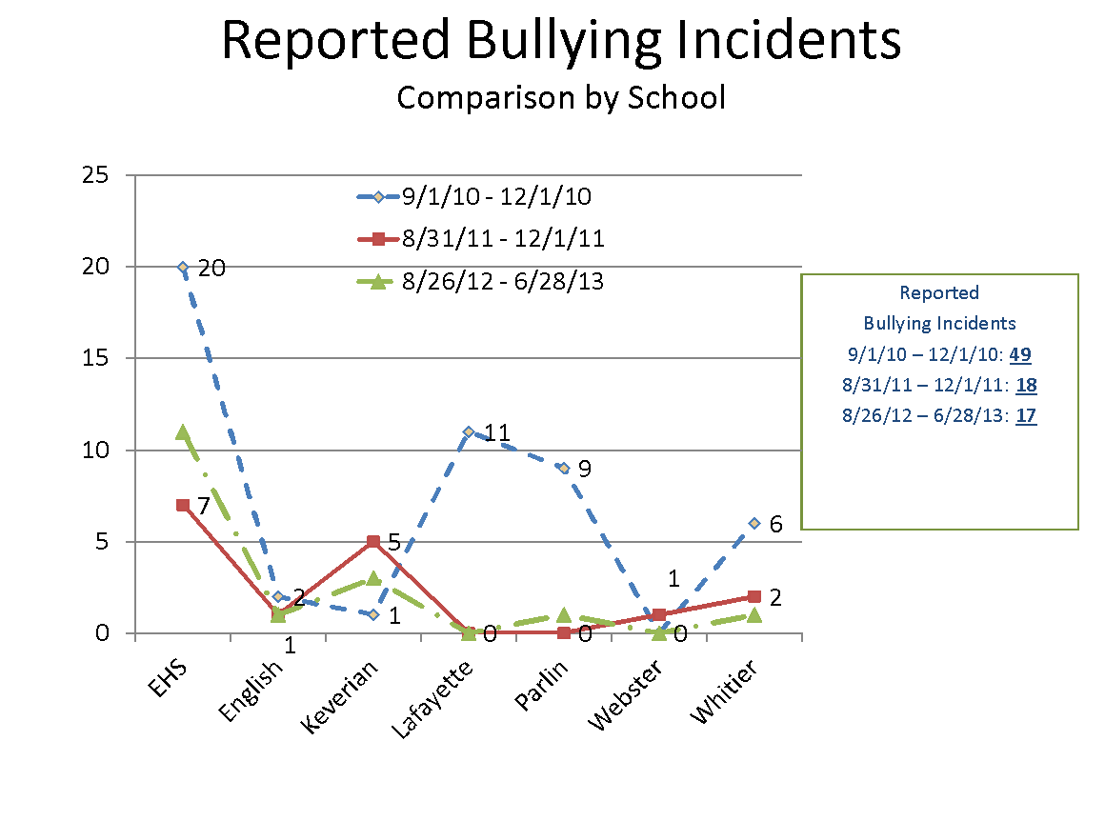

Focus for Improvement

The bullying curriculum is an ongoing top priority in the Everett Public Schools. Students receive lessons and education regarding positive interactions with peers and adults as well as being able to identify the roles in a bullying situation. Students will have full access to support staff to discuss, report or assist in any potential bullying situation. There will be a decrease in the number of bullying incident reports in the Everett Public Schools as students use the skills acquired through the lessons taught to them in a variety of settings ranging from classrooms to small groups activities and discussions. The highest number of bullying report/incidents continues to be at the high school level. In order to attempt to address many early issues, the district has started a transition team that has planned and implemented numerous events such as 8th grade day and parents’ night, 8th grade visits and current high school student seminars to answer any questions and ease concerns about bullying at the high school level. All schools in the district have implemented the Massachusetts Aggression Reduction Center bullying curriculum pilot. The K-8 schools introduced the program in the health classes while the high school incorporated it into both health classes as well as weekly advisory program. The district has also tried to incorporate bullying lessons in a variety of ways outside of the normal classroom/office environment. Recently grades 8-10 were able to learn about bullying through hip hop music. There will be continued emphasis to present a bullying curriculum in a fun and innovated way to keep students engaged while also learning how to treat one another in a caring and respectful manner.

Student Support Personnel Team

The student support personnel team will consist of many people. The Everett Public School’s school counselors, social workers, school adjustment counselors, and teachers will play an intricate role in the implementation of the district wide bullying curriculum.

Staff Name | Position | School
Paul Enfanto | Director of Guidance | Everett High School
Margaret Barner | School Counselor | Everett High School
Johnna Berard | School Counselor | Everett High School
Kelley Buonopane | School Counselor | Everett High School
Melissa Cesco | School Counselor | Whittier School
Michael Engel | School Counselor | Everett High School
Maureen Kacvinsky | School Counselor | Everett High School
George Lombard | School Counselor | Everett High School
Robert Constantine | School Counselor | Lafayette School
Robin Brickley | School Counselor | Keverian School
Maria Forziati-Keefe | School Counselor | Parlin School
Judith Harrington | School Counselor | English School
Laurie Leverone | School Counselor | English School
Elizabeth McLean | School Counselor | Lafayette School
Eric Piazza | School Counselor | Keverian School
Jessyca Redler | School Counselor | Webster School
Megan Smith | School Counselor | Parlin School
Angela-Grace Blais-Leporte | Adjustment Counselor | Parlin School/  Whittier School
Caitlin Ahern | Adjustment Counselor | Keverian School
Marisa Botta | Adjustment Counselor | English School
Kelly Powers | Adjustment Counselor | Lafayette School
Carolyn Troy | Social Worder | Everett High School

