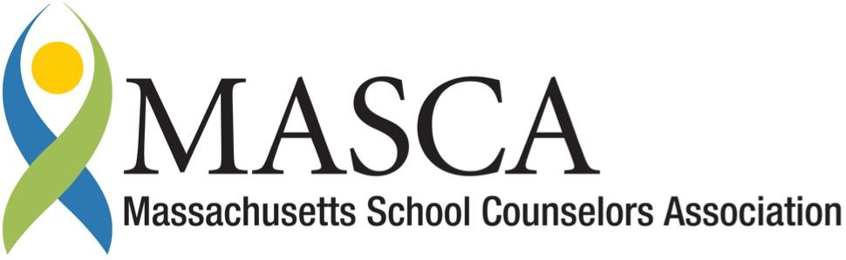 | Massachusetts Accountability Report Card  A continuous improvement document for school counseling outcomes  M.A.R.C. Jr.  2012-2013 School Year

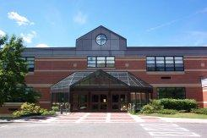
Brayton Elementary School
20 Barbour St
North Adams, MA 01247
413-662-3260
http://brayton.napsk12.org
DISTRICT: North Adams Public Schools
GRADE LEVELS: P - 7 ENROLLMENT: 537
SCHOOL YEAR: traditional with after school and summer programs
PRINCIPAL: Sarah Madden

Principal’s Comments
Brayton Elementary is a "Community of Learners" where collaboration, cooperation and partnership among students, families, school and the community are critical and lead to the successful education of every child. Brayton is a learning environment where expectations allow for creativity and discovery through meaningful life experiences. This is achieved through encouraging the Brayton Habits of Mind: Find Humor; Persist; Think; Question; Create; Listen with understanding and empathy; Manage impulsivity; and Take responsibility. The School Adjustment Counselor, the administrative team, and student support staff play a vital role in implementation of these goals.
The School Adjustment Counselor has demonstrated commitment to providing proactive services in support of student academic achievement, personal and social development and creating a safe and trusting school community. Responsive services provided by the School Adjustment Counselor such as crisis intervention and therapeutic individual, family and group counseling are essential to the well-being and academic success of our students. Our counselor has initiated a program that is aligned with the Massachusetts Model for Comprehensive School Counseling. As principal, I support this school and district initiative. An internal calendar has been developed that details the services and programs of the school counseling program. A developmental guidance lesson that is aligned with MA CDE and curriculum Frameworks has been developed and delivered to all 5th graders.
Sarah Madden, Principal

P-12 School Counseling Mission Statement
School counselors work in partnership with students, parent/guardians, staff and the community to create a safe, respectful and caring environment and to foster the development of each student’s unique and full potential. This partnership strives to provide a comprehensive program that assists students in acquiring the values, knowledge and skills needed to become effective students, responsible citizens, productive workers and lifelong learners. The school counseling program spans across all grades and addresses academic, career and personal/social needs of all students.

Student Results

In line with the School Improvement Plan goals to increase CPI in ELA and Math, a continuum of strategies to increase student attendance and school engagement has been implemented in grades 6 and 7. In addition, the School Adjustment Counselor has identified the goal of sending engaged and intrinsically motivated students to high school; students enter high school in 8th grade in our district.
Accelerated 7th grade math students (who attend math class at the high school) calculate, chart and maintain attendance data on students in kindergarten through grade 7. Each week, the students display average attendance rates per grade level. The grade with the highest level is announced over the PA system and they earn an extra 15 minutes of outdoor recess that week. Although recess may serve as an external reward, the ongoing focus contributes to the development of the school’s articulated habits of mind. It also leads students to see that school engagement and attendance is valuable. This intervention began during the 2010-11 school year and has continued.

Year | Grade 6 |  | Grade 7
 | Attendance  Rate | Enroll-  ment | Attendance  Rate | Enroll-  ment
09-10 | 97% | 40 | 96% | 48
10-11 | 96% | 46 | 96% | 34
11-12 | 96% | 42 | 96% | 45
12-13 | 96% | 38 | 95% | 41
Despite the interventions, the attendance rate shows no change. Closer inspection of the data indicates the need for targeted interventions with the few students that have high absence rates to improve overall attendance. Several students with significant mental health, family or other personal problems have a large impact on the small number of students enrolled per grade; for each one student absent, the rate changes by approximately 3%.
Research indicates that building strong student-adult relationships is paramount to improving school engagement for middle school students. Initiated the School Adjustment Counselor, a Middle Ground Group program was designed that placed all 6th and 7th grade students in groups of 8 or less with one adult mentor (school faculty or staff) over the course of 6th and 7th grade. Groups meet once weekly and focus on: building community and trust; problem solving; social skills development; broadening students’ experiences and perspectives; and building self-efficacy through community service and civic action. This intervention began during the 10-11 school year and has continued.
Surveys were administered to students and adult advisors of the middle Ground Groups in June, 2013.

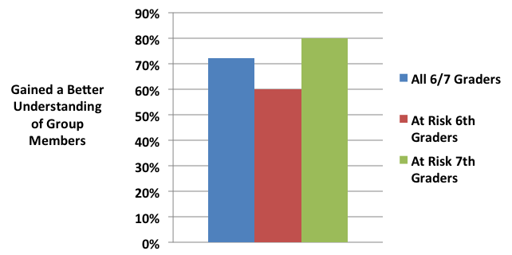
The data from the surveys indicates that the middle ground groups are having a positive impact on student engagement and school connectedness by improving peer relationships, by involving students in meaningful group activities and by strengthening student-adult bonds. Both student and staff survey respondents indicated that they enjoyed community building, discussion, and community service activities in their groups. At-risk 6th graders show a high rate of comfort with talking with their Middle Ground Advisor.
Focused lunch groups were instituted that recruited students based on both their needs and their strengths. These groups provided opportunities for students to develop leadership skills, social skills, problem-solve, serve as positive peer mentors, build positive peer relationships, and perform community service. They identified school-wide issues and named themselves the Anti-Bully Squad and the Stop the Drama group. They began to initiate follow up service projects. Students formed a strong connection with the facilitating School Adjustment Counselor and benefited from positive attention, affirmation, and personal support. Focused lunch groups began 2012-13.
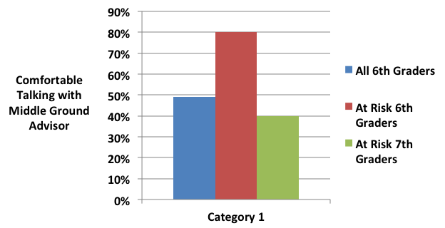

Focus for Improvement
The School Counseling Program at Brayton Elementary School is targeting the following areas for improvement:
- Implement targeted interventions with students who are chronically absent
- Increase the number of focused lunch groups to serve more students
- Expand career awareness experiences and lessons across additional grades
- Utilize data from staff and student survey to improve effectiveness of middle ground groups
- Analyze results of school bullying survey and develop strategic interventions

Student Support Personnel Team
District School Adjustment Counselors meet monthly for case consultation and for systemic planning. The Brayton School Adjustment Counselor meets weekly with the Brayton CORE Team as well as the Transitional (therapeutic) Classroom staff. The School Adjustment Counselor is responsible for facilitating 504 Accommodation Plans and regularly participates in IEP meetings.
The Brayton School Counseling and Student Support Staff consist of:
Team Member | Position | Degree | Yrs. Exp.
Sarah Madden | Principal
Dan Sherman | Dean of Students
Nancy Gallagher | School Adjustment Counselor (SAC) | MS School Counseling | 19
Anne French | Team Leader for District SAC’s | MA Counseling Psychology | 27
Deborah Alves | Student Support Center
Christy Ciempa | Student Support Center

