Massachusetts Accountability Report Card
A continuous improvement document for school counseling outcomes
M.A.R.C. Jr.
2012-2013 School Year

Johnny Appleseed Elementary School
845 Main St.
Leominster, MA 01453
P - 978-534-7765
F - 978-534-7776
http://jaes.leominster.schoolfusion.us

DISTRICT: Leominster
GRADE LEVELS: PreK-5 ENROLLMENT: 660 students
SCHOOL YEAR: Traditional
PRINCIPAL: Dr. Margaret O’Hearn-Curran

Principal’s Comments

The Johnny Appleseed Elementary School guidance department has put in tremendous effort this year in providing support to our staff and students. All this is possible through a strong relationship between the administration and guidance department. Working as a team is a necessity in ensuring strong academic performance and that every student has the tools they need to be successful in the classroom. Although this is not an easy job, we welcome the challenge. The Johnny Appleseed Elementary School team is constantly looking to improve our guidance department in alignment with the Massachusetts Model. Our commitment to our students and community is strong and it is necessary in ensuring maximum academic performance.

Dr. Margaret O’Hearn-Curran
Principal

Student Results

During the school year the weekly School Wide Information Systems (SWIS) report has shown an achievement gap in behavior amongst 1st graders. This poses as a challenge when it comes to classroom management. Disruptions in first grade classrooms affect other students learning. It is hard for our first grade students to remain on task when a teacher has to focus the majority of their time in disciplining their students. The graph below shows the number of office referrals to date for the school year. First grades office referrals are significantly higher than any other grade in the school.

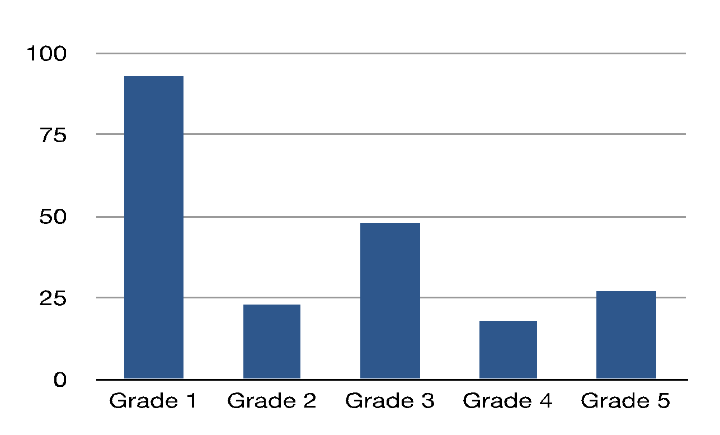

Figure 1 The graph shows the number of office referrals for each grade.

An office referral is when a student commits a problem behavior and is written up by a faculty or staff. There are two types of office referrals: minor and major. A major referral includes abusive behavior, lying/cheating, theft, disrespect, aggression, and inappropriate language. On the next graph you will see how many of the total office referrals are major referrals for grades 1-5. This graph shows that just around 40% out of the office referrals for the school are major referrals.

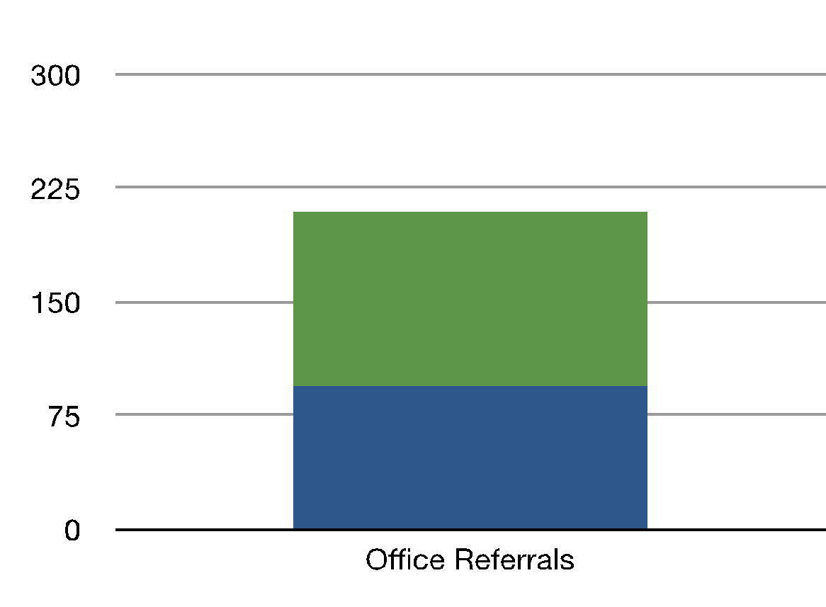

Figure 2 Shows the school wide office referrals the height of the graph shows how many office referrals there were. The blue out of the graph shows us how many were major referrals.
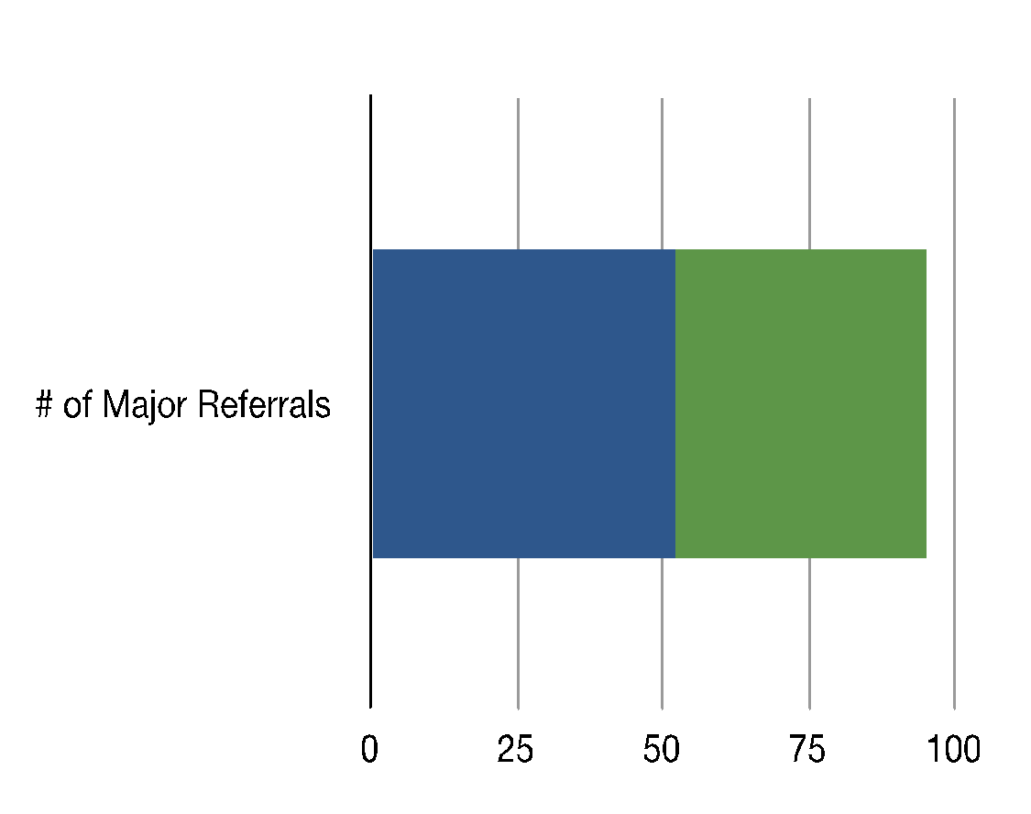

Figure 3 Shows the total number of major office referrals. The blue shows how many of those are from 1st grade.

The total number of major office referrals for first grade compared to the rest of the school raises concern for the guidance department. The guidance department is committed to staging interventions to decrease 1st grade office referrals.

Focus for Improvement

Johnny Appleseed Elementary School has a strong commitment to continuous improvement. Through implementing a first grade guidance curriculum that focuses on positive reinforcement and the education of empathy we have noticed a decline in major office referrals for the first grade.

The guidance department has been collaborating with all of the first grade teachers and aids in rewarding positive behavior amongst the students. Every teacher commits to 2 lessons a week in teaching empathy and tolerance to their class. These lessons focus on modeling and active role-playing. The first grade students have been showing huge improvements during recess, where most of the office referrals are happening.
Through analyzing research and properly planning our approach through necessary outlets we shall continue to monitor progress in the first grade.

Suggested plans for next year:
- Continue to present these lessons to Gr. 1 beginning in fall
- Design and implement fall lessons for Gr. 2 to reinforce and enhance Gr. 1 lessons. And, monitor SWIS data to assess behavior.

Student Support Personnel Team

Guidance Team

Karen Russo
School Guidance Counselor M.S., CAGS

Melissa Hopkins
School Psychologist M. Ed., CAGS, NCSP

Matt Londo – School Counseling Intnern

Administration

Patricia King
Assistant Principal M. Ed., CAGS

Dr. Margaret O’Hearn-Curran
Principal

Student Intervention Team

Elizabeth Kusz
Title 1 Teacher M. Ed.

Karla Lewis
2nd Grade Teacher M. Ed.

Karen Croteau
3rd Grade Teacher M. Ed.

Jessica Gale
Special Education Teacher M. Ed.

