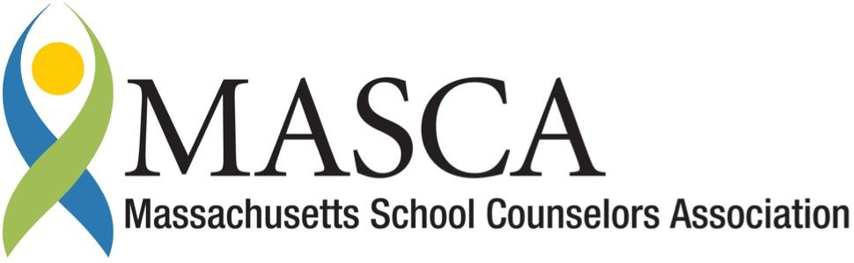 | Massachusetts Accountability Report Card  A continuous improvement document for school counseling outcomes  M.A.R.C. Jr.  2011-2012 School Year
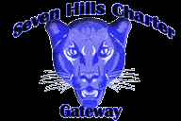 | Seven Hills Charter Public School  51 Gage Street Worcester, MA 01605  508-799-7500  http://www.sevenhillscharter.org/  DISTRICT: Seven Hills Charter Public School  GRADE LEVELS: k-8 ENROLLMENT: 666  SCHOOL YEAR: year-round  HEAD OF SCHOOL: Ms. Louise Nelson

Principal’s Comments

As the Elementary Academy Head of School, I see firsthand the incredible difference weekly Guidance lessons have on our 4th and 5th grade students here at Seven Hills Charter Public School. We take instances of bullying very seriously at Seven Hills Charter Public School, and believe education is the key to student success. The mission of Seven Hills Charter Public School is to prepare a diverse cross-section of Worcester children for success as students, workers, and citizens by providing them with a high-quality education at prevailing public school costs. The Guidance team is an integral part of fulfilling this mission. We are proud to offer comprehensive, standards-based guidance lessons to all 666 of our students in grades k-8.

Louise Nelson
Elementary Academy Head of School

Student Results

Bullying fosters a climate of fear and disrespect that can seriously impair the physical and psychological health of its victims and create conditions that negatively affect learning, thereby undermining the ability of students to achieve their full potential. An Act Relative to Bullying, Chapter 92 of the Acts of 2010 reflects Massachusetts’ appreciation of schools’ important responsibility to maintain a safe learning environment for all students. This Act also requires that students be educated on the school’s bullying prevention and intervention plan annually. At SHCPS students grades k-8 have weekly guidance classes. Students in grades 4 and 5 spent three class periods learning about the Bullying Prevention and Intervention Law and were shown a PowerPoint presentation educating them on the MA legal terminology included in the Act Relative to Bullying. There are three 4th grade classes and three 5th grade classes. All students in 4th and 5th grades were given a pre-assessment prior to the PowerPoint lessons and were then given the same assessment after the lessons were completed. The assessment consisted of 22 true or false questions related to definitions of bullying and related terminology from the Massachusetts law. Students who attended the school last year had similar lessons in their Guidance classes the previous year, (grades 3 and 4 respectively), however there were a number of students who were new to the school and had never been introduced to this material.

The data shows that students in both grade levels showed improvement in their post-assessment scores. The average score on the pre-assessment was 83% for 4th graders and the average score for the post-assessment was 94%. This is an 11% increase in the post-assessment scores from the pre-assessment scores for 4th graders. The data indicates that there was an increase in the post-assessment scores for 5th graders as well. The average pre-assessment score was 79% and the average score post-assessment score was 94%. This is a 15% increase.
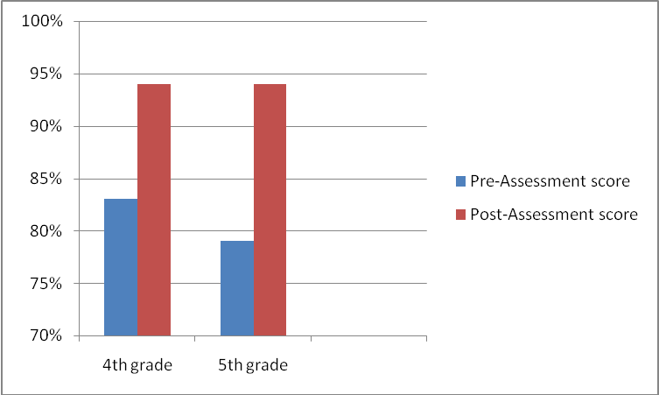

We know that when bullying goes unreported, the consequences and the psychological trauma can be great. In order for school officials to respond to bullying situations quickly and effificently, they need to have the information. Most times, this information comes from bystanders (people who see or hear bullying). In order to ensure that students are reporting bullying, the lessons are permeated with examples of how to report. There is also a strong distinction between tattling and reporting, and this is gone over in detail in the lessons. After the students had the lessons, they were asked to write down at least three ways to report bullying on the back of their post assessment. The data showed that 100% of the 4th and 5th grade students could identify at least three ways to report bullying.
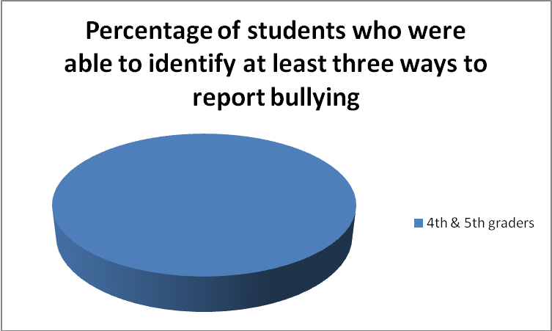
The top three ways to report were: 1.) Send a bully alert, 2.) Ask to go to Guidance and tell Mrs. Rodriguez or Ms. Dirsa, 3.) Tell classroom teacher.

Focus for Improvement

A review of the post-assessment was done with all of the students in every class to ensure that they understood each of the 22 questions. Students who did not understand a question were encouraged to ask questions and further instruction and explanation ensued. Because none of the three 4th grade classes nor the three 5th grade classes scored an average of 100% on the post-assessment, it is clear that students needed further instruction on the terminology and bullying law and several slides were added to the PowerPoint to help clarify some of the areas were students tended to answer incorrectly. This information was presented to the students again in an additional lesson, and the updated PowerPoint presentation will be used next year in the 4th and 5th grade classes.
In addition to learning the law related to bullying, students were trained on how to report bullying. Last year an online bully alert system was put into place. Students in grades 2-8 were trained on the bully alert system last year as well as this year. The goal for next year would be a decrease in the number of instances of bullying through the continuation of the bullying prevention guidance classes.

Student Support Personnel Team

The school counseling program at Seven Hills Charter Public School is designed to help all students reach their potential and prepare them for success as students, workers, and citizens. We work collaboratively with administration, teachers, staff, parents, and the community to support students in achieving academic, personal/social and workplace readiness skills. Our dedication to this is evidenced by our weekly 30 minute guidance classes for all students grades k-8.

Under the direction of Lisa Pugliese Dirsa, the Director of Guidance, and Sherry Trainque, the Director of Student Support Services, and in collaboration with each academy’s Head of School and the superintendent, the Guidance team works to support each and every one of our students.
Our team members include:

Sherry Trainque, M.Ed.
Director of Student Support Services

Lisa Pugliese-Dirsa, M.A., C.A.G.S
Guidance Director

Stephanie Rodriguez, M.S. School Counseling
Assistant Guidance Counselor

Lauren Koleros, M.Ed., C.A.G.S
School Psychologist

Steve Colorio, B.S.
Academy Director

