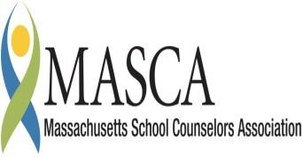 | Massachusetts Accountability Report Card  A continuous improvement document for school counseling outcomes  M.A.R.C. Jr.  2014-2015 School Year

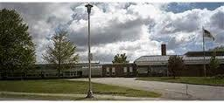
Florence Roche Elementary School
342 Main Street
Groton, MA 01450
978-448-6665
http://www.gdrsd.org/fres
DISTRICT: Groton-Dunstable Public Schools
GRADE LEVELS: K-4 ENROLLMENT: 541
SCHOOL YEAR: traditional
PRINCIPAL: Liz Garden

Principal’s Comments

Florence Roche is dedicated to helping students. We are fortunate to have a strong counseling program that is present for all students. We support them, and want to see them succeed. Currently we are setting goals for ourselves. We want to help those continuing to struggle and therefore, some of our teachers have taken on a more direct social emotional curriculum. We are fortunate to have the staff to help students regulate their emotions. We strive to finish stronger than we started and will continue to implement a stronger curriculum.
Liz Garden
Florence Roche Principal

Vision Statement

The Florence Roche Elementary School community is committed to a comprehensive education that is dedicated to high academic achievement for all students and development of the whole child through staff, family and community partnerships.

Student Results

Florence Roche is invested in keeping students in their classroom. Students who are non-compliant, screaming, destructive, harming others/self, crying uncontrollably, and withdrawing from all activities, are pulled out of the classroom to take a break. When students are pulled from the classroom, they are being taken away from learning. This results in students falling behind and needing extra time to catch up. In addition, peers in the classroom are unable to learn, when the attention and focus is on the one child in crisis. Research suggests that a child in crisis has low social emotional development. By implementing a social curriculum, the students can learn the necessary skills needed to stay in the classroom.
During the second quarter of the school year, thirty students were out of their classrooms on a weekly basis. Of those thirty, seventeen were on a daily basis and three were on a monthly basis.

Graph #1 – 2nd Quarter Data
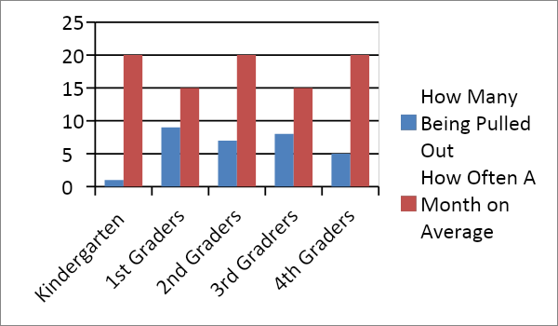

During the third quarter of the school year, fourteen of the thirty students were able to stay in their classes without needing breaks throughout the day or week. Even though some students learned the necessary social skills to stay in class, other students needed extra help outside the classroom with Tier #2 interventions. In other words, of the fourteen lost, another eight new students were added.

Graph #2 – 3rd Quarter Data:
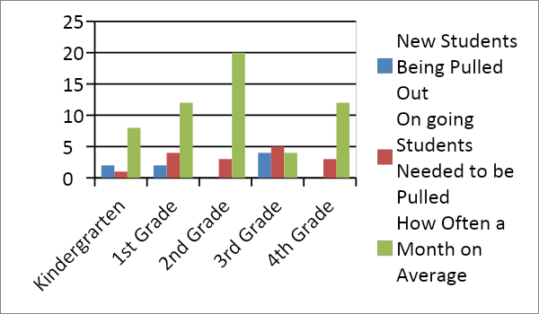

To help the students learn social skills, we plan one social emotional lesson each month for each of the grades. We go into the classrooms with either a video or book geared toward one specific topic. By doing this, we build upon their social emotional development as well as, begin to form positive relationships with each child in the school.
With the counseling lessons in each classroom, students were out of the classroom less often in the third quarter than the third quarter. Closer inspection indicates the need for targeted Tier #2 or #3 interventions with the few students that have a tougher time with social and emotional development.
For the third quarter, we worked with one first grade teacher to begin implementing social emotional curriculum into her daily classroom schedule. Since she began the targeted lessons, her students were seen less by the principal for aggressive reasons, were pulled out of the classroom less to finish assignments, and visited the counseling office less. Graph#3 presents the impact of a social emotional curriculum being implemented in the daily classroom schedule:
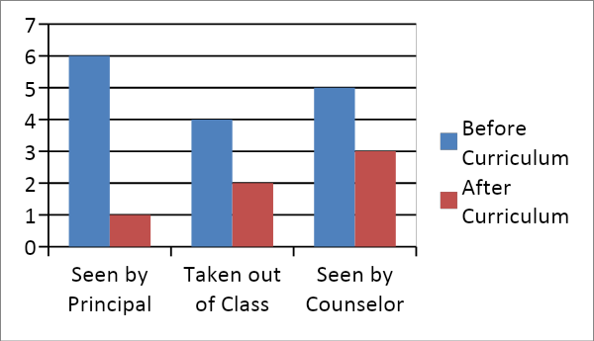
The data reflects the positive behavior impact gained by teaching social skills. For students struggling with self regulation in the classroom, social-emotional learning can help improve their overall learning by keeping them in classrooms and available for academic instruction and learning activities.

Focus for Improvement

The School Counseling Program at Florence Roche Elementary School is targeting the following areas for improvement:
- Increasing the number of focused groups to serve more students
- Expanding upon the Tier #1 classroom social emotional lessons taught each month
- Adding social-emotional development into the classroom curriculum plans
- Providing professional development on social thinking for classroom teachers

Student Support Personnel Team

Each month, the school counselor delivers a developmentally appropriate lesson touching on a variety of issues every month. The lesson is the same for the entire grade, and subject matter is targeted to improve social-emotional functioning and awareness of our students. A follow-up letter is published on the school website each month so parents are aware of topics being discussed.
The Florence Roche School Counseling and Student Support Staff consist of:

Team Member | Position | Degree | Yrs. Exp.
Liz Garden | Principal
Dianna Fullreader | Vice Principal
Maureen Cahill | School Counselor | MS School Counseling | 8
Heidi May | Counselor Intern

