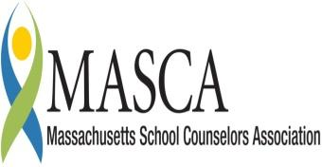 | Massachusetts Accountability Report Card  A continuous improvement document for school counseling outcomes  M.A.R.C. Jr.  2013-2014 School Year

Cheshire Elementary School
19 Church St, Cheshire, MA 01225
T. 413-743-2298 F. 413-743-8412 www.acrsd.net
Adams-Cheshire Regional School District
Grades PreK-5 ENROLLMENT: 230
SCHOOL YEAR: Traditional
PRINCIPAL: Mr. Peter Bachli

Principal’s Comments

When the Massachusetts Department of Elementary and Secondary Education required schools to implement a form of social skills education program, Nicole Seyerlien, our School Counselor, began the research process. She consulted with other local school counselors to find a research based program that fit the needs of our students, teachers, and budget.
Mrs. Seyerlein teaches the Second Step lessons to our two Kindergartenclasses, both fourth grade classes, as well as our fifth grade class. The lessons have made a deep impact on the student population and have given the students social skills, and techniques to help problem solve. Specifically, with this current fifth grade, when they are in a conflict with each other they can refer back to the Second Step lessons and use the S.T.E.P. system to help work out the problem on their own with little adult assistance. The weekly program also includes home link, and follow through lessons. These allow Mrs. Seyerlein to connect her lessons with both the classroom teacher as well as the parents/guardians at home. This program has allowed Mrs. Seyerlein to be more connected with the students by seeing them on a weekly basis in their classrooms. She will continue to work with Kindergarten students each year as they will be new students to Cheshire. However, she will alternate grades to make sure students receive the program every other year to continue to offer social skills to our students.

Student Results

The objectives of our Second Step lessons are to teach social skills and problem solving skills to our fifth graders.
The lesson objectives in relation to the MA Career Development Education (CDE) benchmarks addressed:
- W1-1 Skills in the planning process
- W1-2 Knowledge of decision making as a complex process
- W1-3 Skills and strategies for effective decision-making
- W2-1 Skills and attitudes for developing and maintain the identity of a learner, for life
- W3-4 Knowledge and skills necessary for employment, retention and advancement
- PS1-1 Skills in development and maintain a clear and positive self-concept
- PS1-2 Skills in relating individual learning styles, interests, values and aptitudes to one’s concept of self
- PS1-3 Attitudes and skills, personal responsibility and self-determination
- PS2-4 Knowledge of how positive behaviors and attitudes contribute to educational achievement and workplace success
- PS3-1 Knowledge and skills for maintaining personal and psychological well-being

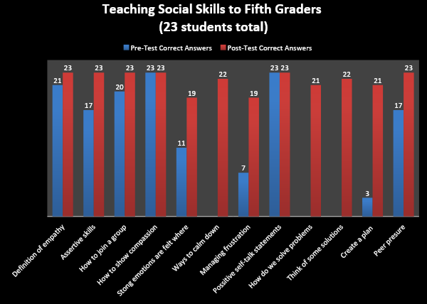

Focus for Improvement

Student Support Personnel Team
The pre-test and post-test data shows that students need to be given this information earlier than 5th grade. Second Step has a curriculum for pre-k, kindergarten, first, second, third, fourth, and fifth grade. This year I have been working with the two kindergarten classrooms, two fourth grades, and one fifth grade on teaching social skills and problem solving. However, I am only at Cheshire Elementary School half time on Tuesday and Thursday and cannot service all of the student population. I also teach the program every other year due to my schedule being half time. These results may indicate that my current part time schedule has a negative impact on the social skills of the current 5th grade class due to the lack of social skills programming in previous years to this current 5th grade class.
The Student Support Personnel Team at the Elementary level in the Adams-Cheshire Regional School District is creatively divided among several people.
- The only School Counselor is Mrs. Nicole Seyerlein and her time is split between CT Plunkett Elementary School in Adams on Mondays, Wednesdays, and Fridays, and Cheshire Elementary School on Tuesdays and Thursdays.
- In addition to Mrs. Seyerlein, each school has a full time school nurse, Mrs. Linda Biros at CT Plunkett and Mr. Philip Grover at Cheshire Elementary School.
- CT Plunkett also has a Dean of Students, Mrs. Patricia Misiuk.

