Massachusetts Accountability Report Card
A continuous improvement document for school counseling outcomes
M.A.R.C. Jr.
2014-2015 School Year

Blanchard Memorial School
493 Massachusetts Avenue, Boxborough, Massachusetts, 01719
978-263-4569 Fax 978-263-0477
www.blanchard.abschools.org
DISTRICT: Acton-Boxborough Regional
GRADE LEVELS: Pre K-6 ENROLLMENT: 420
SCHOOL YEAR: traditional with extended day
PRINCIPAL: Dana F. Labb

Principal’s Comments
Blanchard prides itself on being a 21st century, forward thinking, data-driven school. When children feel supported and valued in a safe nurturing environment, academic risk-taking and student achievement follow. The school counseling team is a vital ingredient in the recipe for a safe, balanced, high performing school. In keeping with our commitment to integrity and pro-social behavior, all members of the school community are expected to learn and model STARR Values, by exhibiting Support, Teamwork, a positive Attitude, Responsibility, and mutual Respect.
The school counselor is open and available to staff. She is proactive in her approach, visiting classrooms and responding to group or individual concerns. The counselor chairs the Teacher Assistance Team, where students are referred if teachers are concerned about their academic performance or social emotional issues. She is also responsible for 504 coordination and report writing. An internal calendar and school brochure detail the services provided by the counseling center.
Dana Labb, Principal

Student Results
A six week self-regulation curriculum was taught to small groups. A pre and post-test was administered to measure student outcome data. The self regulation curriculum at Blanchard aligns with a number of the Massachusetts Career Development Educational Benchmarks, including, PS1: Learners will develop and demonstrate attitudes, behaviors, and skills that promote self knowledge, personal responsibility, and self direction, and PS2: developing and demonstrating positive interpersonal skills to work and relate to others.
Students in grades 1-4 were identified by parents, teachers, or counselors as having social challenges and placed in small groups. The goal was to score a 75% or higher on the self-regulation post-test.
Our data reflect significant growth in every grade level in terms of knowledge gained. First graders scored 25% on the pre-test and 95% on the post-test. The second and third grade had a slower growth pattern, however, they increased their knowledge by forty and fifty-six percent respectively. The fourth grade group absorbed the information very quickly and performed well on the pre and post-tests, scoring 53% on the pre-test and 100% on the post-test.
These groups participated in role plays and were asked to begin incorporating new behavior strategies into their daily lives. Self-regulation lessons were based on The Zones of Regulation by Leah Kuyper and use the same language as the Superflex curriculum by Michelle Garcia Winner.
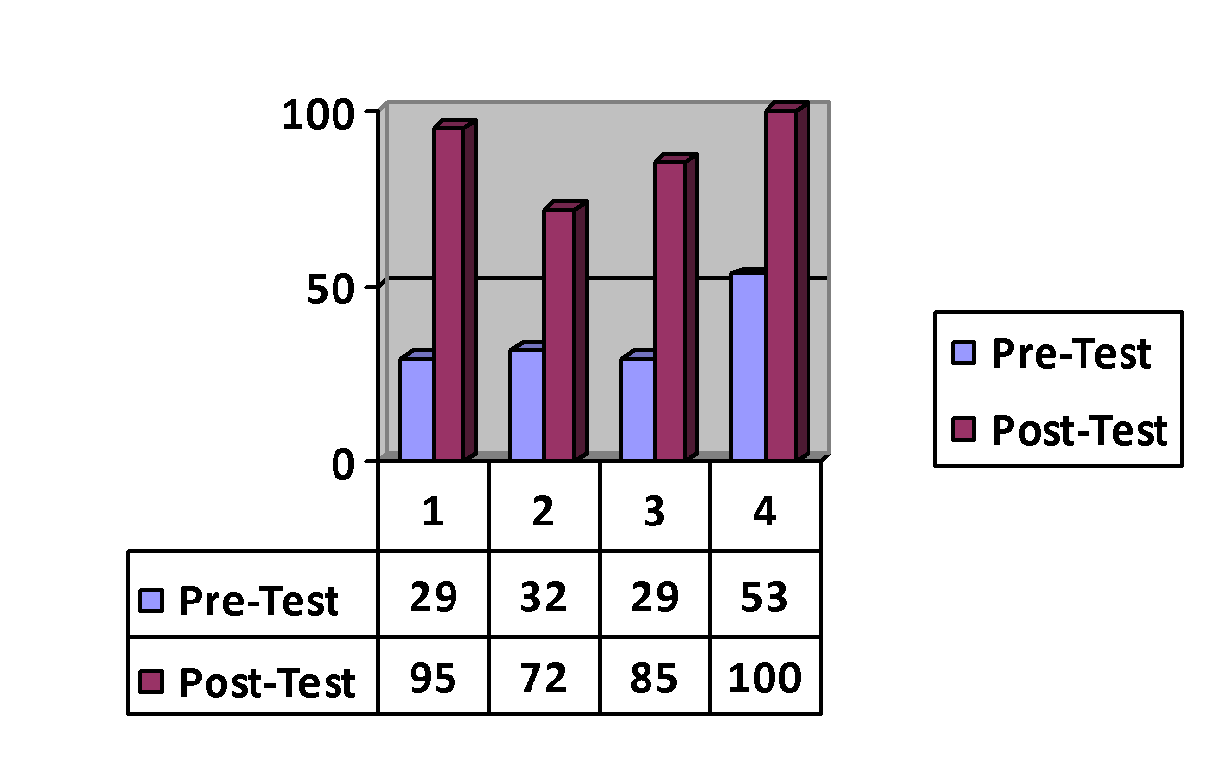
Students were also instructed to utilize “their tools” to arrive and remain in the “green zone,” which is “focused and ready to work.” They were taught positive self-talk and the opportunity to practice new coping skills that would assist them both in and out of the classroom.
The District Determined Measure Goal of Increased Communication is tied to the data collection tool utilized to gather information about how students were feeling at the beginning and the end of individual and group sessions. Students were asked to circle a series of five faces ranging from crying to neutral to very happy at the start of the meeting and again at the finish.
Three students said they were upset when arriving and zero said that they were upset upon leaving. Twelve said that they felt “okay” upon arrival and seven felt that way when they left. Twenty-two felt very happy when they left. This is evidence that counseling services are positively impacting the student population.

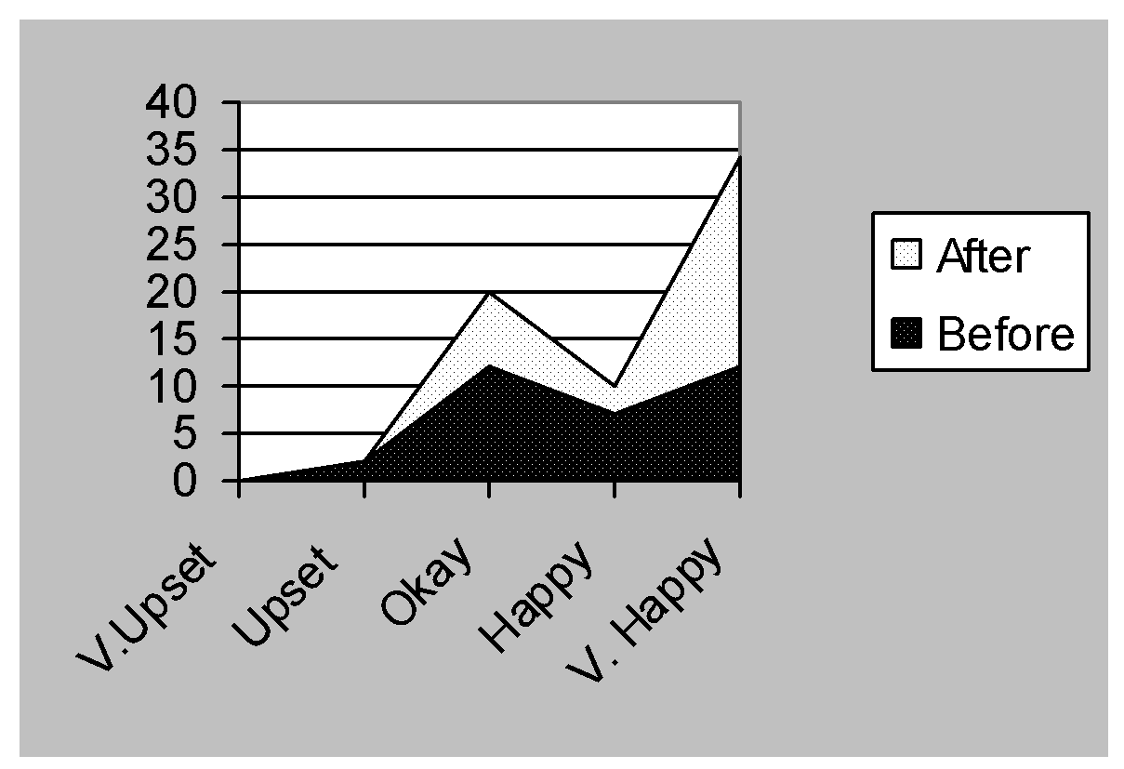

Focus for Improvement
Presently, the school counselor delivers Second Step, a social- emotional curriculum, to grades one through four. This format aligns with the Massachusetts Model for Comprehensive School Counseling. Pro-social instruction is also provided through Superflex, a fun program that teaches students how to be outstanding “social citizens.”
Goal one of the Acton-Boxborough Long Term Strategic Plan is the promotion of social emotional learning. The Blanchard Memorial School has embraced this goal with a comprehensive approach in the classroom and many different types of groups as well as individual and responsive services.
The counseling department has collected data to support the actions that they have taken regarding increased self-regulation skills and positive impact on students’ seeking counseling services.
As part of the 2015-16 School Improvement Plan, Blanchard has committed to providing a comprehensive social curriculum that will foster a common language and flexible strategies for students, teachers, and staff. This includes updating current pro-social curriculum and adopting a school wide program that can be practiced (in addition to the STARR program) and applied at all levels from administrators to staff to students. The Social Emotional Leadership Team plans to conduct a needs assessment survey as well as an evaluation of existing resources to accomplish this goal.

Student Support Personnel Team
The Blanchard Memorial School utilizes the Massachusetts Tiered System of in all grades, as well as Universal Assessment. MTSS allows teachers to break students into small groups so that specific areas of weakness can be tackled. Any achievement gaps or behaviors that are not addressed are referred to the Teacher Assistance Team, a group of cross disciplined professionals that is led by the school counselor and meets weekly to strategize and problem solve on a case by case basis.
The school counseling department is responsible for the design, coordination, implementation, and evaluation of a Comprehensive School Counseling Curriculum that aligns with the MACDE’s. The school counselor is constantly working to strengthen her relationships with all stakeholders in order to more effectively deliver services to all students.

Team Member | Position | Years of Experience
Dana Labb | Principal | 11
Karen Tower | Asst. Principal | 25
Gail Kessler-Walsh | Counselor | 11
Chrisine Garcia | Psychologist | 22
Kathy Daniels | Nurse | 24
Beth Rivet | Counseling Intern | 1
Elizabeth Alberts | Behavior Specialist | 8

