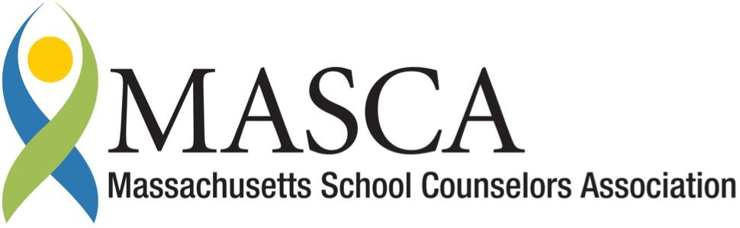 | Massachusetts Accountability Report Card  A continuous improvement document for school counseling outcomes  M.A.R.C. Jr.  2013-2014 School Year

Elmwood Street School
40 Elmwood Street, Millbury, MA 01527
(508) 865-5241
www.elmwood.millburyschools.org
DISTRICT: Millbury
GRADE LEVELS: Pre K-3 ENROLLMENT: 639
SCHOOL YEAR: traditional 2013-2014
PRINCIPAL: Sue Fredricks

Principal’s Comments

As a school administrator, I consistently witness the benefits that a comprehensive school-counseling program can provide the students, staff, and families we work with, at Elmwood Street School. The Massachusetts Model for School Counseling Program provides our team with the framework needed to guide our counselors in delivering preventative, developmental, and comprehensive support to a unique population. I support the initiative of the Mass Model and the Massachusetts Accountability Report Card, in utilizing data with regards to effective decision-making. This is a process, and a tool, that can only benefit our students and our school as a whole.

Sue Fredricks, Principal

Student Results

The Millbury Counseling Department strives to work collaboratively with all staff to ensure that the school as a whole provides the most comprehensive educational experience possible for it’s students. In response to multiple concerns expressed by second grade staff, the administration charged the counseling department with creating a behavior plan to assist students to better understand, and ultimately demonstrate, appropriate behaviors while in the cafeteria. One week of cafeteria observation occurred to better understand the lunchroom processes and behaviors that were expected by staff. All staff responsible for cafeteria duty were asked to take a survey. This survey identified 4 main areas that staff felt needed improvement. They were: 1. Noise level of students entering... 2. Overall noise level… 3. Clean-up and trash disposal… and 4. Noise level of dismissal (see graphs). Lunchroom observations and survey results was used as baseline data for effectiveness of the behavior plan.
Counseling staff met with all second grade teachers and educational assistants involved. A positive behavior plan was developed with input from all second grade teachers. Classrooms demonstrating expected cafeteria behaviors, (i.e.: talking quietly to those at their tables, cleaning up not only their area and table, but the floor around them, and lining up quietly to be dismissed), would receive “points” throughout lunchtime. The classroom with the most points at the end of the week would receive a “fine dining” experience. Fine dining consisted of students sitting at specially decorated tables (table clothes, centerpieces, etc.), having their teacher dine with them, and having an administrator serve them.
A lesson that focused on table manners, specifically cafeteria appropriate behaviors, was developed and delivered to all second grade students prior to implementation. Pre- and Post-tests were completed by students to ensure understanding of the material; data regarding the percentage of correct answers is presented on graphs below.

Purple line = Pre-test Blue = Post-test
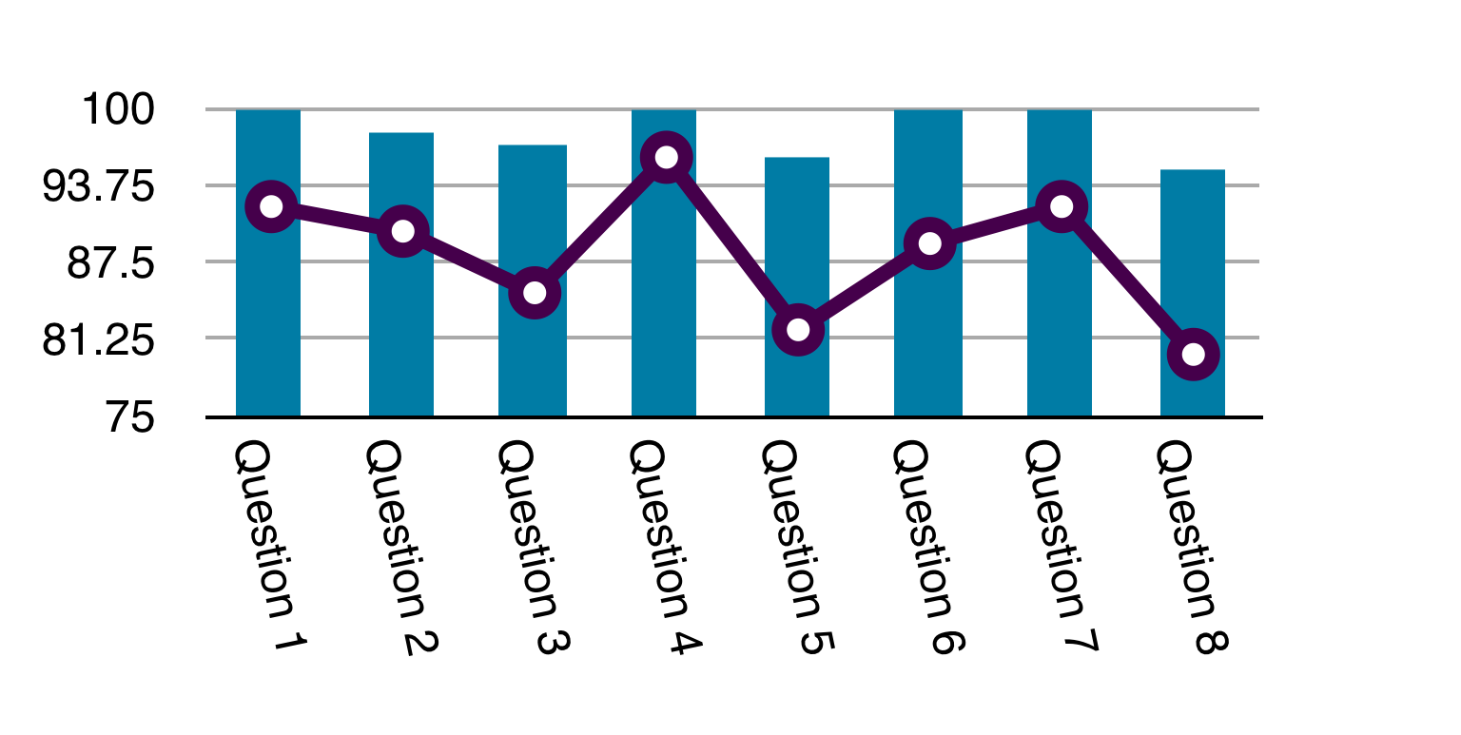
During the implementation process staff were consistently consulted regarding effectiveness. A logistical system design occurred within 2 weeks, to address staff concerns regarding complexity. Table prompts were replaced with wall prompts. Table point sheets were replaced with bowls. Instead of marking a point on a sheet, staff would reward the table with dropping a pom-pom in the bowl. Totals were transferred to a score sheet on the wall. As reported by staff, the change allowed for more consistent evaluation of the student behavior.
After 3 months of implementation, staff survey results show a decrease in all undesired behaviors identified in baseline data. The largest decrease being the “overall noise while students are eating lunch” represented by 60% of staff identifying it as “always a problem” in Pre-implementation data and 60% then identifying it as “Not a significant problem/Occasional difficulties” in post data. Pre and Post staff survey results are presented in graphs below:

KEY
Purple = No Problem
Blue = Not a significant problem/Occasional Difficulties
Green = Often a problem
Red = Always a problem

Pre-Implementation Post-Implementation
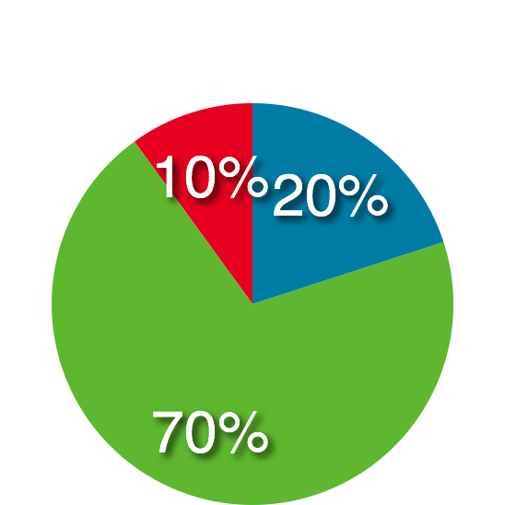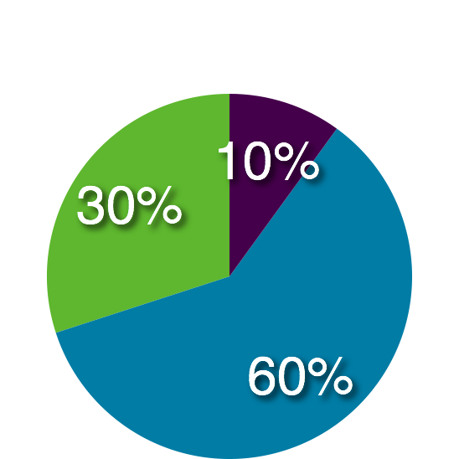
Noise Level of students entering the cafeteria
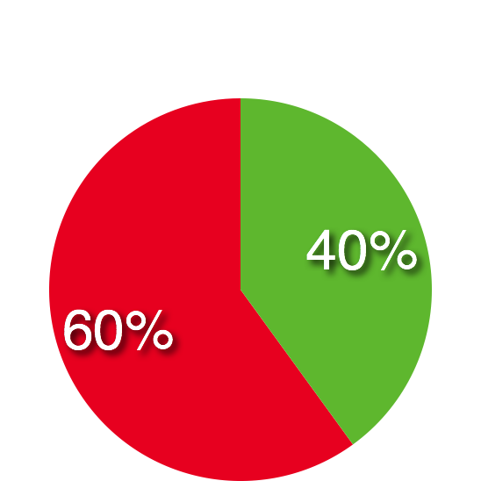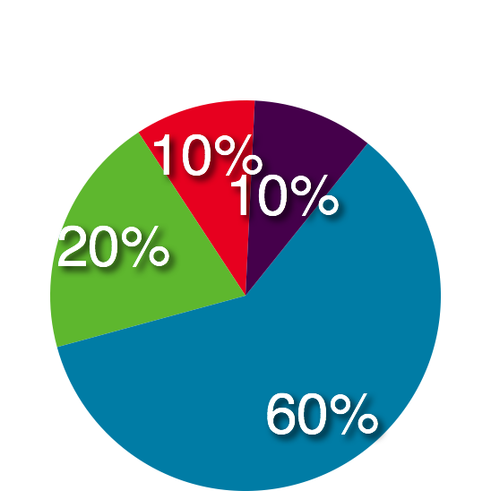
Overall noise level of students while eating lunch.
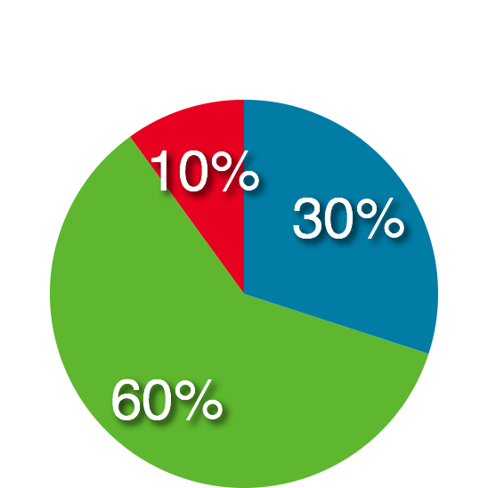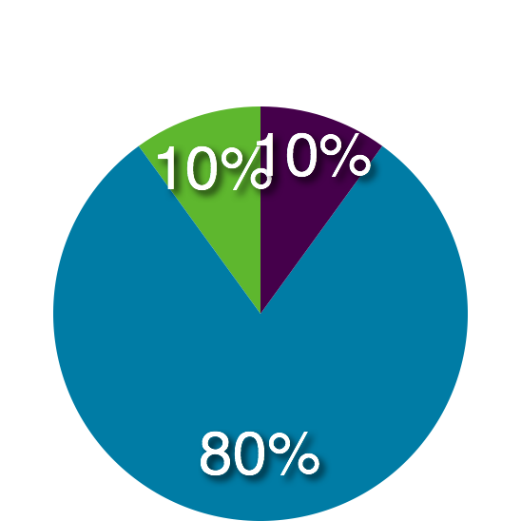
Clean-up of tables & disposing of trash
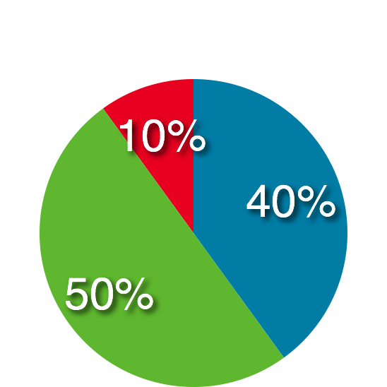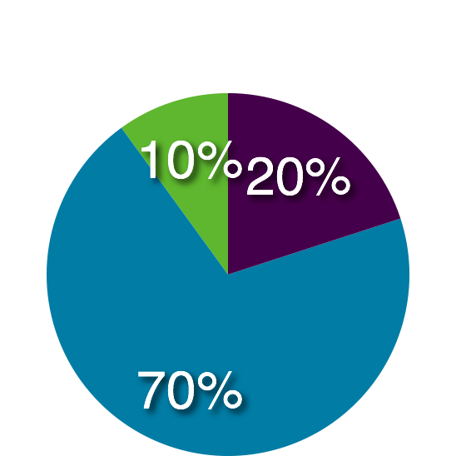
Noise level of dismissal

Focus for Improvement

Data collected through out implementation (weekly fine dining winners) identified which classrooms were exhibiting the desired behaviors most effectively and most frequently. Weekly data was tracked to ensure that the majority of classrooms, if not all, were demonstrating their understanding of appropriate cafeteria behaviors. This was evidenced by the number of points they would acquire throughout the week. When it was discovered that one classroom in particular was not earning as many rewards as the others, a review of the original material was provided. Through out implementation, staff was consistently consulted with regarding their opinions on the effectiveness of the program.
The students have reported that they like the competition and especially enjoy the “fine dining” experience. Staff has reported verbally and through post-implementation surveys that the overall atmosphere in the cafeteria has become more controlled, less noisy, and ultimately less stressful.
The fine dining plan will continue on throughout the rest of the year for the second grade. Any setbacks or revisions will be a collaborative effort with the staff involved and the counseling department. Discussions regarding implementing the cafeteria plan school wide did occur, but it was decided that the “fine dining” reward would be a special benefit of being in the second grade.

Student Support Personnel Team

The team included 7 Second grade teachers, the school counselor, the guidance intern, and 3 instructional aids. Collaboration occurred regularly through various means, and it took place prior to, and during the implementation process. The team interacted and provided gentle verbal reinforcement to students daily. The data collected proved the interventions effective in addressing the areas of need. Teacher support throughout this implementation was imperative to its success. The lesson provided, especially the behaviors expected, were consistently reiterated in the classrooms. Instructional Assistants were essential in keeping daily tallies and promptly responding to positive behaviors. The support teams’ enthusiasm and willingness to take on additional responsibilities throughout this initiative was fundamental to its success.

Student Support Team Personnel
Casey Rocklin | School Counselor
Kelly Beahn | Guidance Intern
Sarah Beckman | 2nd Grade Teacher
Joan Bellarose | 2nd Grade Teacher
Michelle Gauthier | 2nd Grade Teacher
Allison Goodband | 2nd Grade Teacher
Jennifer Kephart | 2nd Grade Teacher
Samantha Maio | 2nd Grade Teacher
Megan Wheeler | 2nd Grade Teacher
Amy Turner | Instructional Assistant
Paula Early | Instructional Assistant

