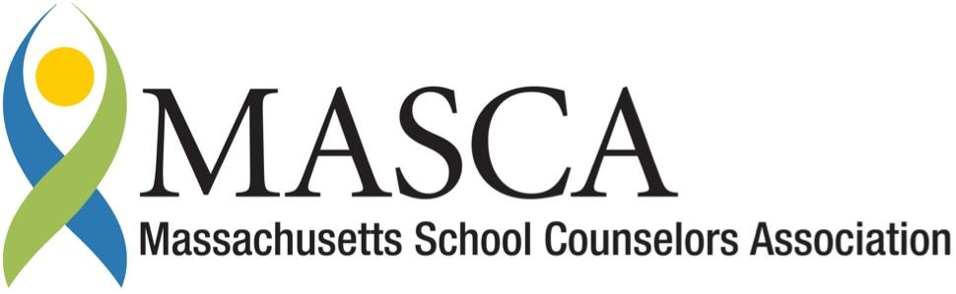 | Massachusetts Accountability Report Card  A continuous improvement document for school counseling outcomes  M.A.R.C. Jr.  2013-2014 School Year
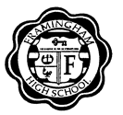 | Framingham High School  115 A St. Framingham, MA 01701  Ph: 508-620-4963 Fx: 508-877-2201  www.framingham.k12.ma.us  DISTRICT: Framingham Public Schools  GRADE LEVELS: 9-12 ENROLLMENT: 1974  PRINCIPAL: Elyse Torbert SCHOOL YEAR: Traditional

District Comments
District Statement:
I am knowledgeable about and in support of the district’s efforts towards implementing the Mass Model, an adaptation of the American School Counselor Association Model, a framework for a social emotional and college and career readiness curriculum in our schools. A more proactive, preventative approach to school counseling services will benefit our students. I am committed to working with the counseling staff on how to increase their ability to serve the needs of all of our students, as well as supporting their professional development to this end.

Judith Styer
Director of Health and Wellness

Student Results
The FHS School Counseling Department and administration saw that data identified a need to implement a College and Career Center to increase college and career readiness among all students, and to better align the counseling program with the Massachusetts CDE Benchmarks. In 2013, The FHS College and Career Center (CACC) was opened and a focus was placed on college and career readiness, serving all students, but especially certain population groups of students identified requiring greater support. The Framingham High School College and Career Readiness (FHSCCR) program provides students access to a school counselor full time, in a classroom setting, four days a week to receive extensive support and resources aiding them with their post-secondary planning. By providing this access, including specialized one-to-one attention, FHS hopes to increase the college and career
readiness for all students.
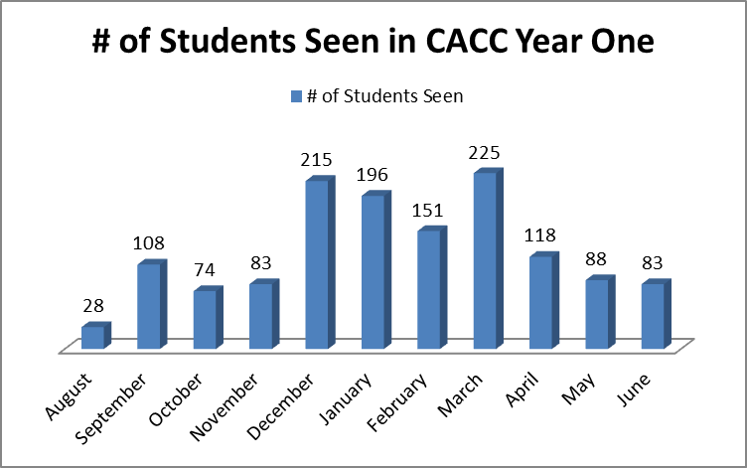

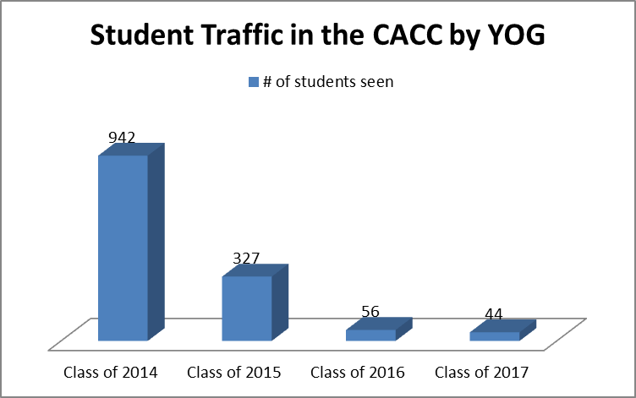

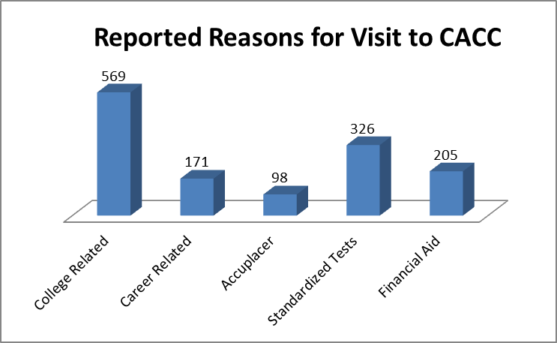

Focus for Improvement

FHSCCR is dedicated to the improvement and use of surveys and data to drive future programming, increase tier #1 CCR opportunities offered to all FHS students, and plan initiatives to reduce identified gaps. The FHS School Counseling Department and FHSCCR are pleased with the first year of the CACC and its reception within the school community. The CACC introduction is aligned with the school improvement plan, as well as the district plans for family and community engagement. The FHSCCR program targets the following groups for specialized and specific services in the CACC:

- First Generation Students
- Low Income
- ESL/ELL Population
- Special Education Students
- Community Based Organizations
- Non-degree seeking students
- Parent Support

Through a number of outreach initiatives, the CACC introduced opportunities to the FHS Community to include:
- College and Career Readiness Night
- MEFA Financial Aid Night
- MEFA Financial Aid Night in Spanish
- Accuplacer Test administration
- Vocational Post Graduate Programs
- College Goal Sunday (Financial Aid)

FHS will continue to make these identified groups a priority, increasing service availability and variety of resources.

Additionally, the FHSCCR program works to insure all students have a post-secondary plan. All students were required to complete a senior survey to report their post-secondary plans.
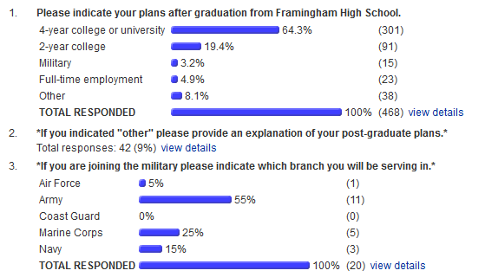

College and Career Readiness Team

The FHSCCR team collaborates regularly to support the academic, and career/occupational needs of our students. FHSCCR meets regularly to discuss what initiatives would be best for the FHS student population. This includes programs in the CACC throughout the year, such as college visits, luncheons with specialized programs, workshops for the college process and an annual Future’s Day event that caters to the whole school population. Future’s Day encompasses administering the SAT to 1,000 students in grades 10 and 11, while providing social emotional and college and career planning activities for students in grades 9 and 12. Below is the breakdown of these activities:

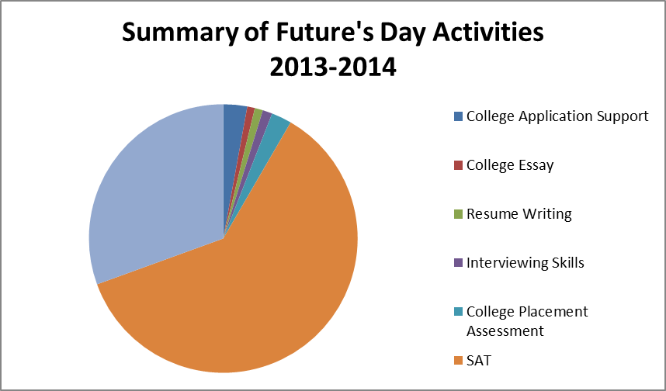

FHS College and Career Readiness Staff:
- Christine Luzi, M.Ed., School Counseling, CAGS, College and Career Readiness Coordinator, FHS
- Alyse Lepkowski, School Counseling Department Head, FHS
- Donna Mello, Transition Coordinator, Special Education Department, FHS
- Rosemary Jebari, ELL/Bilingual Department Head, FHS
- Lauren Kracoff, Director, Mazie Mentoring Program
- Joyce Saret, Student Liaison, Mazie Mentoring Program
- Paul Spear, Work Study Coordinator, FHS
- Linda Curtis, Career Specialist, Partnership for a Skilled Workforce
- Akeem Koshero, Career Specialist, Career Connections, Partnership for a Skilled Workforce

