Massachusetts Accountability Report Card
A continuous improvement document for school counseling outcomes
M.A.R.C. Jr.
2012-2013 School Year
Old Colony Regional Vocational Technical High School
476 North Ave. Rochester, MA 02770 Tel # 508 763-8011 Fax # 508 763- 9821 www.oldcolony.us
DISTRICT: Old Colony Regional Vocational Technical High School District
GRADE LEVELS: 9-12
SCHOOL YEAR: Traditional
PRINCIPAL: Patricia Foskett ENROLLMENT: 586

Principal’s Comments
As principal I support the implementation of the Mass Model for our school’s counseling program and will support our counselors work and commitment to improving school climate and increasing academic and personal success for our students at Old Colony RVTHS.
Through the implementation of programs designed to meet the academic/ technical achievement, workplace readiness/career planning and personal and social-emotion development needs of our students, counselors are making a positive impact on our school community.
The Mass Accountability Report Card (MARC JR.)
is a valuable tool to measure and monitor student data to help ensure academic success and school safety. By using data driven results, our school’s counselors are better able to enhance professional practices and improve counseling services to meet the needs of 100% of our students.

Patricia Foskett, Principal

Focus Study
This initiative was implemented as a result of our Guidance Departments desire to align ourselves to the Mass Model. In our focus to strengthen our school’s counseling program in the college readiness domain, our school began to offer our senior students early ACCUPLACER Placement testing. The ACCUPLACER Placement test is a computer-adaptive diagnostic placement test used by colleges to place 1st year students in appropriate college level courses that meet the students’ skill level. Our goal was to identify students who were academically unprepared and as a result of not meeting the placement testing cut-off scores would be required to enroll in at least one developmental reading, writing, or math course.
The ACCUPLACER Placement test was conducted according to the following format:
- All students were invited to participate.
- Students who registered for the test were provided with the ACCUPLACER study guide and additional testing information.
- Over a four-month period, three testing sessions were scheduled and offered during the school day.
- Students tested in Reading, Writing, Arithmetic and Algebra.
The graph below represents the Arithmetic and Algebra scores of the 65 students who tested. The cut-off scores are 60 for Arithmetic and 72 for Algebra.
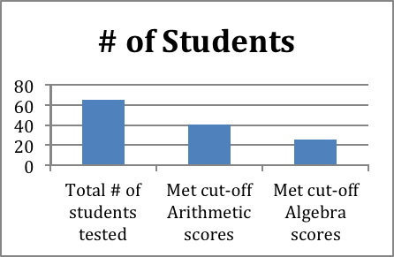

After reviewing the data, we recognized an immediate need to reduce the number of students testing into developmental course work in their first year of college and focused our initial efforts on the Arithmetic and Algebra by offering an Arithmetic/Algebra Refresher course. The refresher course was administered according to the following format:
- All senior students who did not meet the Arithmetic and Algebra cut-off scores were invited.
- The course sessions was held immediately following dismissal of the regular school day over four consecutive weeks @ 2.5 hours per session.
- Students who participated in the course received instruction by a certified Math instructor.
- Remediation was web-based using JFYNet ACCUPLACER Preparation Program.
- Students who did not meet the cut off scores in both Arithmetic and Algebra focused their remediation in Arithmetic only.
- Students who participated in in at least three of the four sessions were allowed to retest.
The graph below represents the testing results after the remediation course:
Student Scores
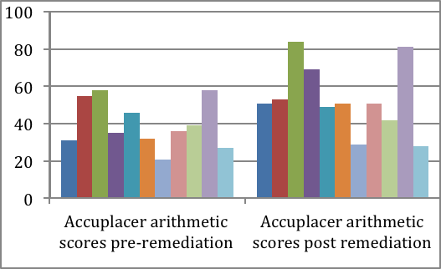

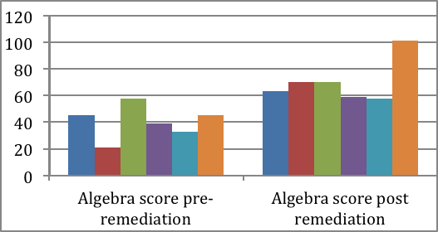

Focus for Improvement
Nearly all of the students who participated in the refresher course showed an increase in scores, however, only a few met the cut off score necessary to eliminate the need for developmental course work. As a result, our focus for improvement will target the following areas:
1. Modify the refresher course by having 1/one hour session to login & learn to navigate the program & 6/two-hour math instructional sessions. All students will have unlimited access to the JFYNet ACCUPLACER Preparation Program & will be required to show an additional 5 hours of additional independent practice.
2. To increase parent participation, information will be mailed to parents & placed on website to identify the importance of early ACCUPLACER testing, testing dates & how to sign up.
3. Meet w/ students who did not meet the "cut- off" to discuss their scores, additional remediation if necessary, and update parents with "next step" information.
For more information visit:
http://www.jfyboston.org/
JFYNetACCUPLACER Preparation

Student Support Personnel Team

Our student support personnel team is headed by our principal and meets weekly to identify students and discuss plans of support.

Patricia Foskett | Principal
Anne Spirlet | School Counselor
Sue Abaray | School Counselor
Kelly Heavy | School Counselor
Sharon Lacroix | School Adj.Counselor
Paula Ward | School Nurse
Jackie Machamer | Vice Principal
Krystla Fay | Special Services Coord.

Old Colony’s School Counseling Department Mission Statement
- Ensure that all students graduate with the necessary academic/technical, workplace readiness and personal/social knowledge and skills for school and future success.
- Support high standards for all students as a means for eliminating the achievement gap by having counselors attend to student’s developmental needs in ways that enable them to achieve success in their endeavors in education, the workplace and society.
- Empower the students to “believe” that they can “achieve” their “dreams”.

