Massachusetts Accountability Report Card
School Counseling outcomes sponsored by the
Massachusetts School Counselors Association
M.A.R.C. Jr.

LUNENBURG HIGH SCHOOL – Jason Kurland
1079 Massachusetts Avenue Lunenburg, MA 01462
Phone: (978) 582-4115; Fax: (978) 582-4153 www.lunenburgschools.net
DISTRICT: Lunenburg
GRADE LEVELS: 9 – 12 ENROLLMENT: 520
SCHOOL YEAR: Traditional
PRINCIPAL: Joseph Dillon

Principal’s Comments  I fully support the Mass Model as a framework for developing and delivering standards-based programs to our students. I’m excited at the opportunity to implement a new program in 2011- 2012 for assisting our college-bound seniors and their families with the FAFSA. I’m confident that instructing our students on the correct way to obtain the financial resources they need to further their education will help prepare them for college and career readiness at the next stage of their lives.  Student Results  The school counseling team identified hands-on FAFSA assistance for students and families as a new Mass Model initiative for the 2011-2012 academic year. Partnering with counseling staff and administration, a financial aid counselor completing his FSU school counseling practicum facilitated several workshops for students and parents at LHS. There were two main goals of these workshops. One goal was to have 100 percent of the participants successfully submit the FAFSA. The second goal was to increase students’ knowledge in specific FAFSA areas to ensure the accuracy of the information provided for this and subsequent academic years. Twenty five participants attended the workshop this year.  The instructional component of the FAFSA workshops links with the following MA CDE Benchmarks:  - A1-1: Flexible, higher order thinking skills  - A1-2: Technical and technological skills  - A2-3: Organizational skills for career and life management  - A2-5: Technical literacy for career and life management (including completing the FAFSA online)  At the beginning of the workshops, students were given six questions to assess their knowledge in specific areas of the FAFSA. After submitting the FAFSA, the students were given the same six questions. Pre and post responses were compared to assess if the students showed an increase in the number of correct responses.  The six questions tested student’s knowledge in three specific areas. Questions 1 and 2 tested knowledge of web addresses to complete the FAFSA. Questions 3, 4, and 6 tested knowledge related to dependency status. Question 5 tested knowledge of where to find correct tax information. With understanding web addresses, there was a 34 percent increase in correct responses. With understanding dependency status, there was a 15 percent increase in correct responses. With understanding where to find correct tax information, there was a 32 percent increase in correct responses.  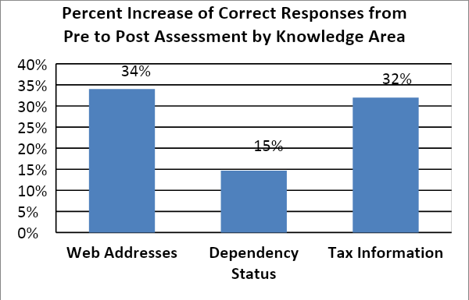  In total, 83 percent of the questions had an increase in student correct responses, 17 percent of the questions made no difference, and 0 percent of the questions had a decrease in correct responses.  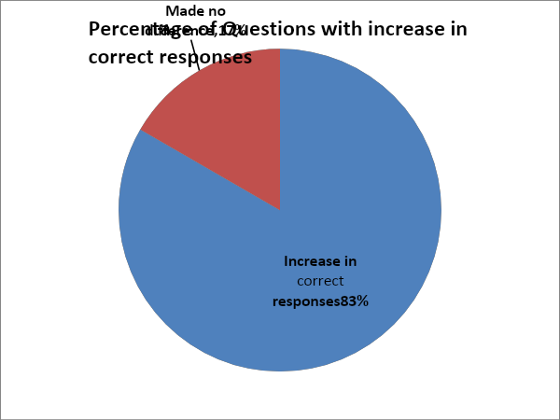 | Broken down by each question, the data showed that five of the six questions yielded an increase in the percentage of correct answers from pre assessment to post assessment. Question 1 showed an increase from 88 percent in pre assessment to 100 percent in post assessment (12 percent increase). Question 2 showed an increase from 36 percent in pre assessment to 92 percent in post assessment (56 percent increase)., Question 3 showed an increase from 16 percent in pre assessment to 56 percent in post assessment (40 percent increase)., Question 4 showed a 0 percent increase, Question 5 showed an increase from 64 percent in pre assessment to 96 percent in post assessment (32 percent increase)., Question 6 showed an increase from 84 percent in pre assessment to 88 percent in post assessment (4 percent increase).  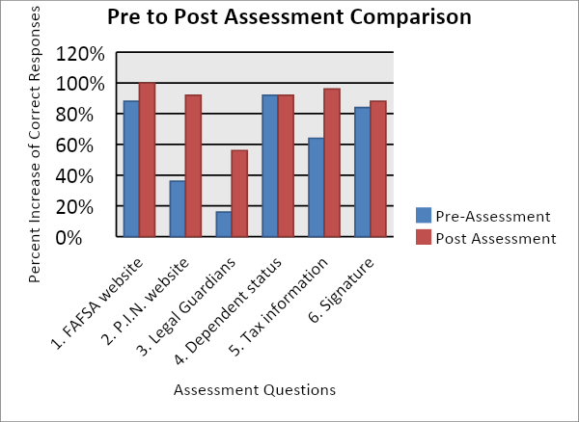  Focus for Improvement  We are extremely proud to announce that both of the two goals of the FAFSA program were successfully reached. 100 percent of the participants successfully submitted the FAFSA. In addition, the data clearly showed an increase in the students’ knowledge in specific FAFSA areas due to the increase of correct responses. The participants completed a survey to rate their overall satisfaction of the workshops. The survey found that 100 percent of the participants rated the workshop “very helpful”, 100 percent of the participants would recommend the workshop to others, and 100 percent of the participants believe they can successfully submit the FAFSA in subsequent years. The focus for improving the FAFSA program next year is to offer the workshops to a greater number of college-bound seniors and their families. In the first year of implementation, twenty five participants attended the workshops. With increased outreach through the new school counseling page on the LHS website and increased email communication to students and parents, we hope to expand the FAFSA program to assist a greater number of college-bound seniors and their families.  The FAFSA program implemented this year aligns with Goal 2 of the LHS 2011-2012 School Improvement Plan. This goal is to implement a formal, ongoing program through which each student has an adult member of the school community who personalizes the educational experience. By providing individual personalized service at the FAFSA workshops, the LHS school community has enriched the educational experience of these students. The FAFSA program also aligns with the Lunenburg Public Schools District Improvement Plan, which is to foster the talents, skills, and potential of all students. By increasing their knowledge in specific FAFSA areas, we have ensured students’ accuracy of providing correct FAFSA information in this and subsequent academic years, thereby fostering their talents, skills, and potential for obtaining the financial resources necessary to further their education and careers.  Student Support Personnel Team  The Student Support Team at Lunenburg High School consists of the following members:  Karma Tousignant – School Counselor  Susan Cavaioli – School Counselor  Phil McMurray – School Counselor  Kristin Mackay – Adjustment Counselor  Joseph Dillon – Principal  Brian Spadafino – Assistant Principal  Carolyn Finch – School Nurse  Nicole Kromer – Special Education Liaison  Joshua Koziol – Special Education Liaison  Brianna Lively – Special Education Liaison  Adam Kurland – Graduate Intern  Jason Kurland – Graduate Intern  The school counseling team at Lunenburg High School is responsible for the design, coordination, implementation, and evaluation of a comprehensive school counseling program within the framework of the Mass Model. In addition to the FAFSA program, we also have expanded our Naviance curriculum this year to assist juniors with college and career exploration.

