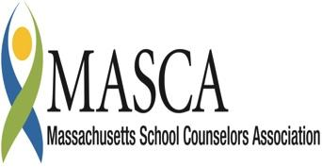 | Massachusetts Accountability Report Card  A continuous improvement document for school counseling outcomes  M.A.R.C. Jr.  2011-2012 School Year
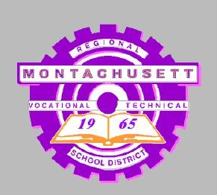 | Montachusett Regional Vocational Technical School  1050 Westminister Street, Fitchburg, MA 01420  (978) 345-9200 (978) 632-8889  www.montytech.net  DISTRICT: Montachusett Regional Vocational Technical School  GRADE LEVELS: 9 - 12 ENROLLMENT: 1400  SCHOOL YEAR: Vocational technical, multi-track, year-round  PRINCIPAL: Nicholas Desimone

Director Comments
The Student Support Services Department in partnership with our students' families and the district communities, provide a progressive and safe learning environment for the intellectual and social development of every student. The goal of the department is to provide academic and career/technical support and provide a comprehensive career plan to all students. Implementation of the Massachusetts Model for School Counseling Programs, will enhance the college and career readiness of our students by providing a variety of means to explore their options, define their goals, and expand their abilities.

Student Results
Student Support Services Department goal is for every student to develop a Student Career Planner portfolio that will follow the student throughout his years at Monty Tech. Each portfolio contains identified learning style, suggested careers/ jobs, ability survey, standardized test scores, resume, and ability survey. This initiative addresses the competencies within the domain areas of Academic-Technical Development, Workplace Readiness Development, and Personal/Social Development as established by the MA Career Development Education benchmarks.
As a first step every ninth grade student is introduced to Career Cruising. Career Cruising is an internet based career exploration and planning tool available to students in grades 9 -12. The Career Cruising program features four assessment tools, Career Matchmaker, My Skills, Ability Profiler and Learning Styles Inventory.

During the Exploratory Program, ninth grade students are required to create a Profile in Career Cruising. By the end of the lesson students demonstrate how it is accessed and develop skills to navigate the program. Students also complete Career Matchmaker and Learning Styles Inventory. In Career Matchmaker students were asked a series of questions about their likes and dislikes. At the end of the assessment students’ received a list of suggested careers and career cluster to further explore. Similarly in the Learning Styles Inventory students were asked a series of questions about how they process new information and skills. At the end of the inventory students received a print out about their preferred learning style: visual, auditory or tactile. The profile also included methods to augment study skills.
Data is collected through Career Cruising Career Advisor Management System (CAMS). CAMS offers data in Portfolio Statistics, Use Reports, Assessment Results, and Portfolio Completion Status Reports.
The following chart illustrates the login history for the four grade levels. The number of times a student logged-in to Career Cruising after the initial creation of a portfolio decreased substantially.
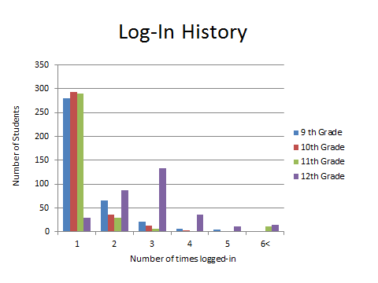
The following chart illustrates the number of students who completed the requirements for their portfolio. The requirements include completion of Career Matchmaker assessment, exploring a minimum of three careers of interest and recording career and life goals.
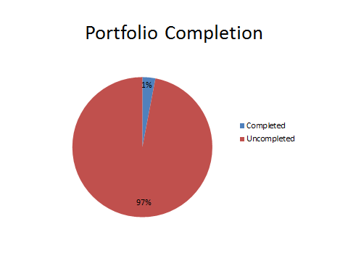

Focus for Improvement

Data indicates that Career Cruising program is not being utilized to it’s maximum potential. The Student Support Services Department will focus on the following areas
- Develop Sophomore year curriculum to include:
  - Completion of My Skills assessment
  - Creation of “brag sheet”
  - 3-5 careers researched outside of vocational trade
  - Educational plan
- Develop Junior year curriculum to include:
  - Completion of Ability Profiler
  - Creation of resume
  - 3 – 5 universities/institutions researched

School Philosophy

The challenging career/technical and academic programs encourage individual excellence and foster the work ethics and life skills necessary to be successful at Monty Tech, post-secondary institutions, and in today’s workplace. In accordance with state and national standards, we are committed to high standards of instruction, relevancy of curricula, integration of programs, and the utilization on on-going assessment to improve student achievement. To attain this ideal, we provide meaningful learning activities in and out of the classroom as well as opportunities for students to develop critical thinking, problem solving, and decision-making skills.

Student Support Personnel Team

The department is comprised of guidance and special education. Collaboration within the department, faculty and administrators enhance the learning environment for the student body. The department takes pride in our students and their achievements. The ninth grade counselor follows students through the exploratory process. Three other counselors have caseloads determined by shop placement.

Victoria Zarozinski | Director | M.S. Ed
Shelley Reyes | Freshmen Counselor | M.S., LSW, Adj Counselor
Mark Haschig | Sophomore, Junior, Senior | M.A. Sch Adj/ Soc Wkr
Bonnie Heikkinen | Sophomore, Junior, Senior | M.Ed.CAGS., Sch Adj/Soc Wkr
Patricia Kozlowski | Sophomore, Junior, Senior | M.S.
Kathleen Hanson | School Social Worker | LCSW
Thomas Thibeault | School Adj Counselor | M.A. LMHC
Martin Benowitz | Clinical Psychologist | Ed.D, Licensed Psychologist
Jean  Enright | Psychologist | Ed.D
John Lenahan | Ed Team Coordinator | M. Ed

