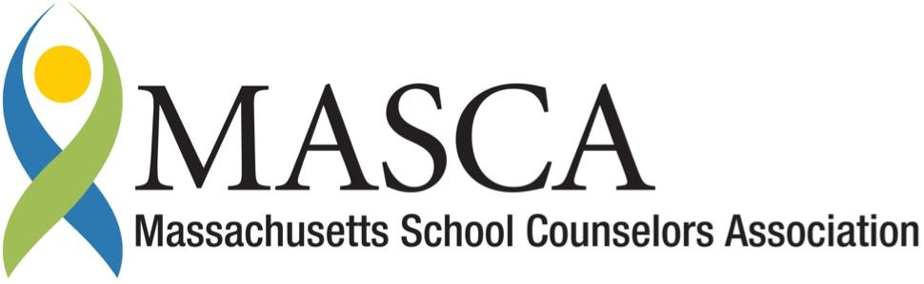 | Massachusetts Accountability Report Card  A continuous improvement document for school counseling outcomes  M.A.R.C. Jr.  2013-2014 School Year

Hoosac Valley High School
125 Savoy Rd. Cheshire, MA 01225
Phone: 413-743-5200 Fax: 413-743-8420
http://hv.acrsd.net/pages/Hoosac_Valley
DISTRICT: Adams Cheshire Regional School District
GRADE LEVELS: 9-12 ENROLLMENT: 352
SCHOOL YEAR: Traditional PRINCIPAL: Vinnie Regan

Principal’s Comments
The Adams-Cheshire Regional School District (ACRSD) is committed to and fully supports the implementation of the Mass Model. The School Counselors work to provide a comprehensive and developmental school counseling program of services that promote the academic, social/emotional, and career potential of all students. Through counseling, advocacy, advising, collaboration, leadership, and systemic change, counselors assist students to achieve personal excellence, to become life-long learners and to be responsible community members.
The Administrative Team at ACRSD depends on and consults with our School Counselors in regards to academic, social-emotional, and behavioral support and interventions. School Counselors are in integral part of our school community support system. In the past two years, our counselors have developed several lesson plans focusing on Elementary to Middle School, Middle to High School, and High School to College transition planning. The lesson plans will help students feel more empowered and prepared to make educated decisions in their future life planning in regards to academic and workforce goals, ultimately leading to more empowered and educated community members.
Vinnie Regan Principal

ACRSD School Counseling Mission Statement
To provide a comprehensive and developmental school counseling program of services that promote the academic, social/emotional, and career potential of all students. Through counseling, advocacy, advising, collaboration, leadership, and systemic change, counselors assist students to achieve personal excellence, to become life-long learners and to be responsible community members.

Student Results
Over the past several years the HVHS Guidance Department and administration have struggled with the limited amount of exposure freshman have with the guidance staff. Last year, the HVHS School Counselors developed a freshman seminar in order to assist the transition from middle school to high school. The seminar allows the counselors to connect with students in their English class four times during the school year. The results include information and data related to the various topics discussed throughout the time spent in the classroom setting. The purpose of the meetings and the results are as follows:

Graph 1: Guidance 101- This first session introduced students to their School Counselor. Students were also given information such as a description of counselor duties, the location of the guidance department, the steps involved in making an appointment, names and locations of other support personnel. A time period for questions and answers was also provided.
The use of a pre and post-assessment resulted in a significant increase in knowledge. The most notable increases as measured in the graph below show that 86% (46% increase) of HVHS freshman know their school counselor’s name, 74% know how to make an appointment with guidance (50% increase) and 92% (16% increase) know where the school counselor department is located.

Graph 2: Graduation requirements- Using redacted examples of guidance documents, students were introduced to several new high school concepts including but not limited to credits, graduation requirements, GPA, class rank, and official transcripts.
Post-test results for this lesson were impressive. After the lesson, 94% (1050% increase) of the HVHS freshman understood the number of credits necessary for graduation, 87% could identify two graduation requirements (173% increase), 98% (23% increase) know what a GPA is and 100% were able to identify the number of years students need to complete math for graduation ( 26% increase).

Graph 1: Guidance 101
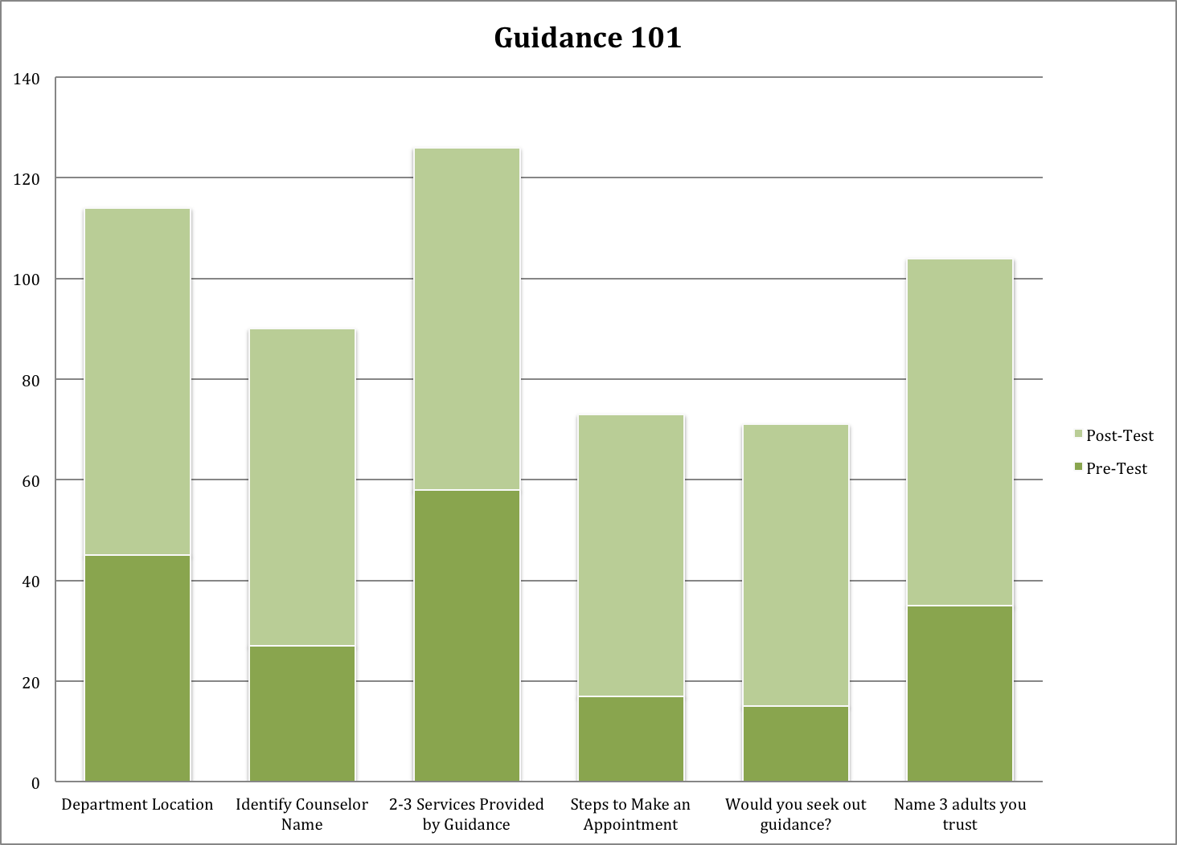

Graph 2: Graduation Requirements
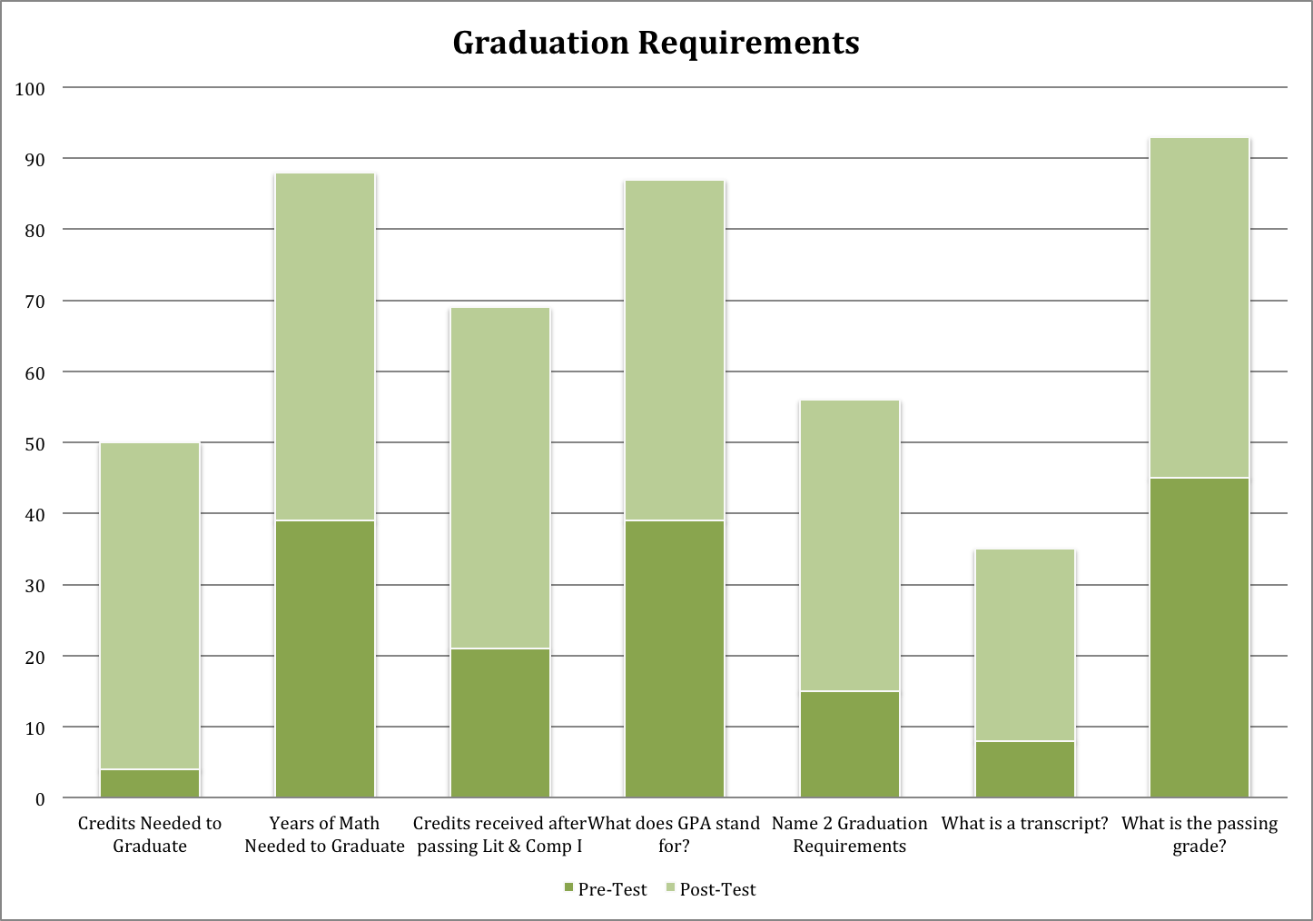
Lessons 3 & 4: Academic & Career Planning- The last two meetings were actually combined and extended for the purpose of allowing students three consecutive days to work with the counselors in the computer lab. Students were directed to the MassCis website to use tools such as the Career Interest Inventory and Reality Check to complete a four page Academic and Career Plan. Of the freshman, 100% completed a plan, 99% of the class identified at least two careers of interest and 93% of the students found this entire activity to be useful. Additionally, 92 % of students felt their career cluster results matched their true career interest and 27% felt their career of interest could support their ideal lifestyle. Anecdotally, students’ comments regarding the experience included the following:
“I learned getting a good job takes a lot of work. It is also very expensive to live how you want. It makes you think about your future and makes you want to do better.”
“With guidance I got the opportunity to explore careers and majors I have not before. I learned that there is so much out there. To be able to pay for everything when you are older you have to have a good job. It was valuable because I learned that I love psychology. This experience with guidance has gotten me to start exploring sports psychology. I had the chance to learn about myself and what the world has to offer.”
“I learned that what I thought I wanted to do in life really was not what stuck with my interests all along. It helped me to pick a career within my interests. I also learned how much it will cost me to live on my own. This is all very helpful for me because it give me an idea as to what I want to do when I graduate.”

Focus for Improvement

The Hoosac Valley High School Guidance Department is dedicated to improving the guidance curriculum by implementing data driven interventions. The Guidance Department prioritizes the following areas that need improvement, according to the data.
- The HVHS Guidance Department will increase the number of freshman class visits from four to six over the next two years.
- The Guidance Department is please with the data and would like to expand the curriculum focusing on all grade levels.

Student Support Personnel Team
Name | Position | Education | Years Experience
Mary Butler | Secretary | BA | 1
Jeff Hine | Adjustment Counselor | MSW | 23
Loriann Moro | School Counselor | M. Ed., C.A.G.S | 22
Megan Scott | School Counselor | M.Ed | 2

