Massachusetts Accountability Report Card
A continuous improvement document for school counseling outcome

M.A.R.C. Jr. 2013-2014 School Year

Leominster High School
122 Granite Street, Leominster, MA 01453
Phone number 978-534-7715 fax # 9788-537-1765
Leominster.mec.edu
DISTRICT: Leominster
GRADE LEVELS: 9-12 ENROLLMENT: 1853
SCHOOL YEAR: Traditional
PRINCIPAL: Thomas Browne

Principal’s Comments

The school counseling department at Leominster High School plays a vital role in assuring that all students who attend meet the standards set in the Massachusetts Common Core and the Massachusetts Model for School Counseling Programs. The counseling team at LHS uses effective strategies to foster academic achievement for all students, has developed effective support for personal and social development, provides strong college and career preparation, and has developed and implements a guidance curriculum at all grade levels. They have high expectations for students and challenge them with rigorous schedules to assure academic success.
Last month, the Massachusetts Department of Elementary and Secondary Education (DESE) completed its annual release of Graduation Rate and Dropout Rate data. We are pleased to report that the data once again indicates positive results for Leominster High School. The school has achieved its second highest Graduation Rate and similar second lowest Dropout Rate in more than a decade. We urge all community members to read through the report knowing that the staff, teachers and administrators of LHS/CTEi will work diligently to continually improve.
Leominster’s 4 year graduation rate for 2012 – 2013 is 89.9% second only to Newton in all urban districts. Leominster gained just over 1 percentage point from its 2012 graduation rate of 88.7%. This result marks the second highest graduation rate for the district since the state began to calculate it in 2006.
The districts dropout rate is at 3.8% down from 5.4% in 2012. We added curriculum and electives to keep supporting students’ interests.
Thomas Browne, Principal

Student Support Personnel Team

The school counseling team at Leominster High School (LHS) provides support for student’s at all academic levels and identifies individual needs and learning styles of students.

Members of student support staff:
- Paula Bolger: HS Counselor, Dept Head
- Mary Billotta Blackman: HS Counselor,
- Steven Dubzinski: Guidance Counselor
- Megan McGowan: Guidance Counselor
- Diane Cameron: Guidance Counselor
- Diana Marchand: Guidance Counselor
- Dayana Carlson: CTE Guidance Counselor

This team meets internally as a department on a weekly basis to plan and develop school wide curriculum and college and career readiness programs. They meet weekly as part of a Student Assistance Team, which provides support for students in need. They meet, when necessary, for Special Education meetings to determine overall education support through IEP or 504’s.

Focus for Improvement

In 2004, members of administration and the school counseling department identified that there was a significant need to evaluate and improve our dropout rate. At that time, data collection, in its present form, was relatively new, and it raised awareness to the fact that our dropout rate was higher than the state average. (See attached graph comparing LHS to state averages from 2004 – present.)
Our department focus was to determine why we were losing these students and what we needed to do to assure every student receive a diploma in 4 years which meets the state standards of academic success.

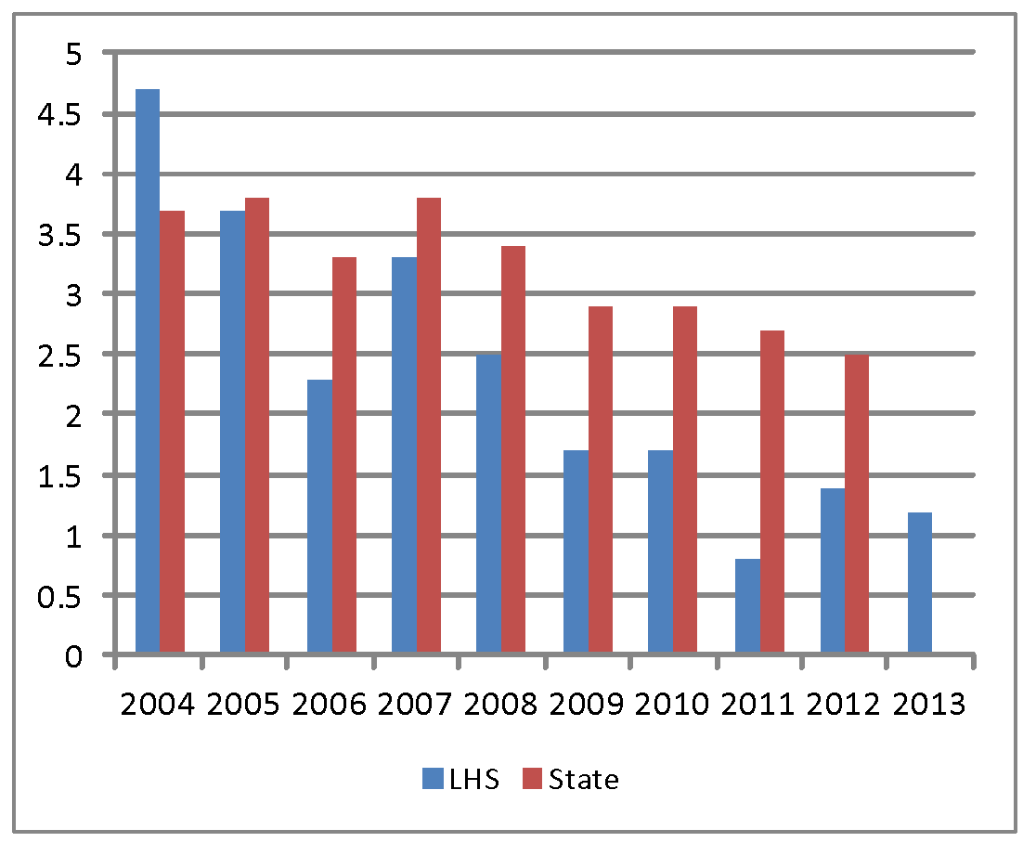 Graph 1: Comparison of Dropout Data-2004 to present

School Counseling Department Tracking Initiatives included:

- Phone survey of all past dropout students.
- Feedback helped develop future dropout prevention programs.
- Exit interview meetings were conducted by school counselors before students were withdrawn.
- Information was provided for all alternative education programs and assistance was provided for students as they transitioned to other educational programs.
- We expanded the high school curriculum and added a large number of new electives that cater to the students’ needs and interests.
- We started a dropout prevention program for students at risk of not graduating. Since its inception the program, which draws about 22 students each year, has had an 87.6% graduation rate.
- We expanded the English Language Learner programs adding tutors to really help bridge any language gaps.
- We also improved implementation of the SIMS data and DESE reporting.
- We keep in contact and follow up with all students.

Graduation Rate: Definition
The Graduation Rate is measured using several methods. However, the primary measurement is the four-year rate which indicates the percentage of students in a particular “cohort” that graduated from a school within a four-year period. This year’s data then reflects the successful completion of requirements to graduate by the cohort of students who began ninth grade as freshman in 2009-2010 and successfully graduated in 2013. Successful graduation includes completion of course requirements and passing ELA, Math, and Science MCAS exams.
.
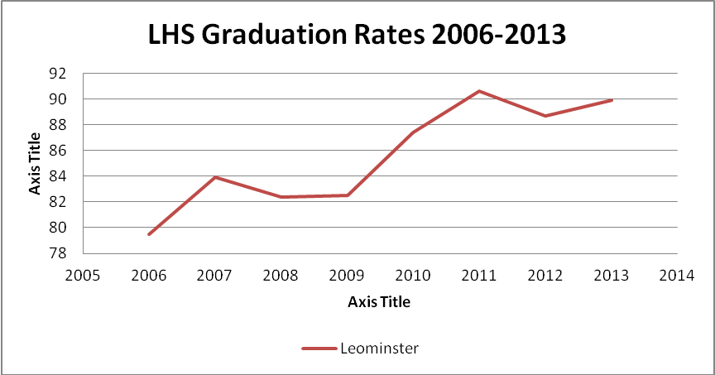
Graph 2: Graduation Rate percentages - 2006 to present

Student Results

Leominster’s 4 year graduation rate for 2012 – 2013 is 89.9% second only to Newton in all urban districts. Leominster gained just over 1 percentage point from its 2012 graduation rate of 88.7%. This result marks the second highest graduation rate for the district since the state began to calculate it in 2006.

For the first time, Leominster exceeded the overall state average in all of the districts measurable subgroups. In addition, the district’s graduation rate continues to significantly exceed the graduation rate for all urban schools by 18 percentage points.

We saw dramatic improvement in the Hispanic graduation rate. In 2013, 82.3% graduated and 7.3% dropped out in 2012 only 70.3% graduated and 16.5% dropped out.

The districts dropout rate is at 3.8% down from 5.4% in 2012. Similar to Graduation Rate, Leominster High School’s Dropout rate surpassed all urban districts except for Newton.

The school counseling department will continue to actively reach out and assist disengaged students and those identified as at risk for dropping out. Our goal is to continue lowering our dropout rate and increasing our 4 year graduation rate.

