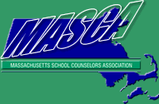 | Massachusetts Accountability Report Card  A continuous improvement document for school counseling outcomes  M.A.R.C. Jr.  2013-2014 School Year
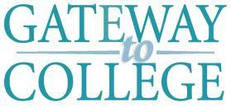 | Gateway to College  670 West Boylston Street, Worcester MA 01606  508-854-4541  www.qcc.edu  DISTRICT: Quabbin Regional and Worcester Public  GRADE LEVELS: 9-12 ENROLLMENT: 45  SCHOOL YEAR: College Semesters  PROGRAM MANAGER: Marci Skillings

Program Manager’s Comments
Gateway to College is an alternative high school program that targets at-risk students between the ages of 16-21. The program, through partnerships with public high schools, allows students to complete high school diploma requirements by taking classes at Quinsigamond Community College. The program was established at QCC in Fall 2012 and has accepted new students each semester. The Resource Specialist (school counselor role) plays a pivotal part in student retention and success. The RS has piloted the Retention Project, which is aligned with the MA Model’s mission of providing services to all our students. She has added many positive and successful pieces to the project, such as “kudos” (immediate reward for students success), creating our Facebook Page,.
offering standards-based instructional lessons and training workshops,
Marci Skillings, Program Manager

Student Results
Our immediate priority is to improve student retention. As a new program, student retention is of the upmost importance, as it is related to student success, positive outcomes, and the recruitment of new cohorts. The first semester, we retained 66% of students. The second semester, we retained only 51% of students.
During the Spring 2013 semester, we began to participate in the Student Retention Project through the Special Populations department. The project targets specific populations within the college to develop retention strategies that could be duplicated on a larger scale. This was the beginning of what became our Gateway to College Retention Project.
The Retention Project touches upon all three domains of the MA CDE Benchmarks: Academic, Personal, and Workplace Readiness. You could cite specific CDE links like A1-2 or ?????
The project included the implementation of several new retention strategies:
- Required weekly check in for all students
- A raffle contest based on student attendance, grades, and engagement in the program (monthly prize winners)
- Supplying snacks for students throughout the day in the Gateway to College office
- Offering workshops to students on relevant topics (Transfer, Employability, Housing/Homelessness)
- Lesson plan on college success in the classroom during new student orientation
We did not see positive effects of the project until Fall 2013. The average GPA of our students was lower than the previous semester:
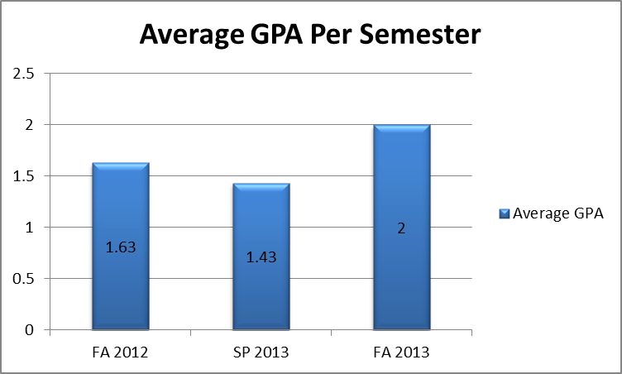
Additionally, we started tracking office visits to see how frequently our students were connecting with us. Again, in Spring 2013 the number was low, but is increasing rapidly. Midway through Spring 2014, the amount of office visits is already higher than the total amount of office visits for all of Spring 2013:
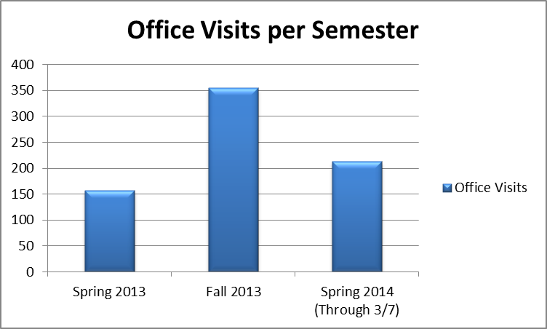
In the Spring of 2014, we added in the following new elements to the Retention Project:
- Group advising meetings for new students
- “Kudos for Kudos”
- Development of a Facebook page
- Parent Orientation
Through the efforts of the retention project, our retention rose to 70% in the Fall of 2013. Our goal is to increase retention to 75% in the Spring 2014 semester:
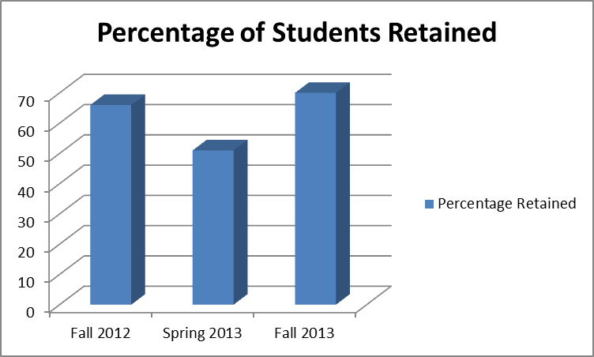

Focus for Improvement

We have had many successes and challenges throughout our first two program years. While we have made great strides in programming and student retention, we also have room for improvement and progress.
We have the following goals for the 2014/2015 school year:
- 75% or higher student retention
- Resource Specialist teachers Orientation to College class for new cohort of students
- Implementation of Academic Lab (time/place students are required to attend and do homework)
- Continuation of Retention Project
- Increase group advising sessions
- Establish Mentoring Program through QCC Staff and Faculty community (work with MassMentor partnership

Student Support Personnel Team

Marci Skillings, Med., Program Manager
Jenna Glazer, MS, Resource Specialist
Vanessa Colon, BA, Clerk III

