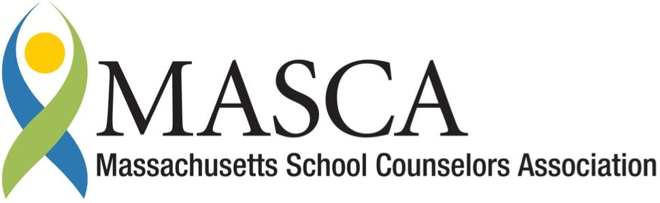 | Massachusetts Accountability Report Card  A continuous improvement document for school counseling outcomes  M.A.R.C. Jr.  2011-2012 School Year
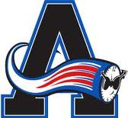 | Ashland High School  65 East Union St. Ashland, MA 01721  Ph: 508-881-0177 Fx: 508-881-0186  http://ahs.ashland.k12.ma.us  DISTRICT: Ashland Public Schools  GRADE LEVELS: 9-12 ENROLLMENT: 718  PRINCIPAL: James E Adams SCHOOL YEAR: Traditional

Principal’s Comments

Principal’s Statement

Ashland High School is committed to the academic and social development of all students. Essential to this is a comprehensive dynamic counseling program that focuses on student personal, social, academic and career development that aligns with the Massachusetts School Counseling Model. Through grade level seminars, evening programs for the community and individual work with students, school counselors are a dynamic component of our school community. This Massachusetts Accountability Report Card (MARC Jr.) is an example of the modern use of data to validate and use as a measure of improving counseling services to all students at AHS.

James E. Adams
Principal

Student Results

Five years ago, the AHS Guidance Department and administration saw an immediate need to implement freshman, sophomore, and junior guidance seminars in order to increase college and career readiness among all students, and to better align the counseling program with the Massachusetts CDE Benchmarks. These guidance seminars allowed students to access a school counselor in a classroom setting four to five times during the year to receive a structured, standards-based guidance curriculum. All lessons are aligned to ASCA and MASCA Performance Standards, MA Curriculum Frameworks, and MA CDE Benchmarks. Freshman guidance seminars focused on orienting students to AHS, creating an understanding of self-awareness, building a 4-year plan for high school, and ultimately increasing college and career readiness. In order for the effectiveness of the seminars to be studied and the lessons themselves improved upon, pre- and post-tests were administered. Post-test results indicate a significant increase in knowledge. For the freshman seminars, most notable increases as measured in the graph below show that 92% of AHS freshman know the role of the guidance counselor (Q1, 22% increase), 80% have a 4-year plan for high school (Q6, 27% increase), 80% know what a GPA is (Q7, 15% increase), 98% have a Naviance account set up (Q8, 96% increase), 92% understand how Naviance can help them explore career options (Q9, 82% increase), and 86% know what is required for graduation (Q10, 14% increase).

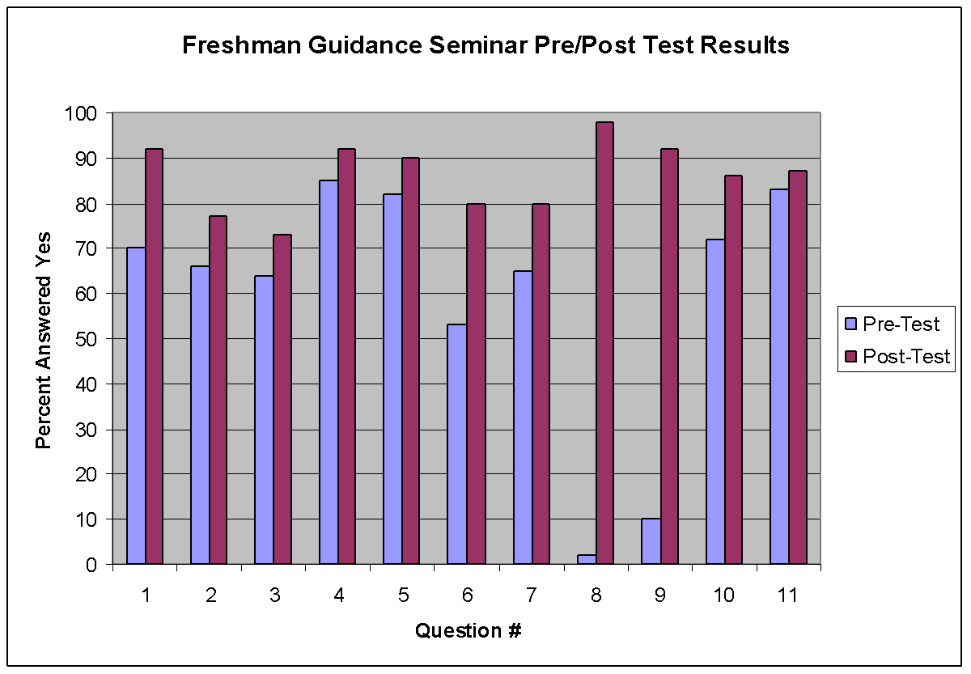

Sophomore guidance seminars focused on career exploration, goal setting, resume building, understanding standardized tests, and beginning the college search process. Again, post-test results indicate a significant increase in knowledge. Most notable increases as measured in the graph below show that 68% of students know the difference between the SAT and ACT (Q9, 41% increase), 62% of students know how to identify colleges by specific college majors (Q7, 35% increase), 77% of students can relate occupations to specific college majors (Q6, 29% increase), and 85% of students know how to identify different occupations that share things in common (Q3, 22% increase).

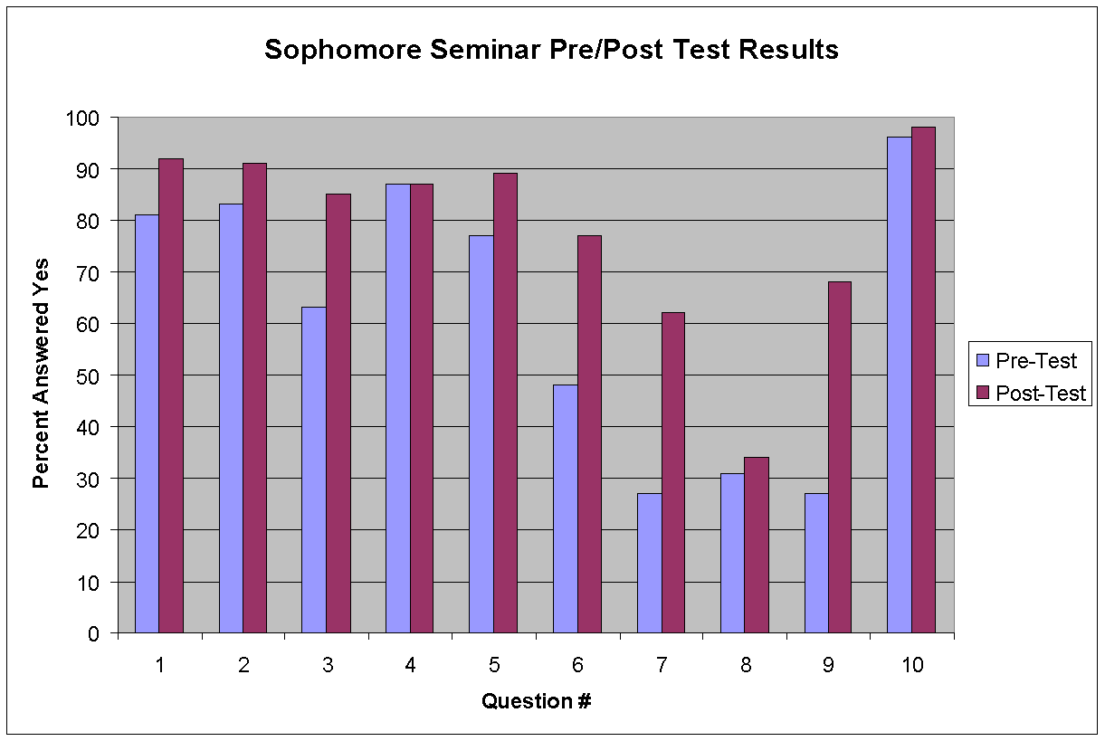

Lastly, junior guidance seminars focused heavily on the college search process and post-secondary planning. For junior seminars, unlike freshman and sophomore, juniors were placed in seminar classes with their own assigned school counselor. Seminars focused on understanding standardized test scores and next steps, post-secondary educational pathways and admissions standards, the admissions process, and how to research colleges effectively. Students also met individually with their counselor for a “junior interview” to solidify their post-secondary plans. As with the freshmen and sophomore seminars, post-test results indicate a significant increase in knowledge. Most notable increases as measured in the graph below show that 88% of students know the admissions requirements for UMass and Massachusetts State Universities (Q3, 63% increase), 100% of students understand and know how to use the college search function of Naviance (Q8, 37% increase), and 97% of students have an initial list of colleges they are considering (Q9, 44% increase). It is notable that over 90% of students answered affirmatively on 8 out of 10 post-test questions. It should also be noted that while only 67% of students marked that they have individually met with their counselor to discuss post-secondary plans, in some occasions the post-test was given after the last seminar class but before the one-on-one meetings, explaining the negative skew in the data. By the end of the year all junior students will have met one-on-one with their counselor to discuss their plans after high school.

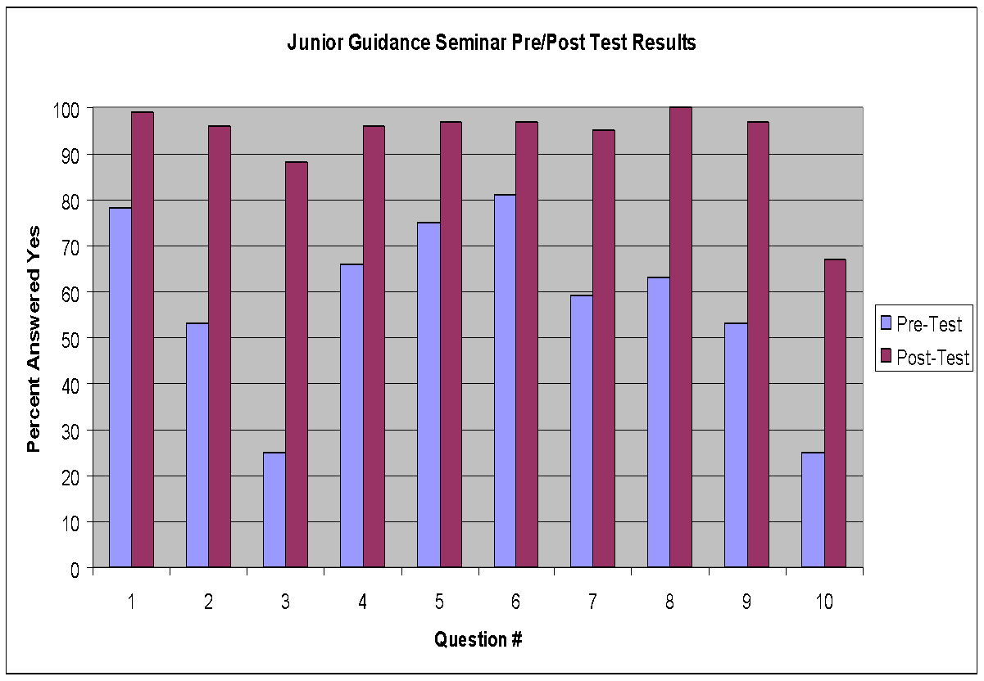

Focus for Improvement

The AHS Guidance Department is dedicated to improvement and the use of data to drive future interventions and implementation of the guidance program. The Guidance Department prioritizes the following areas that need improvement, according to the data. Their efforts are also aligned to the school improvement plan.

1. While the AHS Guidance Department is pleased with the post-test results of the guidance seminars, they would like to see an increase in overall proficiency and affirmative responses to the seminar post-test questions, specifically those that fell under 80% this past year. Using the data, AHS will review the guidance curriculum and make necessary changes in order to see improved results next year.

2. The guidance department will increase the number of seminars from 4 to 6 over the next 2 years.

3. Additionally, though SAT and ACT scores have been on the rise since 2006, AHS has determined that there is a discrepancy between the percent increase among Reading, Writing and Math SAT scores. The English department is actively consulting with our regional representative from the College Board to review SAT data in order to develop solutions to address this discrepancy.

Student Support Personnel Team

AHS Guidance Mission Statement:
The guidance staff at AHS helps students and their families navigate academic, personal and social development during the high school years. Our goal is to build partnerships that allow students to identify their strengths and weaknesses, explore interests, make appropriate course selections, and develop post-secondary plans. The guidance department is committed to providing a comprehensive and developmental counseling and guidance program, aligned with the MA Model, which includes the following components: group and individual planning, proactive and responsive services, and system support. Guidance services, in both individual and group settings, are available for every student in the school.

AHS Student Support Personnel Team
NAME | POSITION | Education | Years Experience
Brian Garrigan | Guidance Liaison | M.Ed | 30
Jennifer McMahon | School Counselor | M.Ed | 9
Beverly Chase | School Counselor | M.Ed | 15
Cory McGann | School Counselor | MA | 4
Jennifer Shiels | Adjustment Counselor | MSW | 10
Laura Guarino | School Counselor Intern | BA | 1
Kristina Hunter | Guidance Secretary |  | 8

