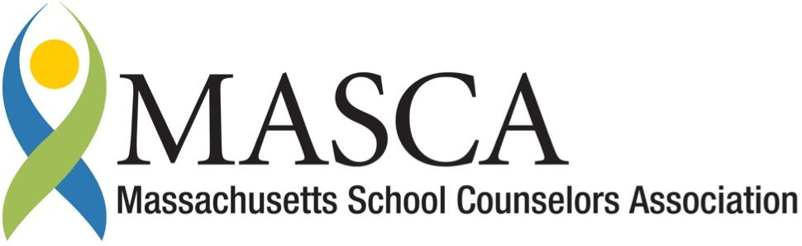 | Massachusetts Accountability Report Card  A continuous improvement document for school counseling outcomes  M.A.R.C. Jr.  HARWICH HIGH SCHOOL  2013-2014
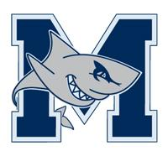 | Harwich High School (regionalized as Monomy Regional HS - 9/14)  75 Oak Street Harwich, MA 02645  www.monomoy.edu/hhs  DISTRICT: Monomoy Regional School District  GRADE LEVELS: 9-12 ENROLLMENT: 400  SCHOOL YEAR: traditional, multi-track, year-round  PRINCIPAL: Kevin Turner

Principal’s Comments

The School Counseling Department plays an integral role in the execution of our core mission. The program, based on the Massachusetts Model for Comprehensive School Counseling Programs, provides comprehensive support to the academic, technical and social development of all students. Our counselors work with students on a number of issues ranging from understanding their learning style to negotiating the career/college process. Such work includes helping students to set goals, exercise their talents, explore careers and plan to achieve post secondary success. Through individual work, grade level seminars and evening programs for the community our School Counselors endeavor to address critical issues that face the student of the 21st Century.

This year we will be working toward the smooth transition next year to our new high school, Monomoy Regional High School. The Guidance Department will be critical to this effort. I am proud of the pivotal role our school counselors play in the success of our students and community at large.

Kevin Turner, Principal

Student Support Personnel Team
Counselors
Jonathan Bennett, MS jbennett@monomoy.edu
Margaret Callagy, MA mcallagy@monomoy.edu
Richard Gifford, Director, M.Ed rgifford@monomoy.edu

School Counseling Mission Statement

Through advocacy and collaborative partnerships with students, teachers, parents and administrators, the Monomoy School Counselors provided students opportunities to: understand the school environment; understand self and others; learn interpersonal and communication skills; and make informed decisions.

Providing academic advising, promoting college and career opportunities, and personal social/emotional support allows for all Monomoy students to be empowered with the knowledge, perspectives and competencies to make responsible choices and contribute to their communities by teaching them to ADAPT:

Assimilate self-knowledge
Develop specific goals
Adjust to changing conditions
Plan programs to achieve goals
Teach themselves to practice problem solving and decision making skills and accept the outcomes of their choices

Student Results

In our efforts to further our impact with students and exercise best practice, the school counselors began implementing a 4-year school counseling core curriculum. The initial offering is a seminar for our incoming students. Each seminar lasted 60 minutes and included time for group discussion on topics such as goal setting and credit requirements for graduation.
The Grade 9 seminar is designed with three areas of focus:
- Introduction of the School Counseling Department - acquaint the students with the School Counseling staff, explain the school counseling program and available services, and identify the protocol to access school counseling services;
- Naviance Program – guide students through creating an account for our Naviance program and introduce the students to the software.
- Learning Styles Inventory - to aid students in identification of their learning styles.

Summary of Pre/Post Data Results
Analysis of the pre/post data informed us about improving our techniques and provided information for planning future curriculum lessons.

Chart # 1 – Awareness of School Counseling Services.
Prior to the seminar Pre-test data showed that 30% of the students knew what services our Department offered, 60% were unsure and 10% had no knowledge about our program. After instruction Post-Test data showed 80% could identify four services provided by our department,15% were still unsure and 5% still had no knowledge.

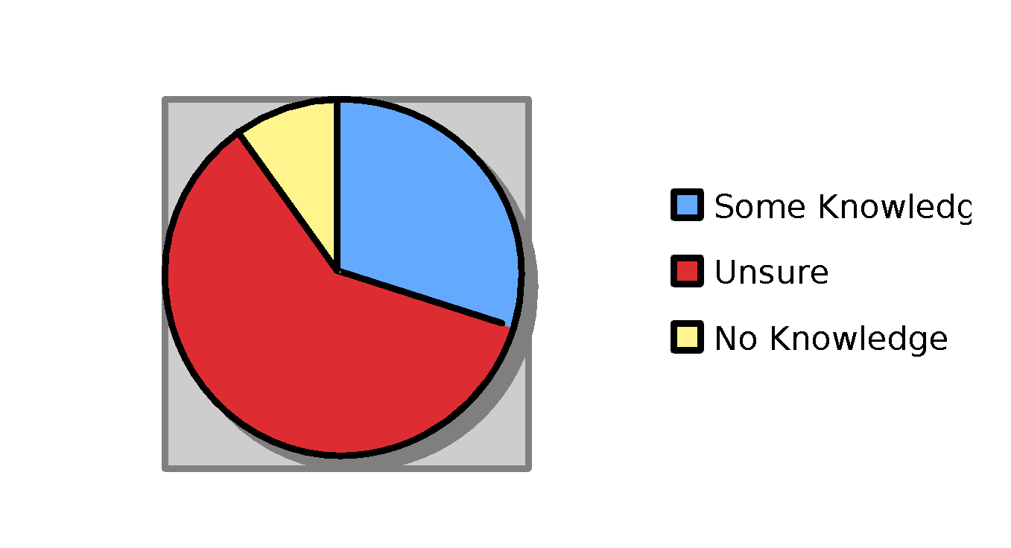
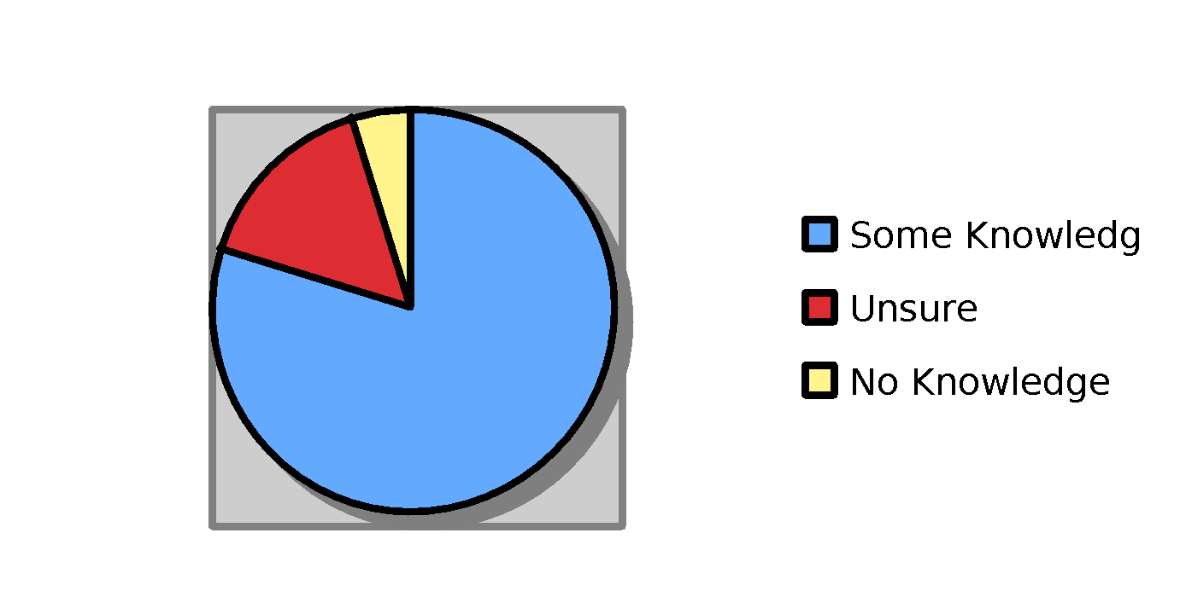
Chart #2: Gr. 9 Knowledge about Naviance
Prior to the seminar, Pre-Test data showed 60% of students knew the uses of the Naviance program, 30% were unsure and 10 % had no knowledge. After our class 93% could identify the uses for and how to access the program, 5 % were still unsure and 2% showed no fluency. 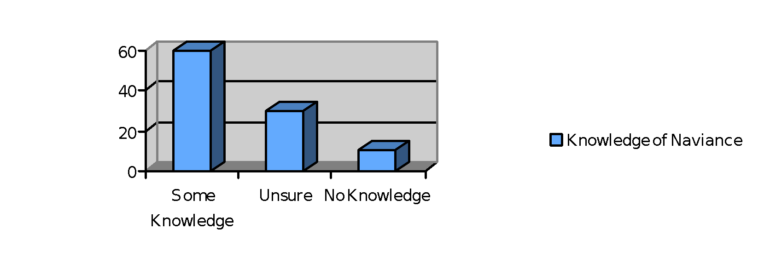
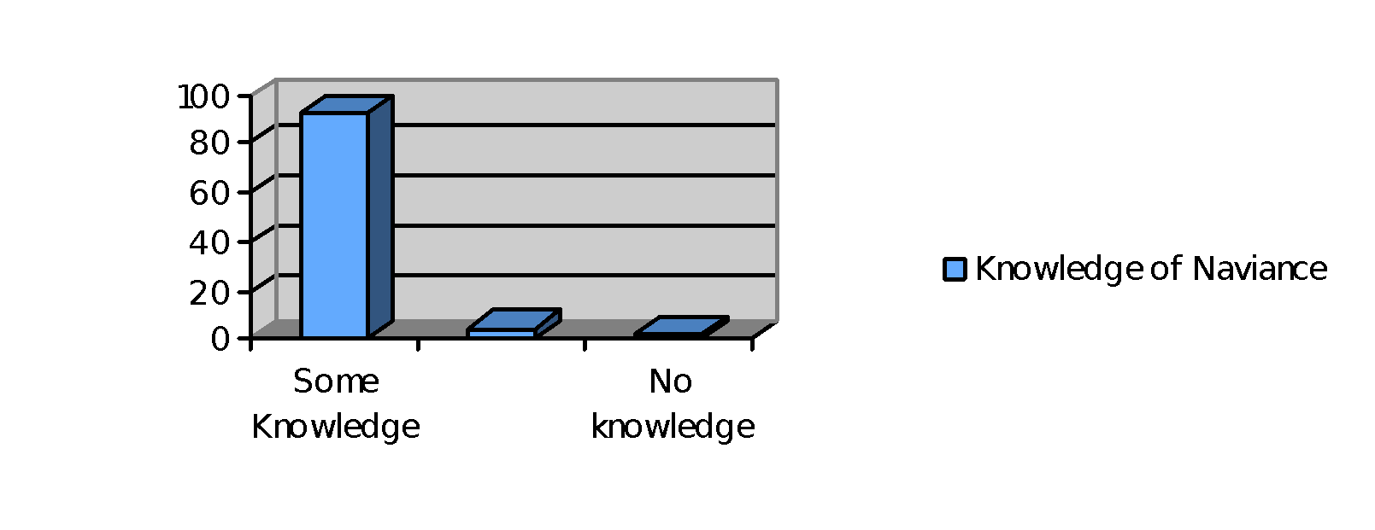

Chart #3: Student’s Awareness of their Learning Style

Prior to the class Pre-Test data showed 48% of students had an idea of their learning style, 40% had limited understanding and 12% had no knowledge concerning their learning style. Post Test data revealed 92% now had an understanding of their learning style, 6% had limited understanding and 2% still no knowledge.
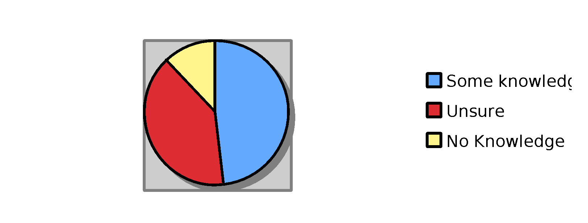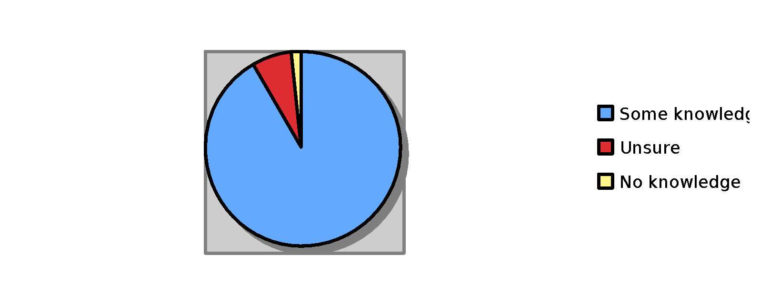

Focus for Improvement

These results clearly demonstrate the seminar is an effective teaching tool for this material and skills acquisition. We will continue to refine our process as a result of the data.

The School/Guidance department is committed to implementing our plan of instruction to all student including self-understanding and efficacy, careers and post secondary options and how to navigate social issues. We will utilize resulting data from our seminars to guide us, closely targeting our desired outcomes and refining our process. We will work closely with other support teams within the school to maximize this effort. This includes meeting with each academic area department head, collaborating with teachers, attending IEP meeting and taking every opportunity to meet with students and parents. Our initiatives are integral to the systemic health of our school community so we closely partner with the Administration. We are committed to increasing our fluency in The Naviance software that has tremendous capacity to organize and maximize our program. We will continue to professional expand our knowledge of MEFA (Financial Aid training), NEACAC (college admissions training) and aligning our practice with MASCA (Massachusetts School Counselor Association) Model for excellence.

