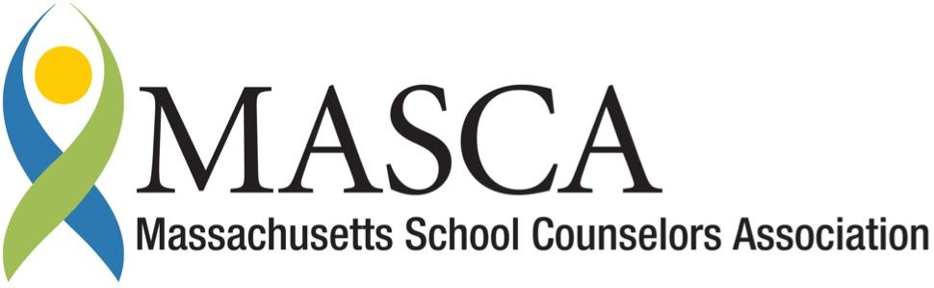 | Massachusetts Accountability Report Card  A continuous improvement document for school counseling outcomes  M.A.R.C. Jr.  2014 - 2015 School Year

Turners Falls High School
222 Turnpike Road Montague, MA. 01351
(413) 863-7203 Phone (413) 863-2107 Fax
www.gmrsd.org
DISTRICT: Gill - Montague Regional School District
GRADE LEVELS: 9-12 ENROLLMENT: 262
SCHOOL YEAR: Traditional
PRINCIPAL: Thomas Osborn

Principal’s Comments
Turners Falls High School staff and administration are committed to providing students with a great education and preparation for life, including three domains: academic achievement, career development and social emotional support. During the 2014-2015 school year, school counselors worked with school staff to begin implementation of the MA Model and develop curriculum and programming to provide career development activities to students. The district received a grant from the Department of Elementary and Secondary Education to plan during 2013-2014, and to provide services for students during the current year.

The Massachusetts Model for school counseling provides a framework for systematically supporting students in the three domains, and our school counselors are essential for the implementation of this program. Our school’s mission includes creating a safe, supportive environment for our students. Our professional, dedicated school counselors are essential to upholding this mission.
Thomas Osborn, Principal

Student Results
One of the initiatives the TFHS School Counseling Department implemented this school year was a freshmen seminar which took place over three lessons. The purpose of the seminar was to help freshmen successfully transition from middle school to high school. Students learned about activities and
services available to them and were introduced to the academic requirements and expectations of TFHS. Basic skills and helpful strategies for academic success were discussed.

One major goal of the seminar was to create Individual Learning Plans for the entire Freshman Class. During the seminar, students created a paper and online four-year plan through The Massachusetts Career Information System (MassCIS). The four year plan and other documents will be added to the student’s Individual Learning Plan (ILP) each year.

The last lesson in the seminar was on Learning Styles. A standards based lesson was created and a pre and post survey was administered. Data was gathered to analyze and assess the results. The following MA Career Development Education (CDE) benchmarks were linked to the lesson:

- Academic-Technical Development A1-2, A1-3, A2
- Workplace Readiness Development-W-2
- Personal/Social Development PS1-2

Forty-four freshmen took part in the seminar. Of the total 44 respondents, 20 are visual learners, 11 are auditory learners and 13 are kinesthetic learners. Post survey results indicate an increase in the number of students correctly identifying their preferred learning styles.
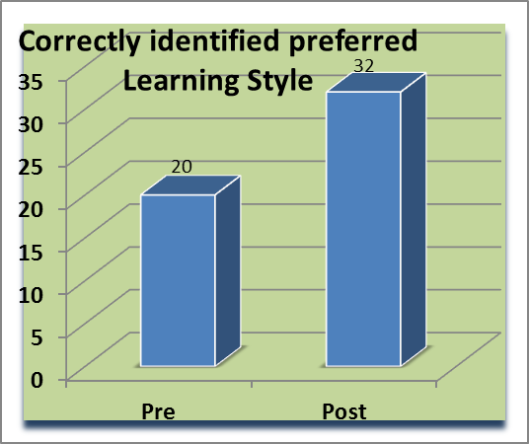
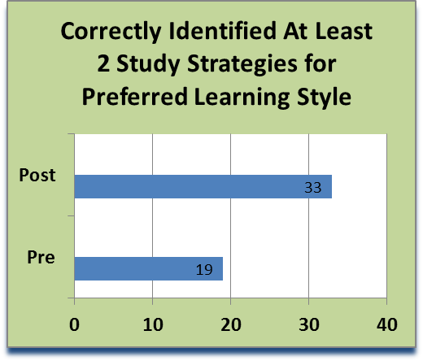
68% of the students reported that the guidance lessons in the seminar were helpful.
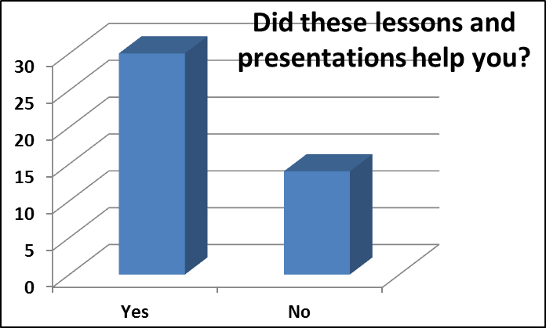

Focus for Improvement
Although the counseling team was able to gather some valuable information, overall the pre and post survey yielded flat results. This was probably due to previous guidance lessons in the middle school. As such, the lessons and questions on the survey will be redesigned to align and build more on their previous learning experiences.

Positive outcome from the lessons
- Counselors were able to gather data about students’ self-identified learning styles. This valuable information will be provided to the teachers so they will be able to teach to students’ learning styles.
- Students learned helpful study strategies for their dominant learning styles which will help them maximize their learning potential. Expanding the curriculum in the seminar to include important topics such as time management, study skills, career development, goal setting and decision making will be considered for the future.
- As a result of delivering the freshman seminar lessons, the counselors were able to get to know their new students better and earlier in the school year, when compared to previous years.
- 100% of the freshman class began their ILP’s, which will help students stay on track for graduation and progress toward their personal goals each school year.

Student Support Personnel Team (SST)
All counselors are part of the weekly SST meetings for collaborative planning to ensure student academic success. The counseling team consults, partners with, and makes referrals to community agencies that provide in and out of school services (MEFA, FHRB, FAFSA Day, Community Action, CSO, DCF, GCC, Servicenet, 3rd Place, etc.).

Through the implementation of the MA Model, the counseling team provides guidance curriculum, individual student planning, responsive services and system support within TFHS.

Karen Hidalgo, M.Ed./CAGS,  School Counselor | MASCA member, Certified Dropout Prevention Specialist  All students gr 9-12
Beth C. Fortin, M.Ed.,  School Counselor 9-12 | MASCA member  Last names A-L
Maria Paoletti, M.S.,  School Counselor 9-12 | MASCA member  Last names M-Z
Sharon Girard | Administrative Asst.

