Fairhaven Public School Counseling Mission:
Counselors work together in partnership with the families and community at large to promote the development of each student's academic, personal/social, and career potential. The goal of counseling is to take a proactive and preventative approach when possible, but also to work with students to resolve current issues that impact personal growth and achievement. Through a comprehensive counseling program that is developmentally appropriate, counselors assist all students in realizing their abilities, interests, and goals as they transition through the educational process to become successful members of society and life-long learners.
Principal’s Comments

As principal of Fairhaven High School I support my school counselors and the work they do. Together we are working toward full implementation of the
Massachusetts Model for school counseling programs. The school counseling team and the programs they deliver are a vital component of student academic success as they prepare for post-secondary plans, college, and careers. In addition, our school counselors ensure that Fairhaven High School is a place where students are able to learn in a safe environment. The M.A.R.C. Jr. provides accountability and data that is a valuable tool in measuring the effectiveness of the interventions provided by our school counseling department. Sincerely,
Tara Kohler, Principal

Student Results

Members of the FHS Counseling Staff are dedicated to the delivery of a comprehensive, developmental school counseling program that addresses students’ academic/technical achievement, workplace readiness/career planning and personal/social development. As part of this program, lessons were delivered to seniors educating them on post-secondary financial aid planning and scholarships. Using data collected
from pretests and post-tests. It was our hope that students would use the skills learned from this lesson to maximize their
scholarship and financial aid earning potential (MA CDE Benchmark A4-3: Skills in maximizing educational and workplace achievement for employability, work satisfaction, and optimal earning potential and W1: knowledge and skills in the planning and decision making process).

Graph 1 compares the pre and post test results regarding the importance of focusing priorities when applying for scholarships. Results indicated a 48% increase in knowing that the most important aspect in applying for scholarships is to concentrate on scholarships that are the best fit for you. (G
GRAPH 1
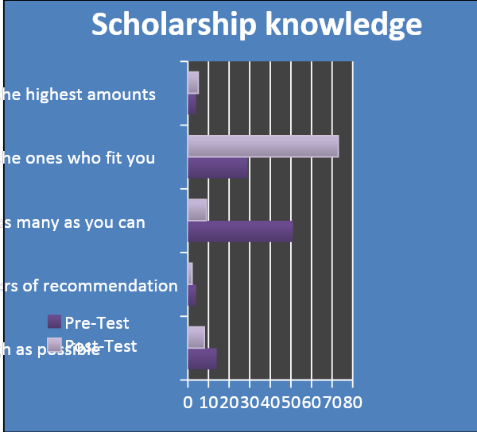
Graph 2 demonstrates that our current senior class took the knowledge learned from this lesson and earned not only more scholarships than previous years, but more individual seniors in the current class won more scholarships than seniors from the previous 3 graduating classes.

GRAPH 2
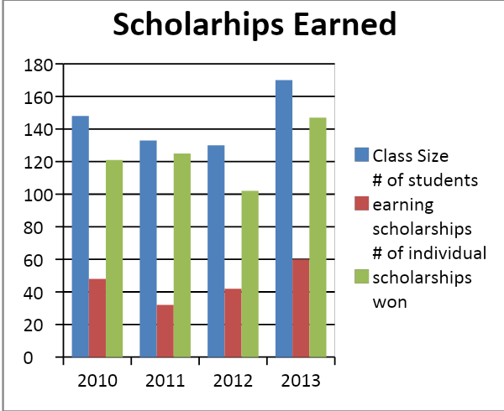

As you can see from our third graph, the amount of money that our current seniors earned from individual scholarships increased as well. (Graph 3)

GRAPH 3
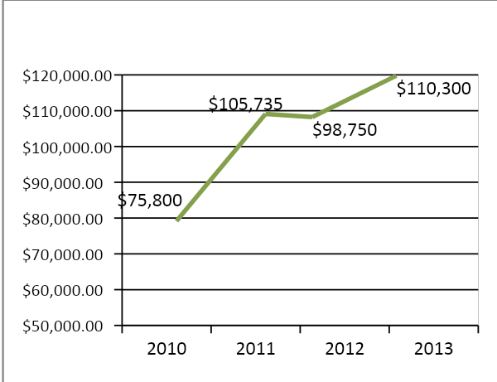

Focus For Improvement
Our overall goal for this lesson was to increase successful access and understanding of post secondary financial aid opportunities as it aligns with our school improvement plan. There were a few areas in delivery that needed improvement.
- First of all, the lesson plan was delivered before the holiday break. It is our belief that this lesson would have been more effective if it had been delivered when students have more time to devote to the scholarship and financial aid process. Guidance Counselors noticed more questions from students about this process later in the year.
- Secondly, the pre/post test data indicated students lacked a clear understanding of the financial aid forms that needed to be completed and did not fully understand the difference between the loans available to further their education. We plan to refine the lesson plan to aid in providing a clearer understanding of the differences between the forms and the types of aid available.
Student Support Personnel Team

With full support of the Superintendent and district Principals, the Fairhaven Public Schools’ district counseling staff began meeting every other month. During this time, an additional counselor was hired at the high school. Counselors all collaborated to develop the foundation of a comprehensive school counseling program: Vision, mission, logo, job description and program calendars. All high school counselors are MASCA members. High school counselors deliver standards-based classroom lessons for all students, targeting academic, college/career, and personal/social readiness and achievement; 25 lessons were delivered grades 9-12 this year. In 2012-2013, the end of year MA Model program audit showed significant progress towards full MA Model implementation: __% of Program Audit areas were rated “3” or higher as compared to __% in August of 2012.

High school counselors regularly meet within the department and with building administrators, weekly with the school nurse, daily with the school social worker, and consult frequently with the school resource officers, building security, freshmen collaborative teachers and special education case managers. School counselors manage a caseload of approximately 220 students, 504 plans, and attend IEP meetings.
STUDENT SUPPORT TEAM
Staff | Position | Degree | Certification | Yrs. Of Exp.
Tara Kolher | Principal | A.S., B.A. & M.Ed | Principal/VP & Supt/Ass. Supt. | 17
MJ Muello | Vice Principal | B.S., M.Ed. & CAGS | HE/PE & Assis. Principal | 35
Doug Medeiros | School Counselor | B.A. & MSW | 6-12 Guidance | 18
Nora Kelley | School Counselor | B.A., Ed. M. & CAGS | K12 Guidance | 1
Ashley Garth | School Counselor | B.S. & MA | 6-12 Guidance | 5
Marjorie Joseph | School SW | B.A. & MSW | LICSW & School SW | 35
Kerrie Oswald | Secretary | B.A. |  | 8
Lisa Drusket | School Nurse | B.S., BSN & RN | School Nurse | 7
Scott Joseph | Resource Officer | B.S.
Paul Gomes | Security
Shan E.  Bishop | Volunteer | M.Ed | Guidance & SAC | 7-02

