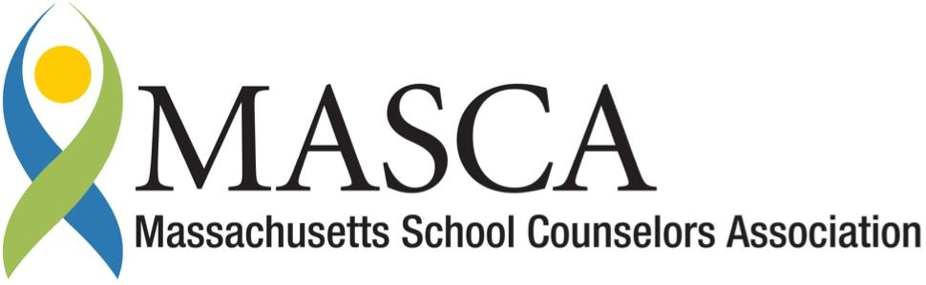 | Massachusetts Accountability Report Card  A continuous improvement document for school counseling outcomes  M.A.R.C. Jr.  2012-2013 School Year

Westport High School
19 Main Road
(508) 636-1050 Fax (508) 636-9914
www.westportschools.org
DISTRICT: Westport Community Schools
GRADE LEVELS: 9-12 ENROLLMENT: 416
SCHOOL YEAR: traditional
PRINCIPAL: Cheryl Tutalo

Principal’s Comments
It is my honor to introduce our school’s Massachusetts Accountability Report Card (MARC), a document which highlights some of the outstanding work of our School Counseling Department.

For the past two years, the Westport High School counseling department has aligned our program to the MASCA model. This has been accomplished by writing and implementing a standards based counseling curriculum. Each quarter counselors meet with students in all grade levels to monitor academic progress and to insure that each student develops a comprehensive four year college and career plan.

Cheryl Tutalo
Principal Westport High School

Student Results
The Westport High School Counseling Department, through their commitment to implement the MA Model for school counseling, has developed a comprehensive guidance curriculum based on academic-technical, personal-social, and work place readiness domains. The graphs summarize the results of our senior seminars.

Introduced in September 2012, the Grade 12 seminars began with a discussion of credits and senior status. Once established, students were divided into groups based on individual credit status and college and career readiness.
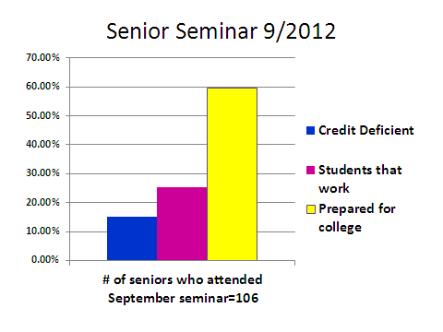
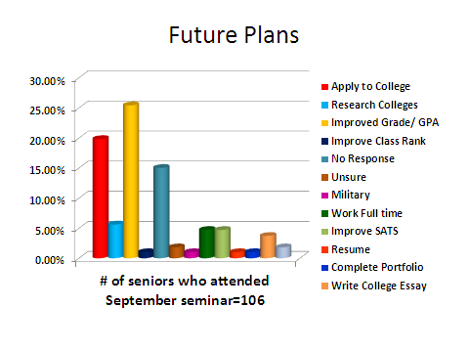
The culmination of the introductory seminar was a student exit slip indicating future plans.
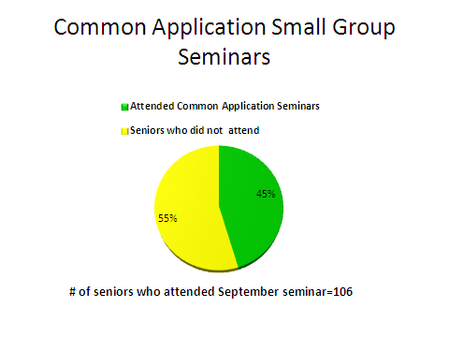
The data gathered from the initial meeting was utilized to convene a small group seminar that focused on completion of the common application.
Post-secondary planning was detailed in our second meeting with seniors. An open forum allowed for an excellent discussion of diverse college and career paths. The data collected ensured that individual student interest would be addressed by counselors in one on one meeting. Students identified through the data as having an interest in Bristol Community College resulted in small group application sessions.
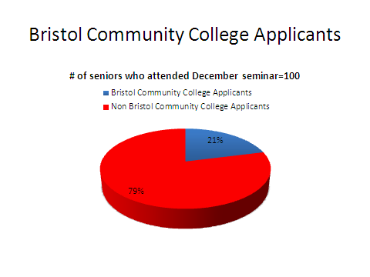

Focus for Improvement

- Family involvement is an area of focus for improvement. Building upon the success of the grade 9 parent information evening, a senior family night is in the planning stage and will be implemented in the 2013 -2014 school year. Senior Family Night will be an outreach to those families whose seniors are undecided as to their after high school path.
- Continue to collect data to monitor and evaluate seminars.
- Develop surveys as a way to communicate with alumni to develop a working relationship with current students and staff.
- Incorporation of the school adjustment counselors to address the personal/social domain will be included in the reorganization of the counseling curriculum.

.

Student Support Personnel Team

The mission of the Westport High School Counseling Department is to provide a comprehensive program that will assist all students in acquiring the skills, knowledge and attitudes needed to become effective students, responsible citizens, productive workers and global learners.

Staff Name | Position | Certification | Yrs. Exp.
Cheryl Tutalo | Principal | B.A. –Secondary Education  M.A. – Secondary Administration | 35 years
Karen Antonelli | Asst. Principal | M.Ed. | 30 years
Paul Amaral | School Counselor | Masters + 80 credits | 40 years
Marie Fallows | School Counselor | B.A. - Psychology  M.Ed. – School Counseling | 15 years
Leslie Ruel | School Counselor | B.A. – Psychology/Political  Science  M.Ed. – School Counseling  M.A. -Personnel Psychology | 19 years Westport  Schools  7 years in Guidance
Mary-Jo Medeiros | SSW/SAC | MA/LSW – Rehab. Counseling  SSW/SAC | 21 Field  5 WHS
Melissa Plourde | SSW/SAC | B.A. – Psychology  MSW  LCSW- Clinical SW  SSW/SAC | 13 years in Field  3 years at WHS
Suzanne Walinski | School Nurse | BSN
Robert Reed | Resource Officer
Maggie Bednarz | Clerk | 1.5 years college | 5 years

Counselor Meetings include:
- Grade level counseling seminars 4 times per year.
- Ongoing student small group and individual counseling and advising sessions as needed.
- Event planning meetings for department programs.

Counselors chair/attend IEP, 504, student concerns, and RTI meetings.

