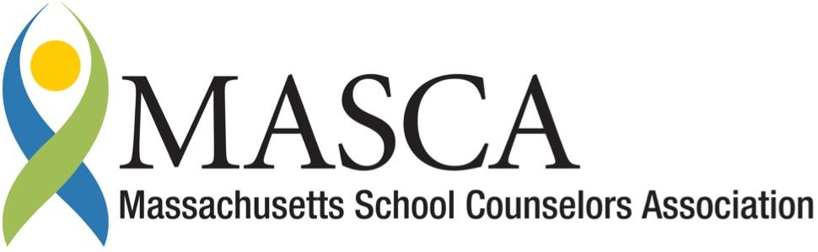
Massachusetts Accountability Report Card
A continuous improvement document for school counseling outcomes
M.A.R.C. Jr.
2013-3014 School Year

Rindge School of Technical Arts at Cambridge Rindge & Latin School
459 Broadway, Cambridge MA 02138 phone: (617) 340-6630
HYPERLINK "http://www.cpsd.us" http://www.cpsd.us
District: Cambridge Public Schools Executive Director: Dr. Michael V. Ananis
Completed by Clare H. Garman, M. Ed, RSTA Career Counselor

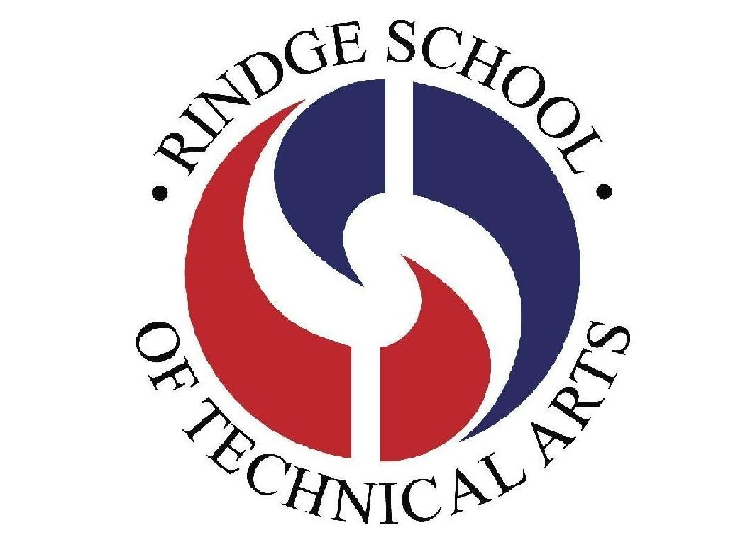

Rindge School of Technical Arts Program Mission

Our Vision
The Rindge School of Technical Arts aims to provide the best technical education for high school students in the Commonwealth of Massachusetts. In a high-tech environment we will deliver a curriculum that connects knowledge development with its application in the workplace.
Our Motto
Where Excellence is Part of Our New Tradition
Our Mission
To meet our vision, the RSTA staff provides students with the highest quality instructional resources and tools in an environment that is safe, healthy, and fully modernized. We promote and encourage a climate of high expectations and a respect for education.
Our challenging curriculum provides all students with learning opportunities, and the chance to continually improve and master skills that are taught by experienced teachers. We provide an education that is relevant, modern and rigorous for all levels of students.

Message from the Executive Director

As Executive Director of the RSTA program, I support full implementation of the MA Model school counseling program and continuous improvement of instruction delivery through the use of data collection and review; and prioritizing those areas identified as areas in need of improvement. The RSTA Career Counselor implements programs that prepare all students for post-secondary plans, college and careers.

Sincerely,
Michael V. Ananis
Executive Director

Rationale for Study

CRLS successfully completed and submitted its NEASC Self Study Report in SY 2012-2013. The Self Study reported detailed strengths and weaknesses as recognized and voted on by the entire teaching faculty of the school. Prior to the NEASC Evaluation site visit, the staff voted and identified the most critical strengths and needs from the Self Study report. The list of critical
needs and corresponding NEASC Standard included:
Standard 2 (Curriculum), additional job readiness, career exploration, and other skill-building opportunities that
would benefit all students and further prepare them for internships, projects, and post-secondary life.
Rindge School of Technical Arts Program Mission

Profile of Exploratory Class SY 2013-2014

During the first semester of 2013, 111 students were enrolled in the Exploratory class. An ethnic breakdown showed that 60% were of African-American descent and approximately 40% were a combination of Caucasian, Asian and Hispanic origin, and 45.2% of this population was either on IEP's or 504 plans.

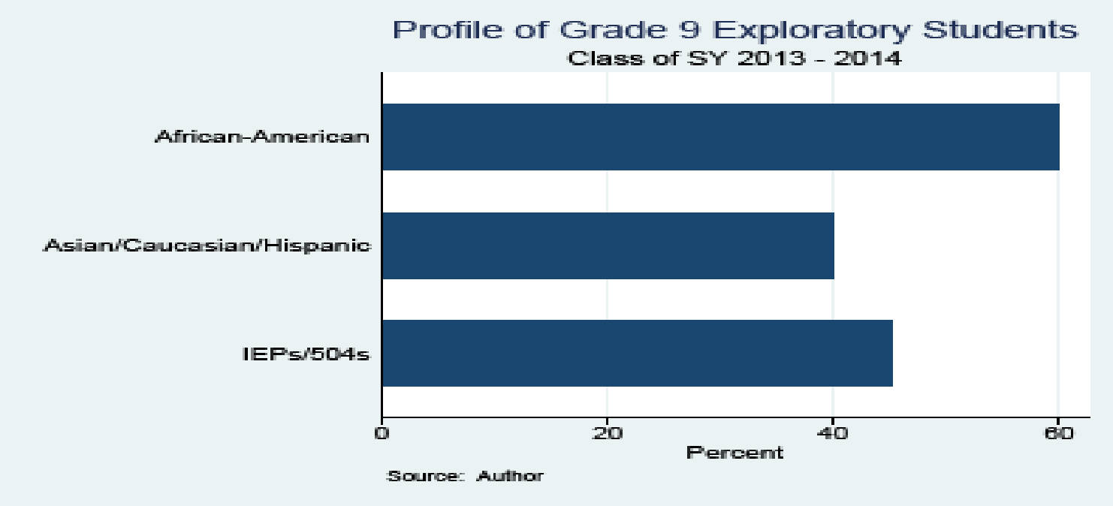

Career Counseling Performance Objectives

During the 4-day career class the career counselor introduced students to the six career types and characteristics associated with each type. Since 45.2% of the population was either on 504’s or IEP’s, materials were modified as needed and were presented using differentiated learning instructional strategies.
All students discovered their top career type/s, and identified careers that matched that type/s. The Performance Objective stated that 80% of students would be able to recall their career type on the last day of the career class and 75% would remember their career type at the end of the Exploratory program.

Student Results

Post-Test
On the last day of the 4-day class, students were given the post-test worksheet, “What did you learn about careers?”
- How many different career categories (types) did we talk about?
- Of all the types, which one describes you best?
- Why is it important to know your career type?
- Name a resource on the web that will give you career information?
- What is one way that you can find out about careers while still in high school?
The percentage of students who answered correctly for each pre-test question was:
- 83.8%
- 82.4%
- 78.4%
- 82.4%
- 83.8%
The following graph shows the pre/test and post/tests comparisons.
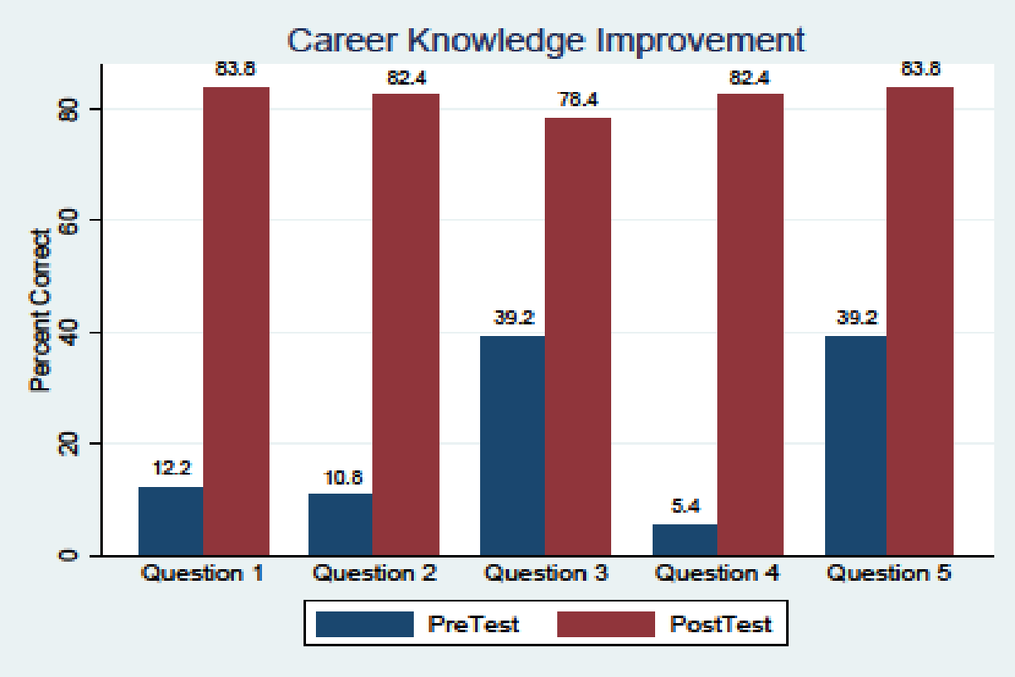

The Final Career Survey:
The Final Survey was given to students simultaneously on the last day of the Exploratory program. Since students took the class and the post-surveys at different times during the semester, I was curious to see if they would recall their career type at the end of the class. Thus, all students regardless of when they took the career class were given a worksheet at the same time on the last day of Exploratory and were asked to circle the name of their top career type/s. The Exploratory teachers were previously given a list of their current students’ career types and were asked to check each one.

The results of the Final Career Survey:
Ninety-five (95) students were surveyed on the second last day of the Exploratory program, 80 or 84.2% circled the career type that was correct for them. This was the exact same percentage as in the first survey. Although in the first pre-test/post-test only 74 students were surveyed.

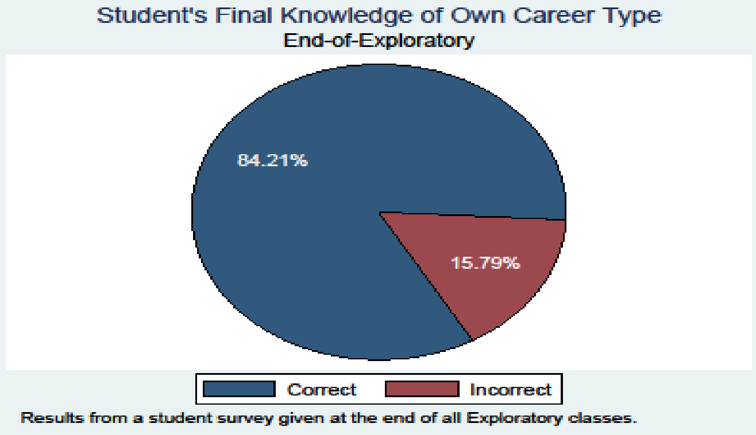

Reflections and Suggestions for Future Learning

The general impact of the class and its results were positive. Most students gain formation about their career type, an awareness that different people have different career types and knowing your career type can help direct you to a satisfying career. Students were directed to www.masscis.intocareers.org to access accurate career information. We discussed various activities and actions that students can take to discover career information and their career interests while in high school.
My perception is that students had the most difficulty in recalling and recollecting the career type terms. On the final day of the students’ career class, students were asked to recall and recollect information with only their worksheets and classroom posters as possible cues. On the second last day of Exploratory students were asked to recognize information on another worksheet. The data showed that students were more able to recognize their correct type out of the six possible answers. It appears that recognizing was easier than using recalling. By actively teaching strategies for recalling, recollecting and retrieving information some of these differences between students can be remediated so that all students can be more successful. Some strategies that can be utilized in future activities include:

Using mnemonic devices to help student recall information

Giving students additional opportunities to rehearse and repeat the information desired.

Having students relate new information to things already known and establishing relationships between new ideas and previously existing memories.

Reading materials out loud and having students actually teach new concepts to others enhances understanding and recall.

