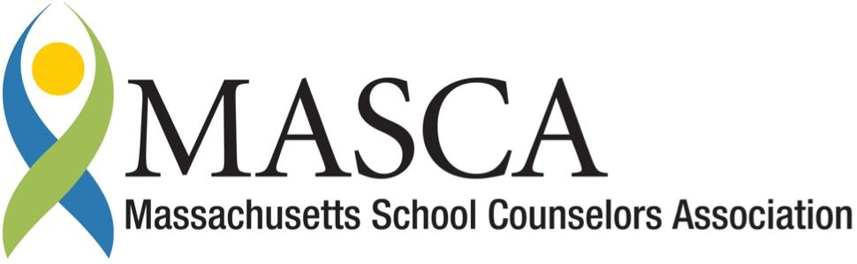 | Massachusetts Accountability Report Card  A continuous improvement document for school counseling outcomes  M.A.R.C.

Dr. Paul Nettle School
150 Boardman Street, Haverhill, MA 01830
Phone: 978-374-5792 Fax: 978-374-3441
http://nettle.haverhill-ps.org/
DISTRICT: Haverhill
GRADE LEVELS: 5-8 ENROLLMENT: 502
SCHOOL YEAR: Traditional
PRINCIPAL: Timothy Corkery

Principal’s Comments
Dr. Paul Nettle School is dedicated to ensuring that each student meets or exceeds the rigorous academic standards to become citizens with integrity, skills, and the resources needed to be college and career ready in the global community. As part of this mission, the school counseling team works to support every student to make sure that their academic and social/emotional needs are being met appropriately. Over the past year, the counselors have taken steps to implement the MA Model for Comprehensive School Counseling Programs. This year, the counselors, along with the Director of Student Support Services, have developed and implemented four lessons on the 7 Habits of Highly Effective Teens to all 7th grade students in our building. I fully support the efforts of our counselors that are linked to our school and district’s mission.

Timothy Corkery, Principal

Student Results

The HPS middle school counselors developed and implemented a classroom guidance curriculum based on The 7 Habits of Highly Effective Teens by Sean Covey. In an effort to increase our efforts to proactively deliver Tier #1 classroom instruction and focus on the development of a comprehensive developmental middle school guidance curriculum, MS counselors implemented a four-session program for all 7th grade students in Haverhill Public Schools during the 2014-2015 school year. The 7 Habits of Highly Effective Teens program aligns with both the American School Counseling Association standards and DESE’s Massachusetts Career Development Benchmarks.

ASCA’s National Standards for Career Development:
C.A1.3, C:A1.5, C:A1.7
ASCA Mindsets and Behaviors for Student Success:
Category 1: 1-6
Category 2: Learning Strategies 1, 4; Self-Management Skills 1-8, 10; Social Skills 1-9
MA Career Development Benchmarks:
Academic-Technical Development A4-1, 2, 3
Workplace Readiness Development W1-1, 2, 3,
W3-4
Personal/Social Development PS1-2, PS1-3

Through the use of pre- and post- questionnaires, the school counseling team was looking to increase student engagement and their development in the academic, career, and personal/social domains. This was a new initiative this year and therefore, data was collected to establish a baseline.
Pre and Post Questionnaire Results from Lessons 1-4
Lesson 1: When I receive a grade that I think is
unfair, I blame the teacher.
Lesson 2: I’m too young to make a plan for my
future yet.
Lesson 3: There are some people that have no
strengths or talents.
Lesson 4: Identifying goals will not help my schoolwork
and academics.
*Table #1: Responses were recorded on a 5-point Likert scale. The mean scores were included on the graph.
Table #1: 1=strongly disagree, 5=strongly agree

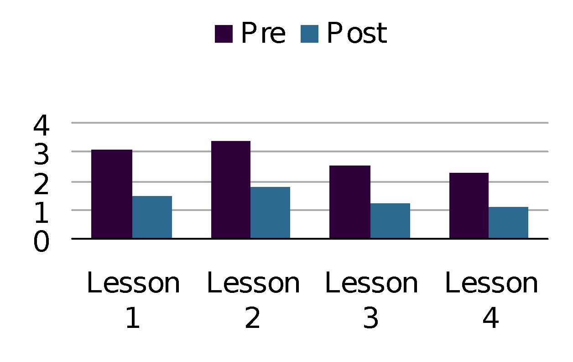
==========================
Pre and Post Questionnaire from before and after the 7 Habits Program
Lesson 1: I take responsibility for my moods and actions rather than blame others and circumstances.
Lesson 2: I know what I want to accomplish in my life.
Lesson 3: I am disciplined at carrying out goals.
Lesson 4: I cooperate with others.

*Table #2: Responses were recorded on a 6-point Likert scale. The mean scores were included on the graph.
Table #2: 1=very poor, 2= poor, 3= fair, 4= good, 5= very good, 6= outstanding.

The 7 Habits of Highly Effective Teens program was delivered to all 130 7th grade students at Dr. Paul Nettle MS. Data was collected from the pre and post questionnaires provided by the 7 Habits Company to assess the effectiveness of the program. There was a pre-questionnaire that students completed at the beginning of the program and one that they completed following the fourth lesson. This questionnaire consisted of four questions that were scored based off of a 6-point Likert scale. Additionally, students completed a pre- and post-questionnaire for each lesson. These questionnaires consisted of four to five questions using a 5-point Likert scale. Overall, the students’ questionnaire responses indicated significant learning for each lesson. 94% of students were able to identify a realistic academic report card goal to be completed by June; 6% of the students were absent when we completed this activity.

Focus for Improvement

The Haverhill School Counseling team plans to continue this program for the 2015-2016 school year. For Grade 7, it would be helpful to revamp and reorganize some of the 7th grade lessons before implementing this program next year. One of the key areas of improvement for next year would be to reduce the number of questionnaires that the students have to complete and focus more on increasing the quality of the questions. For Grade 8, the counseling teams want to design, deliver and assess implementation of the final 3 lessons in The 7 Habits of Highly Effective Teens program.

Parent/Guardian Volunteer Involvement

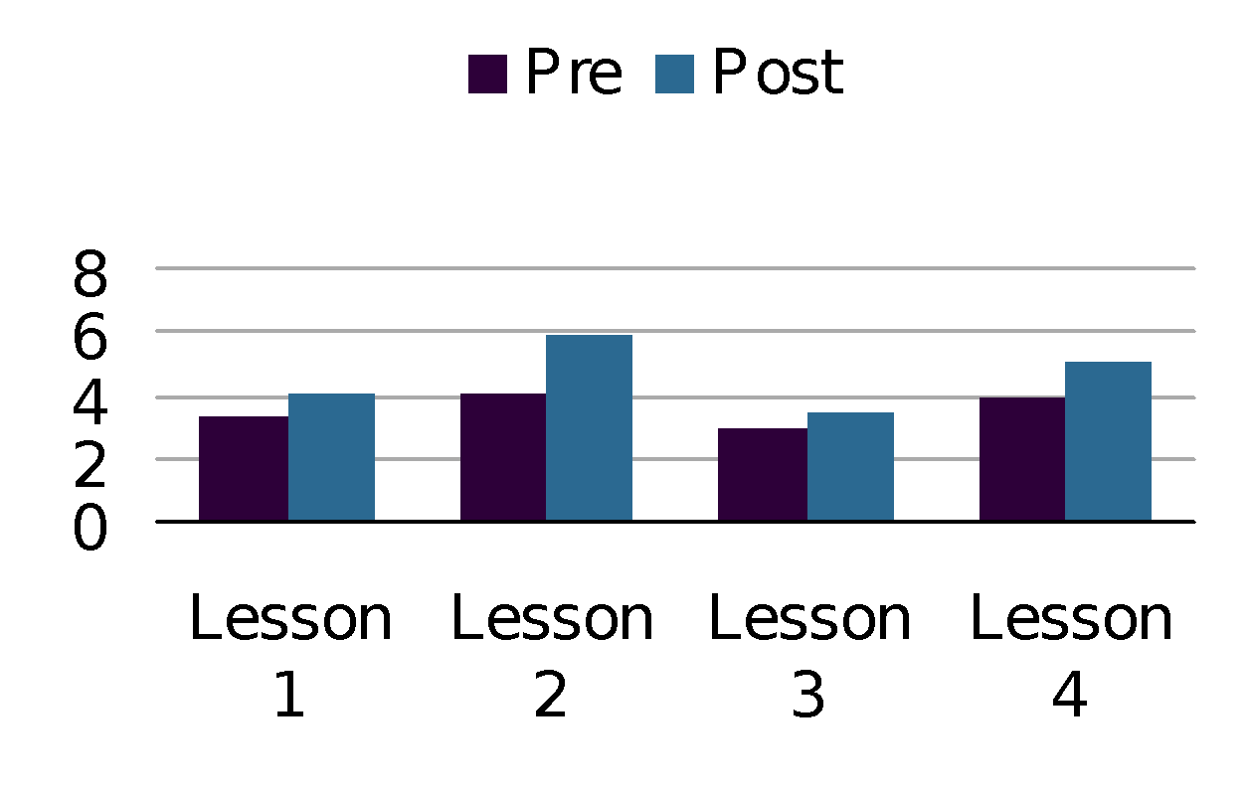
The school counseling team has developed a school newsletter describing the 7 Habits program and the dates that the curriculum was delivered to the students. The Nettle school counselors are also scheduled to meet with parents/guardians during the 2nd trimester parent/teacher conferences to discuss the 7 Habits program. Parents/guardians will have an opportunity to discuss and ask questions regarding this program. Also, parents/guardians will have an opportunity to sign a book out to read and review at home.

Student Support Personnel Team

The Haverhill Public Schools (HPS) middle school school counseling team is composed of six individuals, five guidance counselors and one Student Program Facilitator. The school counselors support and enhance all student achievement in their individual growth and development through the academic, career, and personal/social domains. Four of the counselors hold a Master’s in School Counseling, one holds a Master’s in Social Work. The Student Program Facilitator has a Master’s in Education. The school counselors are required to complete additional professional development trainings. The HPS school counselors collaborate closely with the school’s administrators, school psychologist, school adjustment counselor, social workers, teachers, nurses, parents, and guardians. The department meets monthly to plan, organize, implement, and evaluate the current counseling program.

Dr. Paul Nettle School Counseling Team:
Kara Melillo,  Master’s in Education | Student Program Facilitator
Megan Crowley,  Master’s in Social Work | Guidance Counselor

