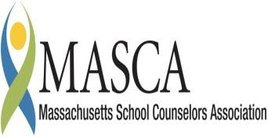  GRADES 4 - 7  2012 – 2013 school year  Timothy Santry, Principal  Heidi Champagne,  Asstistant Principal | Massachusetts Accountability Report Card  A continuous improvement document for school counseling outcomes  M.A.R.C. Jr.  2012 -2013 School Year

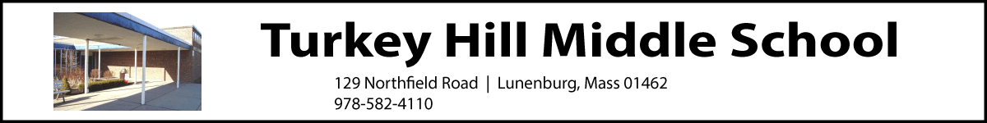
www.lunenburgschools.net

Principal’s Comments

“Be a buddy, not a bully!’ That is the mantra of the Peer Mediators at Turkey Hill Middle School. This group is made up of 19 fifth, sixth, and seventh grade students who have an amazing ability to be impartial and understand students different perspectives on difficult situations. Middle school is full of challenging avenues to navigate, but the Peer Mediators act as role models both during mediation sessions and in the school community.

Personal/social development is a primary task of middle school students; they are working on their identity (PS 1), learning to work cooperative (PS 2) and increasing their respect for difference (PS 3). The Peer Mediators help students learn to address each other respectfully; communicate self-confidently without teasing or disrespecting others; acknowledge their classmates’ hopes and fears; and discuss the upcoming school day’s activities.

Classroom teachers and school counselors spend an inordinate amount of time managing peer conflicts, but the implementation of the Peer Mediator Program has become an invaluable asset to staff, Teachers have more time available to devote to all students, engaging them in the learning process and school counselors have the ability to service more students and reinforce the goals of peer mediation during enrichment class, with the additional support of the Second Step program.

Timothy Santry, Principal

Student Results

The School Counselor presented a pre-test to each fourth and fifth grade student before the implementation of the peer mediator program. After two months of mediations, a post test was given to the same students. The data below represents the counselors’ ability to achieve the goals of educating the students and its relationship to the MA CDE Benchmarks.

Question 1 asked students if they knew where to seek help from regarding a conflict. (PS3-1)
- The results show that, after implementation students know have an increased knowledge of where to seek help with a conflict: come to the guidance suite, and scheduling a mediation
Question 2 addressed students’ ability to work through the conflict using appropriate personal and social skills. . (A1-1, A2-1) (PS2)
- Students responded that they struggled with conflict management before receiving help from peer mediation. Students now understand the importance of respectively expressing needs and wants as well as the need to be able to communicate effectively.
Question 3 addressed their feelings after solving a conflict, either on their own or with help from the peer mediators. (PS1-1) (PS1-3) (PS1-4)
- Students report feeling heard, supported, and validated after their mediation. Students have also discussed during enrichment class that they have increased skills in the areas of understanding others point of views, compromise, and accepting responsibility (see graph 2.)

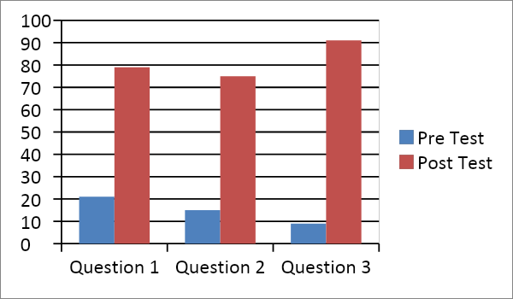

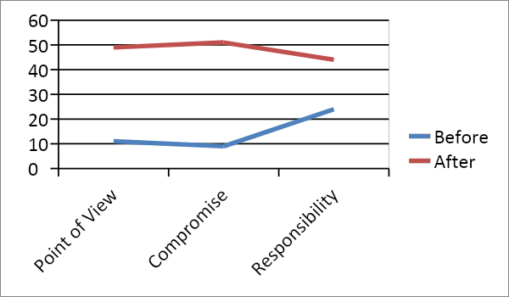

As a result of implementing the Peer Mediator Program, both teachers and school counselors have more time available to devote to all students, and both the Peer Mediators and their peers are increasing their knowledge of conflict resolution technique’s, as well as enhancing their social growth.

Focus for Improvement

There is always room for improvement. Counselors feel that supporting both the classroom teachers by addressing these conflicts but allowing students to miss minimal class time is a struggle. This leaves a very small window of time to conduct mediations. Teachers, counselors and administration want students to get the most out of their academic day, as well as participate in the social emotional process by attending specials and recess, yet finding time to complete the mediation without something else being comprised is a constant battle.

It is the feeling of this school counseling team that continual training, more mediators, and time to conduct the mediations should be the focus for the next step.

We will continue to have ongoing classroom instruction and use social settings inside and outside the classroom to focus on the life skills of empathy, emotion management, and problem solving. We balance the school discipline plan with positive incentives, as well as appropriate alternative consequence plans. School wide rules are posted in each classroom. Positive incentives are offered for positive behavior/attitude, good attendance, positive wellness, and practices, academics. Alternatives reviewed as options to positive discipline include campus clean-up, campus projects, incentives, community services, behavior plans/contracts, Friday School (afterschool), site or off-site group
or individual counseling, and/or alternative placements.

The school counseling department would like the luxury of being able to address all needs of the students but understand that time management is the key.

Student Support Personnel Team

The guidance department at THMS works to help students become self-reliant, responsible individuals with the self-esteem and confidence needed to become successful in school and in the community. The school counselors help students assess their abilities, interests, and needs by meeting with them in groups and individually. Students can depend on the guidance department for both academic and social support.

 | Degree | Assignment | Yrs. in profession
Gail Okerkman | M ed, MHC | Gr. 4-5 | 35
Cheryl Nelson | LMHC | Grade 6-7 | 12
Katie Hakey | CAGS in progress | Counselor Intern | 3
Elena Oksanish |  | Speech and Language Pathologist | 3
Timothy Santry |  | Principal
Heidi Champagne |  | Assistant Principal
Chad Adams |  | Dean of Students
Suzanne Saven |  | School Psychologist

Building administration collaborate regularly with the middle school counselors regarding individual student issues as well as whole school approaches to improving school climate and increasing academic and personal success for our students. Over the past year the counselors have taken steps to implement the MA Model for Comprehensive School Counseling Programs. School Counselors including a variety of teachers meet biweekly as a Teacher Supported Team (TST) to share concerns and strategies for ensuring student success. The team also partners with families, teachers, administrators, and other outside agencies. Members belong to numerous local, state, and national professional organizations.

