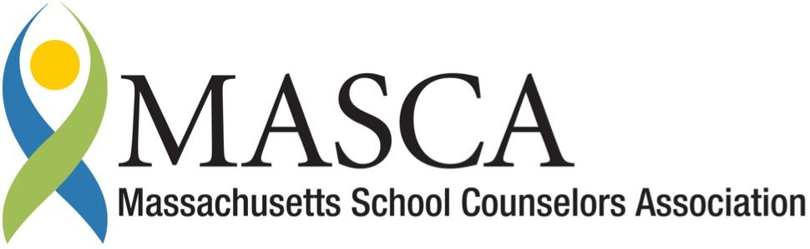 | Massachusetts Accountability Report Card  School Counseling Outcomes Sponsored by the Massachusetts School Counselors Association  M.A.R.C. Jr.  2014-2015 School Year

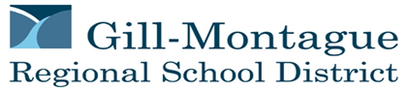
Great Falls Middle School
224 Turnpike Road, Montague, MA 01351
Phone (413) 863-7300 Fax (413) 863-2089
District: Gill Montague Regional School District Website www.gmrsd.org
GRADE LEVELS: 6-8 ENROLLMENT: 220 SCHOOL YEAR: Traditional
PRINCIPAL: Donna M. Fitzpatrick

Principal’s Comments
I strongly support the school counseling program in our middle school. Our school counselor is respected by students, staff and parents and is a valuable member of the school community. Consistent with the MA Model for School Counseling Programs, the comprehensive school counseling program at Great Falls Middle School addresses the academic, college and career readiness, and social-emotional needs of all students in grades 6-8. Our school counselor partners closely with other staff, parents and outside agencies in order to promote academic success, resolve attendance issues, facilitate the transitions entering middle school and moving on into high school, and respond effectively to student crises.
- Donna M. Fitzpatrick, Principal

Student Results
Providing career readiness education to students is an essential component of a middle school counselor’s program. CDE Benchmarks indicate that preparation and planning for careers is an essential component of workplace readiness (W1-1) and that it is important to know how to access career and labor market information (W2-2).

This year, as a result of College and Career Readiness grant funds through ESE, career activities were expanded to include the 7th grade. Students in the 7th grade created an online career portfolio through MassCIS (Massachusetts Career Information System) and completed the Career Cluster Inventory. The lesson also included a discussion around the purpose of career exploration in middle school.

The total number of 7th grade students who received the career lesson was 76. Results data is as follows:

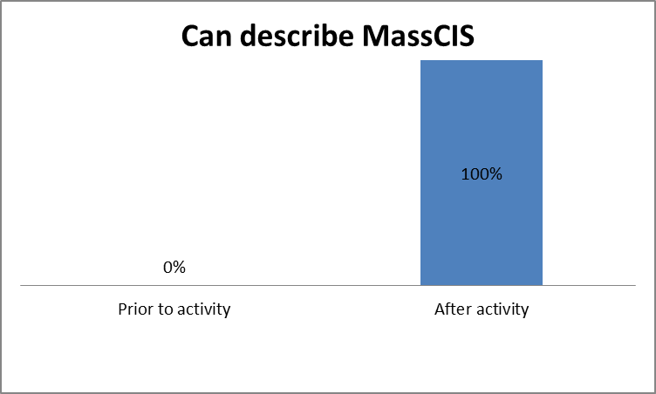
Prior to the lesson, 0% of students could describe what MassCIS is, while 100% were able to describe MassCIS and had developed a career portfolio.

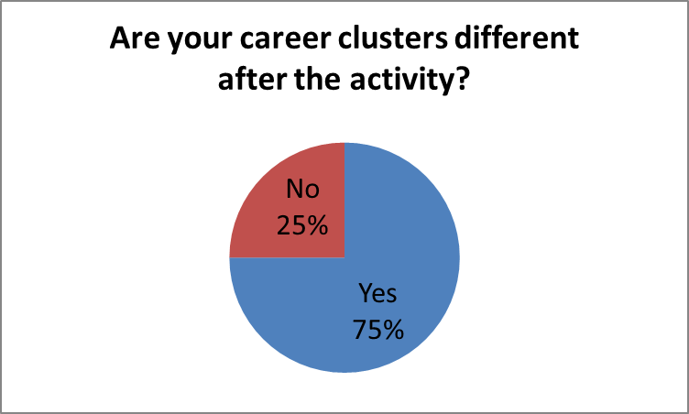
Most students’ (75%) career clusters that they chose prior to the activity differed from their top career clusters as a result of their completion of the MassCIS Career Cluster Inventory.

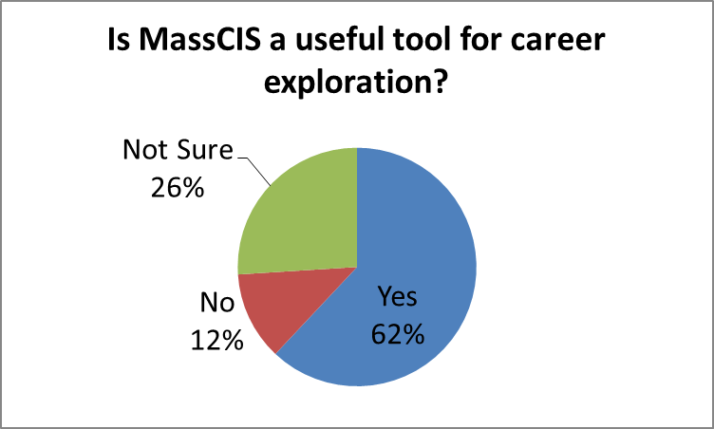
More than half of the students indicated that MassCIS is a useful tool for career exploration.

Focus for Improvement
Data supports the success of the career pilot program for Gr. 7. Future plans include continuing implementing the pilot career initiative in Grade 7 and develop/deliver career curriculum into Grade 8.

In addition, one of the items included in the school improvement plan for Great Falls Middle School is to “increase parent and community engagement in GFMS.” This is also a district-wide goal. To be in alignment, the school counseling program has targeted increased parent and community engagement as a department goal and area for improvement.
Currently, parents are engaged through the 504 process, during a student crisis, parent conference, phone and email contacts, scheduling, transitions, and at open house. They are informed with website postings and information sent home from school. However, there could be more opportunities presented by the school counseling department for parents to become involved, aware of, and participants in programs within the school. The GFMS and TFHS school counseling department agrees to the following:

- Update the guidance webpage at least 4 times a year on the school district’s website as well as whenever there is an announcement of upcoming events.
- Establish an annual orientation program prior to the start of school for families of students entering GFMS for the first time.
- Distribute a survey every other year to parents/guardians regarding the needs of the school and the priorities of the school counseling program.

School Counseling Mission Statement

Great Falls Middle School &

Turners Falls High School
The School Counseling Program’s shared mission is to deliver a comprehensive program to ALL students that promotes lifelong learning and active citizenship for grades 6-12. In partnership with the school and greater community, we provide a safe and supportive environment for students to discover their interests, pursue their goals, succeed academically, explore postsecondary options, and develop and improve their interpersonal and workplace readiness skills.

School Counseling Team

The middle school guidance counselor works closely with teachers, administrators, paraprofessionals, nurses, high school guidance counselors, parents and outside agencies to meet the academic, career and personal-social needs of 6th, 7th and 8th grade students. Additionally, there is ongoing collaboration with other members of the Student Support Team:

Emily Krems, M.Ed./CAGS | School Guidance Counselor
Kathryn Hayden, MSW | School Adjustment Counselor
Andrea Leydon, LICSW | School Adjustment Counselor
David Pino, Ed.D. | School Psychologist
Anne Mastrototaro, RN,  BN, NCSN | School Nurse

