Massachusetts Accountability Report Card
A continuous improvement document for school counseling outcomes
M.A.R.C. Jr.
2013-2014 School Year

West Boylston Middle/High School
125 Crescent Street, West Boylston, MA 01583
508-835-4475; Fax: 508-835-3925
www.wbschools.com
DISTRICT: West Boylston
GRADE LEVELS: 6-12 ENROLLMENT: 520
SCHOOL YEAR: traditional
PRINCIPAL: Larry Murphy

Principal’s Comments

The implementation of the Massachusetts Model for School Counseling Programs helps teachers and counselors better support the students at West Boylston Middle/High School.

I truly support all the work that the counselors do here at West Boylston. They are often the lifeline of the school and help during all times of need. From the many one-on-one counseling sessions to the guidance seminars in the classrooms, the students benefit vastly from the counseling department at West Boylston.
Larry Murphy, Principal

Student Results

I presented a lesson on stress to the seventh grade classes at West Boylston Middle School. The lesson was presented once to each class, where each student took a pre and posttest. The main goal of this lesson was to address the issue of increased stressed at the middle school level. I wanted to provide the students tools in recognizing their stress levels and what they can do to decrease those levels. As part of the West Boylston Middle School health and guidance curriculum, this lesson was taught with the help of the middle school health teacher allowing us the use of the class time. The goal of the lesson was to allow students to have a forum to discuss their stress in an open forum with feedback from guidance counselors.

I was working to address the following CDE Benchmarks with my lesson plan:
- Academic-Technical Development: A2-3: Organizational skills for career and life management
- Workplace readiness: W4-3: Skills in managing competing life roles at home, school, work and in the community
- Personal/Social Development: PS2-4: Knowledge of how positive behaviors and attitudes contribute to educational achievement and workplace success
- Personal/Social Development: PS3-1: Knowledge and skills for maintaining personal and psychological well-being

Based on the pretest I gave all the classes, 90% of the students were able to correctly define what stress is on the pre-test. Graph 1: Define Stress (Pre-test)
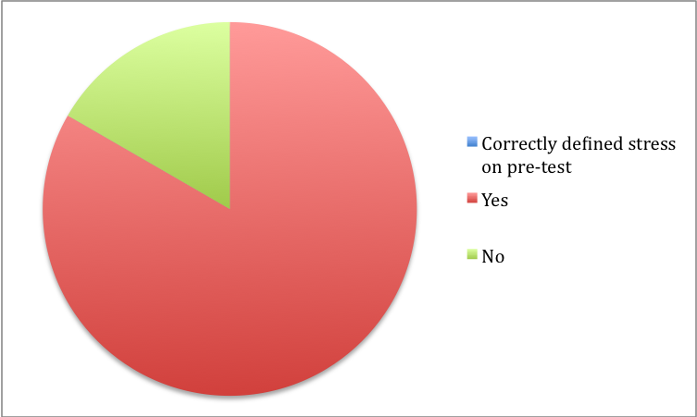

After the lesson was complete, on the post-test 100% of the students were able to define stress correctly. Based on the pretest, most of the students reported feeling the most stress when it came to school. During the lesson they reported feeling stressed about tests/quizzes, homework, teachers expectations, and long-term projects. Graph 2: What areas of your life cause the most stress?

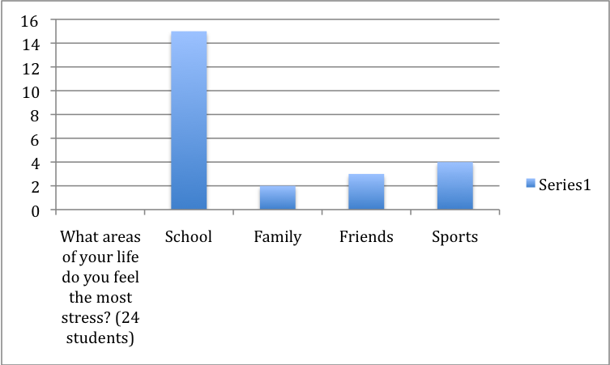
The students reported the following bodily and emotional reactions to stress. Graph 3:How does your body react to stress?
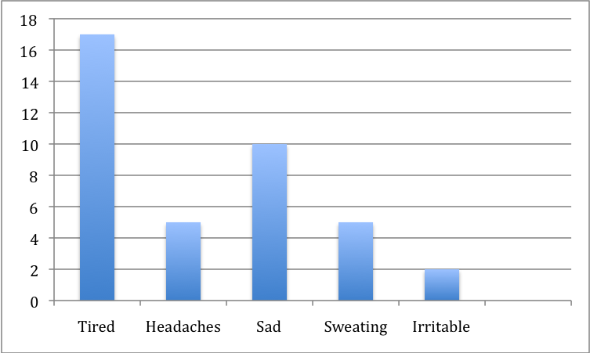

Focus for Improvement

The main issue causing stress for the students was that there just didn’t seem to be enough time in the day to do everything that needed to be done.

Based on the data gathered, it became clear that if students were able to learn organizational skills, they were able to feel less stressed at school.
An organizational skills and time management lesson plan have been added to the sixth grade guidance seminar’s to help with these issues. The middle school teachers here at West Boylston, are excellent at building a strong foundation of study skills and organizational skills for all students. There is a referral process that if there is a concern about these skills, the student comes to guidance for some extra support. The guidance counselor would work one-on-one with the student to help them improve their organizational skills by giving them some tips. Also, at the beginning of every school year a stress, time management and study skills seminar will be taught as part of the seventh and eighth grade guidance seminars.

Student Support Personnel Team

The mission statement of the School Counseling department is: “The Guidance Department understands, appreciates and respects each student’s uniqueness. The comprehensive developmental counseling and guidance model aims to assist all students in achieving their full potential in three broad areas of student development: academic, personal, social/emotional and career awareness.”

At West Boylston Middle/High School the student support personnel team consists of one middle school guidance counselors, two high school guidance counselors, and a school physiologist.

Staff name | Position | Certification
Rebecca Spencer | Middle school Guidance | M.S., CAGS
Todd Salmonsen | High School Guidance Counselor | M.S., CAGS
Kristen Tokarz | High School Guidance Counselor | M.S.
Holly Brockmire | School Physiologist | M.S.
Christine Lanotte | Guidance Secretary

