Massachusetts Accountability Report Card
A continuous improvement document for school counseling outcomes
M.A.R.C. Jr.
2013-2014 School Year

Hoosac Valley Middle and High School
125 Savoy Road, Cheshire, MA 01225
T. 413-743-5200 F. 413-743-8412 www.acrsd.net
Adams-Cheshire Regional School District
Grades 6,7,8 ENROLLMENT: 333
SCHOOL YEAR: year-round
PRINCIPAL: Mr. Vinnie Regan

Principal’s Comments
The Adams-Cheshire Regional School District (ACRSD) is committed to and fully supports the implementation of the Mass Model. The School Counselors work to provide a comprehensive and developmental school counseling program of services that promote the academic, social/emotional, and career potential of all students. Through counseling, advocacy, advising, collaboration, leadership, and systemic change, counselors assist students to achieve personal excellence, to become life-long learners and to be responsible community members.
The Administrative Team at ACRSD depends on and consults with our School Counselors in regards to academic, social-emotional, and behavioral support and interventions. School Counselors are in integral part of our school community support system. In the past two years, our counselors have developed several lesson plans focusing on Elementary to Middle School, Middle to High School, and High School to College transition planning. The lesson plans will help students feel more empowered and prepared to make educated decisions in their future life planning in regards to academic and workforce goals, ultimately leading to more empowered and educated community members.
Vinnie Regan, Principal

Student Results
As part of the high school transition program, the middle school counselor annually presents lessons to all 8th grade students relating to course selection, available electives, the registration process and basic high school awareness.
The pre-test and post test data presents evidence about the impact of this 8th grade transition advising program by assessing each student’s high school knowledge and awareness of the course selection process.
The lesson objectives in relation to the MA Career Development Education (CDE) benchmarks addressed:
- W1-1 Skills in the planning process
- W1-3 Skills and strategies for effective decision-making
- PS1-2 Skills in relating individual learning styles, interests, values and aptitudes to one’s concept of self
- PS1-3 Attitudes and skills, personal responsibility and self-determination
- PS2-4 Knowledge of how positive behaviors and attitudes contribute to educational achievement and workplace success
- PS4-1 Knowledge and skills that promote participation, positive behavior and regard within diverse groups
Graph 1: Was the presentation helpful?
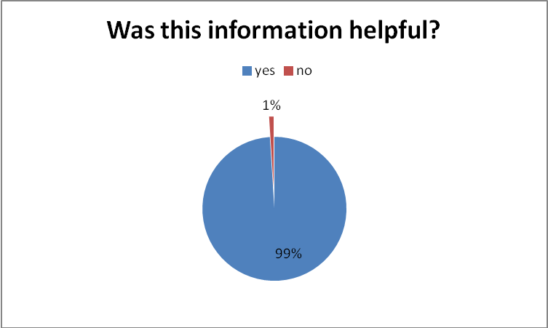
99% of the students reported the transition program was helpful.

Graph 2: Assessment of Student Learning

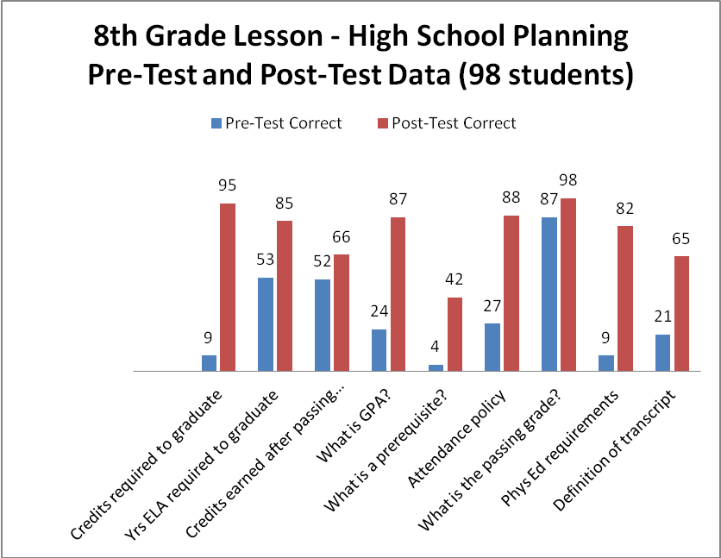

Focus for Improvement

Student Support Personnel Team

After several years of having no School Counselor or full-time School Adjustment Counselor, in 2012-13 a Middle School Counselor position was added. As a result, needs of the middle school students are continually being assessed, and lesson plans are being developed, based on identified needs.
An example is this HS transition awareness lesson. Pre and post-test results data indicate that students need to be given this information earlier than 8th grade. In response, curriculum is being designed for 6th and 7th grades to expand the HS transition program.
This year, professional development of the ACRSD School Counselors included reviewing and developing:
- ACRSD school counseling mission statement,
- ACRSD school counseling vision statement,
- ACRSD school counseling calendar,
- Delivering standards based lesson plans
- Gathering and assessing student learning data
- Development of SMART goals,
- Attended both MASCA conferences and presenting a MA Model Implementation Poster Session
- Compiled a MA Accountability Report Card (MARC Jr.)
- Successfully completing the MA Model Institute.
The vision of the Adams-Cheshire Regional School District: “Achieving personal excellence while becoming life-long learners and responsible community members.”
The mission of the Adams-Cheshire Regional School District Counseling department: To provide a comprehensive and developmental school counseling program of services that promote the academic, social/emotional, and career potential of all students. Through counseling, advocacy, advising, collaboration, leadership, and systemic change, counselors assist students to achieve personal excellence, to become life-long learners and to be responsible community members.
School Counseling Staff

*Ms. Megan Scott, High School Guidance Counselor (A-K)
*Mrs. Loriann Moro, High School Guidance Counselor (L-Z)
*Mr. Jeffrey Hine, High School Adjustment Counselor
*Mrs. Shannon Clark, Middle School Adjustment and Guidance Counselor
*Mrs. Nicole Seyerlein, Elementary School Adjustment Counselor
*Mrs. Mary Butler, Middle and High School Counseling Secretary

