Massachusetts Accountability Report Card
A continuous improvement document for school counseling outcomes
M.A.R.C. Jr.
2012-13 School Year

Leominster High School
122 Granite Street, Leominster, MA 01453
Phone: (978) 534-7715 Fax: (978) 534-7738
www.leominster.mec.edu
DISTRICT: Leominster
GRADE LEVELS: 9 - 12 ENROLLMENT: 1812
SCHOOL YEAR: traditional
PRINCIPAL: Thomas Browne

Principal’s Comments
As Luann Burke, an accomplished member of our faculty, continues to work towards her licensure in school counseling, I wanted to take a moment to offer my support for her efforts as well as the overall implementation of the Massachusetts Model for School Counseling Programs. While Mrs. Burke’s experience as a school nurse has certainly provided her with the foundational skills that allow her to identify and support a variety of student and family needs, the formal training that she is receiving through the Massachusetts Model program will allow her to fully address not only social and emotional needs, but academic needs as well. Leominster High School has a student body well over 1800 students so it is not surprising that our student counseling needs are diverse. It is essential that candidates, like Mrs. Burke, receive the proper training so that they are prepared to address the obstacles that threaten our student’s achievement.
Thomas Browne, Principal

Student Results
School data, height, weight and BMI (Basal Metabolic Index), was utilized that demonstrated needs of some students. This counseling one-on-one program was to provide students with information about a healthy lifestyle that can be beneficial to them now and in the future – lifelong learning. The counseling program was also intended to promote a positive self-image.
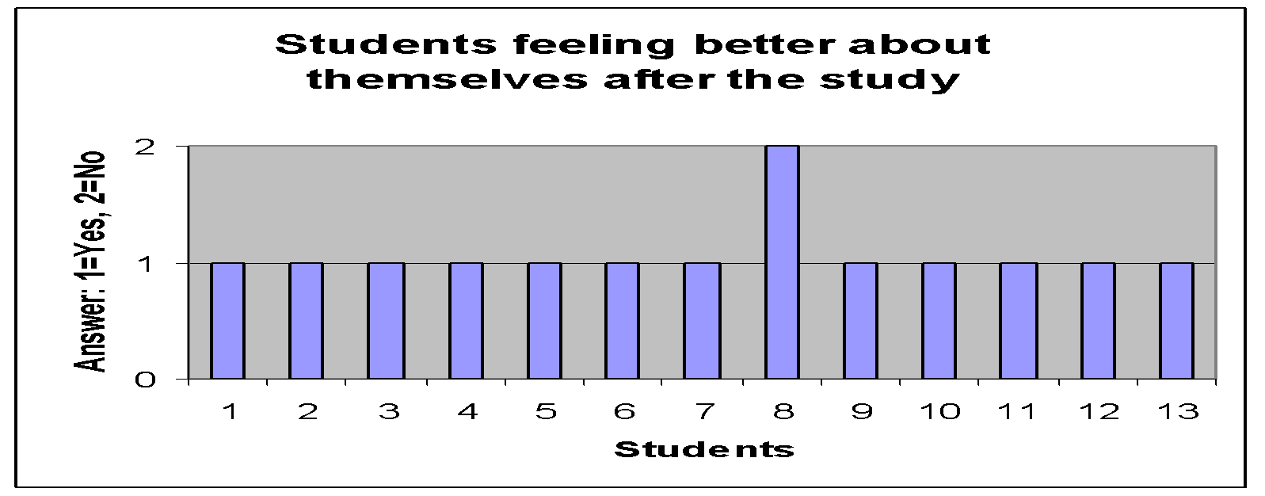
Thirteen overweight students met with the school counselor intern twelve times over a 20 week period. The intern provided information and counseling on different topics related to healthy eating and physical activity. A student’s baseline weight was established prior to the first meeting. The students were then weighed at each meeting and their GPA was noted at the end of the first, second and third terms of school. The students also answered an anonymous survey asking them four questions.

Graph #1: “ Being involved in this research study, did you learn anything about eating healthier and increasing your physical activity?” “Yes” = 1; “No” = 2.

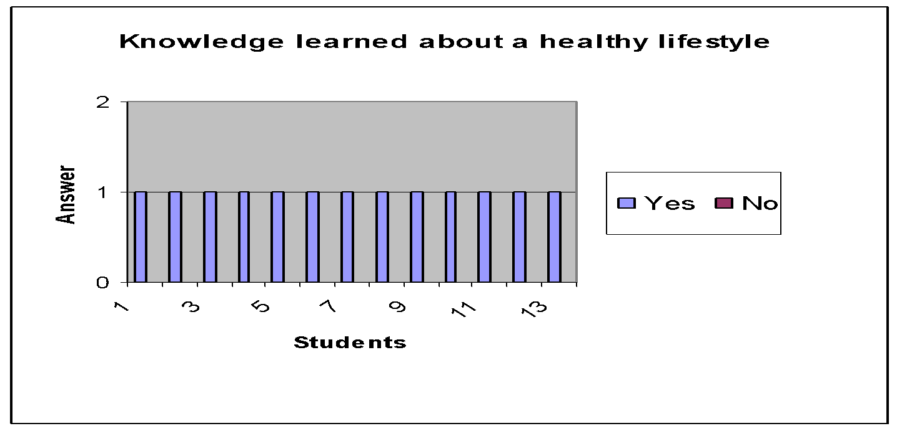

Graph #2: “Being involved in this research study, how much did you learn about healthier eating and increasing your physical activity?” Likert Scale: 0 - 5, with 0 = not much at all; 5 = an enormous amount

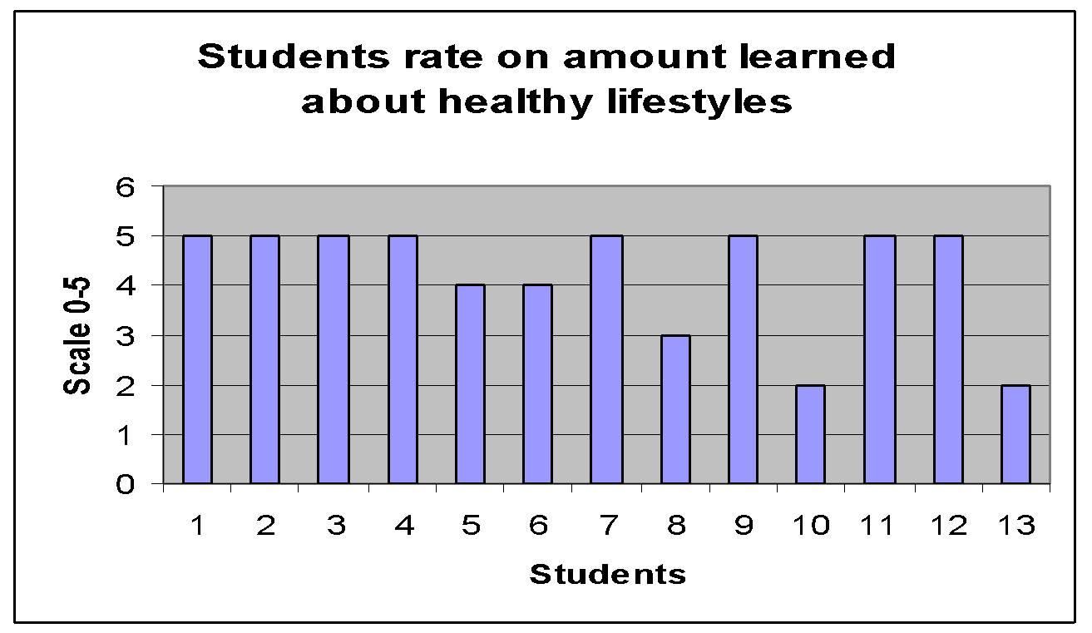

Graph #3 ‘Being involved in this research study, are you
feeling better about yourself now than before this study began?” “Yes” = 1; “No” = 2. 12/13 students respond yes.
“Graph 4: “ How much are you feeling better about yourself?” Likert Scale: 0 to 5, with 0 = not much at all;
5 = an enormous amount.
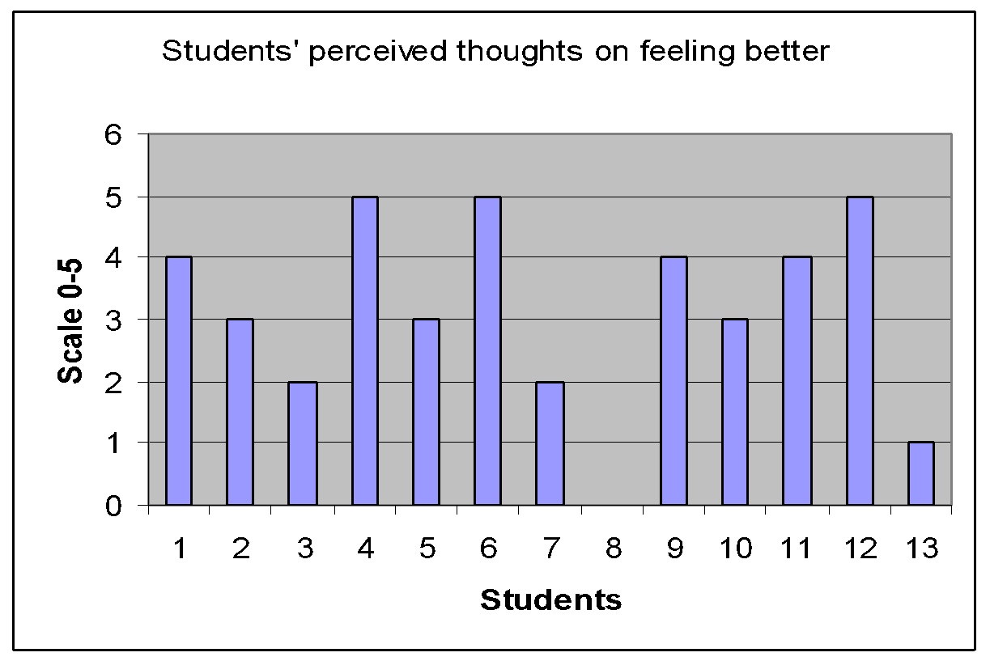

Chart #1 : GPA at the end of term 1, 2 and 3. Student in alternative education program - no GPA provided.
Student | Term 1 GPA | Term 2 GPA | Term 3 GPA
1 | 2.59 | 3.29 | 3.57
2 | 2.26 | 1.73 | 2.66
3 | 3.30 | 3.07 | 2.59
4 | 2.73 | 3.27 | 2.83
5 | 2.66 | 1.87 | 3.55
6 | 2.65 | 2.38 | 2.33
7 | 2.71 | 2.83 | 2.57
8 | 3.78 | 3.81 | 3.49
9 | 1.55 | .95 | 1.34
10 | 3.23 | 3.44 | 3.11
11 | 2.69 | 2.09 | 2.89
12 | Alt.Ed. | Alt. Ed. | Alt. Ed.
13 | 3.61 | 2.88 | 3.38

Graph #5 – Weight gain or loss
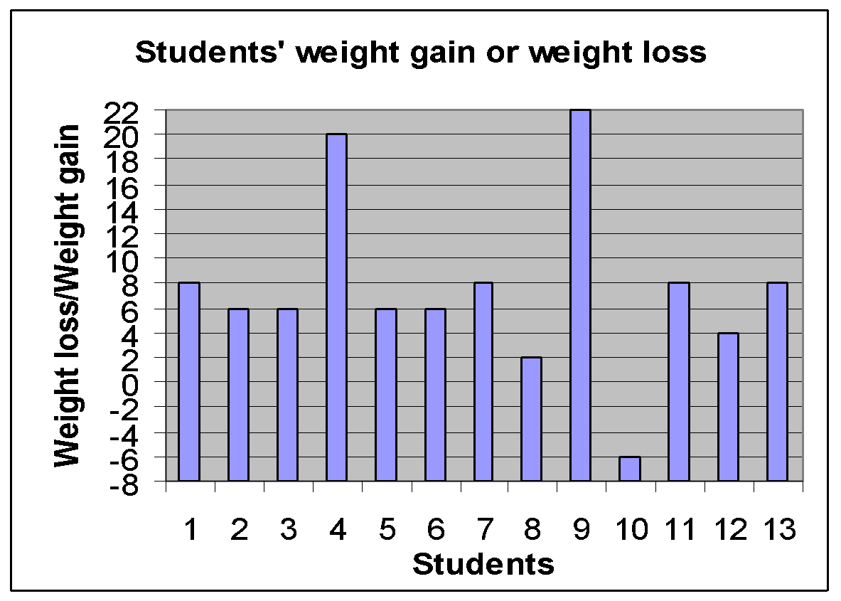

Focus for Improvement
School guidance counselors will be aware of student health and wellness and provide counseling to those students who demonstrate unhealthy eating and lack of physical activity. Counselors will be aware that promoting one’s physical health can also contribute to promoting one’s mental health.
As evidenced from the surveys, most students (11 out

of 13) felt that they learned a good to enormous amount about
eating healthier and increasing their physical activity. But
with the data on weight loss and weight gain, students were not following through with what they were learning. Almost all students (12 out of 13) gained weight (from 2 to 22 lbs. with an average gain of 8.7 lbs.) over the course of the counseling program. Only one student lost weight (6 lbs.). The data from the surveys also shows that most students (9 out of 13) were feeling better about themselves after the counseling program than before it began. Three students were not feeling that much better about themselves and one student was not feeling better at all.
Health promotion needs to be a priority and the guidance staff can improve on addressing this need. From the data, school counselors need to spend quality time counseling students so that they know that someone cares about their physical and mental health. School counselors can improve on promoting physical and mental health by giving lesson plans on health promotion to individuals or groups of students.

Student Support Personnel Team
School guidance counselors at Leominster High School are continually collaborating with school social workers, school nurses and other colleagues and team members when appropriate. They are able to do this either in person, by telephone, by email or when they meet during Student Assistance Team (SAT) meetings when all school support personnel are present. The school guidance counselors are continually evaluating the school curriculum and school counseling program to meet the needs of all students. New mathematics courses are being introduced into the curriculum in the next school year to help students to improve their performance on college placement exams. The school counselors have developed a timeline for what needs to be done each month of the school year so that all counselors are coordinating and implementing the same tasks with each grade level and at the same time. Starting in the 2013-2014 school year, school counselors will have each freshman student define three SMART goals: a career goal, educational goal and personal goal.

Name | Position | Education | Experience
Paula Bolger | Guidance Dept. Head | Masters/CAGS in Counseling; | 9 yrs.
Mary Bilotta Blackman | Guidance Counselor | Masters in Counseling | 11 yrs.
Diane Cameron | Guidance Counselor | Masters in Counseling | 10 yrs.
Dayana Carlson | Guidance Counselor | Masters in Counseling | 9 yrs.
Steven Dubzinski | Guidance Counselor | Masters in Counseling | 10 yrs.
Diana Marchand | Guidance Counselor | Masters in Counseling | 3 yrs.
Megan McGowan | Guidance Counselor | Masters in Counseling | 2 yrs.
Pamela Carey | Adjustment  Counselor | Masters in Social Work | 12 yrs.
Sandra Trippi-Leroux | Adjustment  Counselor | Masters in Social Work | 12 yrs.
Kathleen Holmes | School Psychologist | Doctorate in Psychology | 15 yrs
Mary Brow | School Nurse | Bachelors in Nursing | 18 yrs.
Luann Burke | School Nurse | Bachelors in Nursing | 13 yrs

