School Counseling Curriculum
UNIT: Career Exploration  Title/Topic of Lesson: MassCIS Portfolio Creation and Career Cluster Inventory  Grade Level: 7th Grade  Time Needed: 45 Minutes  FOCUS QUESTIONS:  - Will 7th grade students be able to explain what MassCIS is?  - After completing the Career Cluster Inventory, can students identify changes in their career clusters of interest?  - Will students find MassCIS to be a useful career exploration tool? | MATERIALS NEEDED:  - Computer access for each student  - Printer access  - Whiteboard  - Pre-assessment  - Post-assessment  - Student login information (access login and student-specific login)
CURRICULUM LINKS
Common Core Standards:
CCSS.ELA-LITERACY.SL.7.4
CCSS.ELA-LITERACY.SL.7.1.B
CCSS.ELA-LITERACY.CCRA.L.6
- MA Curriculum Frameworks:
Science and Technology Engineering Guiding Principle linked to W1-3
ELA Composition General Standard linked to W2-2
Mathematics Core Concepts linked to W1-3 and W1-6
- MA CDE Benchmarks:
Academic-Technical Development A1-3, A2-5
Workplace Readiness Development W1-3, W1-5, W2-2, W2-3
Personal/Social Development PS1-2
ASCA National Standards:
Please identify ASCA Mindsets and Behaviors
GFMS/TFHS School Counseling Mission: The School Counseling Program’s shared mission is to deliver a comprehensive program to ALL students that promotes lifelong learning and active citizenship for grades 6-12. In partnership with the school and greater community, we provide a safe and supportive environment for students to discover their interests, pursue their goals, succeed academically, explore postsecondary options, and develop and improve their interpersonal and workplace readiness skills.

PLANNING REFLECTION:
- I am teaching an attitude shift in that students might have pre-conceived ideas of career clusters that they would like but may be presented with new ones upon completing the activity that they hadn’t considered before. Skills taught are how to create an online portfolio and how to access career information online. Students gain knowledge of a useful tool for career exploration and planning.
- Prior to the lesson it is necessary to have baseline data of whether students know what MassCIS is and whether they already have an idea of the careers they are interested in (to evaluate whether they have an attitude shift). These are asked in the pre-assessment and activator.
- Pre/post assessment will be the evaluative tool.
- Student learning will be assessed upon reviewing the pre/post assessment.
COUNSELOR/TEACHER PERFORMANCE OBJECTIVES
- Provide a pre/post assessment
- Facilitate a discussion about the purpose of career exploration in middle school
- Assist students in creating an online career portfolio
- Provide instructions for completing the Career Cluster Inventory
- Instruct students to browse various occupations within MassCIS
STUDENT PERFORMANCE OBJECTIVES
Cognitive: As a result of the lesson, the students will:  - Identify 2 career clusters that link to their interests | Affective: As a result of the lesson, the students will:  - Recognize whether their career clusters have changed as a result of completing the MassCIS activities  - Find value in working on the MassCIS website | Behavioral/Performance: As a result of the lesson, the students will:  - Create an online career portfolio  - Complete the Career Cluster Inventory  - Complete the pre/post assessment  - Describe the MassCIS tool
PRE-ASSESSMENT  Attached |  | POST-ASSESSMENT  Attached
DESCRIPTION OF THE ACTIVITY/SEQUENCE OF THE LESSON
- Activators:
Question: “Raise your hand if you know what career you would like to pursue in your life.” Then, “Does anyone want to share what career(s) they are considering?”
Question: “Why do you think that you we are doing career-related activities with you in 7th grade instead of waiting until you’re in high school?”
- Pre-Assessment
- Explanation of MassCIS Tools
  - Explain that MassCIS is the career awareness/exploration website and that on that site the students will be creating an online career portfolio that will be used throughout middle school and at TFHS (for those attending TFHS)
  - Explain that MassCIS has lots of tools for exploring careers and finding out what it takes to pursue a career, expected salary, projected growth, and more.
- Creation of Online Portfolio (show these steps on the projected screen)
  - Students log onto computers and go to the website www.masscis.intocareers.org
  - Students enter the username and password provided to them (all use the same to be linked to the GFMS/TFHS cohort) – put these on the whiteboard or projector
  - Students click on “Create My MassCIS Portfolio” and on the next page again they click on “Create My MassCIS Portfolio”
  - Pass out the usernames and passwords for each student while students fill out all the portfolio fields, making sure that at this point students use their unique usernames and passwords
  - Students click “yes” on next screen for school counselors to see portfolios, then “submit”
- Career Cluster Inventory
  - Under Assessments, students click on Career Cluster Inventory
  - Students answer the 80 questions
  - Once finished, students print out their results to take with them and browse careers by clicking on links
- Post-Assessment
  - Students complete the post assessment using their Career Cluster Inventory results
- Discussion Questions
  - Was anyone surprised by any of the top career clusters in your results? (ask a student to explain what surprised them)
  - Are there career clusters that you hadn’t thought about for yourselves that came up in one of the top 3 slots that you will begin to think about?
MODIFICATIONS FOR DIFFERENTLY ABLED STUDENTS:  I have discussed the requirements of this lesson with the ELL teacher in the school. If needed, a translation could be provided for the Spanish-speaking students. The ELL teacher will co-teach the lesson with me for the ELL students. There is always an additional teacher in the room for this lesson so he/she can read portions aloud to students requiring that assistance. | LEARNING STYLES ADDRESSED:  Learning styles addressed are visual (computer screen and projector), auditory (explanation of MassCIS, instructions spoken).
Data Analysis and Summary:
I had planned to include activity questions within this lesson, but when I piloted it I realized that there was not enough time for a discussion about results, and I believe that the discussion is crucial for 7th graders to process what they are being presented with and appreciate this website as a useful career exploration tool. So I decided to remove the activity section from the post assessment and instead will present the activity portion as part of the 8th grade career lesson.

The following are the 3 main questions and their results: (see attached data charts)
- Can students describe MassCIS?
  - 0% of students could describe MassCIS prior to the lesson
  - 100% of students could describe MassCIS after the lesson
- Did the results from the Career Cluster Inventory show different career clusters than their own answers in the pre-assessment?
  - The Inventory results for 75% of students were different than the careers clusters they chose for themselves
  - The Inventory results for 25% of students were similar to the career clusters they chose for themselves
- Do students find MassCIS to be a useful career exploration tool?
  - 62% of students say YES it is a useful tool
  - 12% of students say NO it is not a useful tool
  - 26% of students say they are UNSURE whether it is a useful tool
REFLECTION:  All students were engaged in the career lesson and answered all of the pre and post assessment questions. All of the students were able to describe what MassCIS is and nearly two thirds found the tool to be useful for career exploration.  For the future, I will keep the lesson simple, so I will not be including an additional activity. I may add more discussion questions to the lesson. | RESOURCES  Massachusetts Career Information System (MassCIS)  www.masscis.intocareers.org
SUPPLEMENTAL MATERIAL: Attached

The total number of 7th grade students who received the career lesson was 76. Results data is as follows:

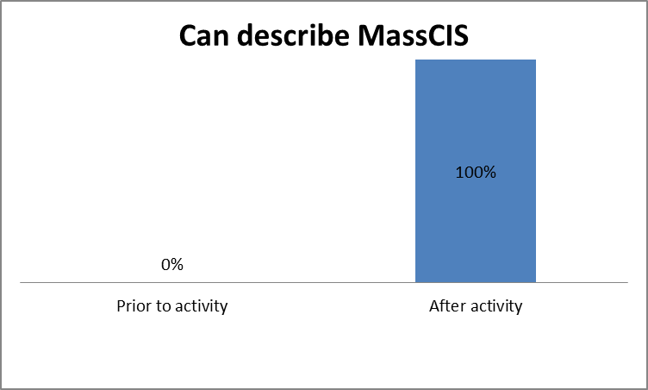
Prior to the lesson, 0% of students could describe what MassCIS is, while 100% were able to describe MassCIS and had developed a career portfolio.

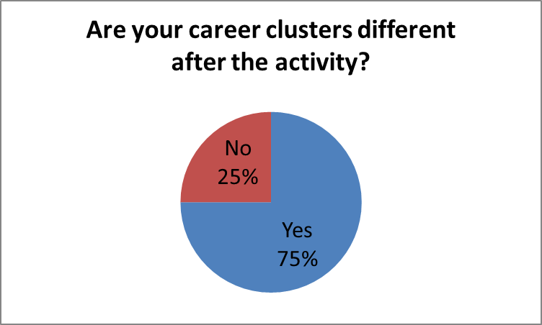
Most students’ (75%) career clusters that they chose prior to the activity differed from their top career clusters as a result of their completion of the MassCIS Career Cluster Inventory.

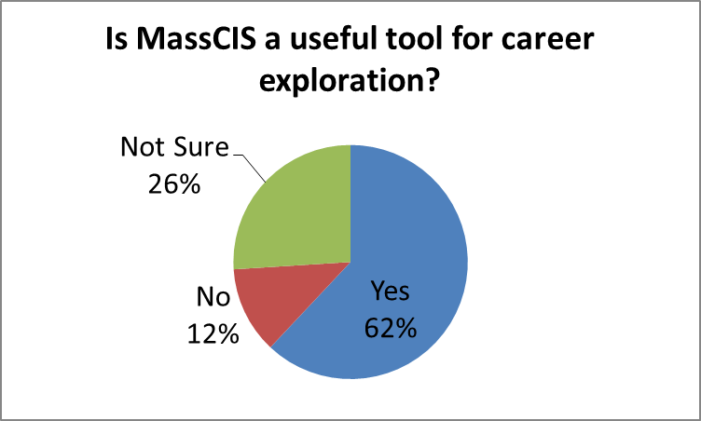
More than half of the students indicated that MassCIS is a useful tool for career exploration

======================================================================

Name: _________________________________ 7th Grade

PRE-ASSESSMENT
- What is MassCIS? ____________________________________________________________
- List 2 career clusters that match your interests:
  - __________________________________________
  - __________________________________________
POST ASSESSMENT
- What is MassCIS? ____________________________________________________________
- Look at your results from the Career Cluster Inventory. List the top 2 career clusters that match your interests:
  - __________________________________________
  - __________________________________________
- Look at question #2 that you answered before the activity. Are your career clusters different after completing the Career Cluster Inventory? YES NO

- Is MassCIS a useful tool for career exploration? YES NO NOT SURE

