Liza Tierney●Groton-Dunstable Regional High School●meminnelli@hotmail.com

Lesson#: 1 of 2 Topic: Introduction to NAVIANCE Grade Level: 11 (1st half of year)
Time needed: 1 class period

Focus Questions: What is Naviance? How can it be used as search tool for a student’s post high school plan?
Materials Needed:
- Pre-Survey & Post-Survey
- Computer
- Access to NAVIANCE (codes for students)

Curriculum Links:
MA Curriculum Frameworks:
ELA Composition General Standard: Gather information from a variety of sources, analyze and evaluate the quality of the information obtained, and use it to answer their own questions.
ELA Guiding Principles: Strategies necessary for acquiring academic knowledge, achieving common academic standards, and attaining independence in learning.
Mathematics Guiding Principle: Technology is an essential tool in education.
Mathematics Core Concepts: (1) Formulate questions that can be addressed with data and collect, organize, and display relevant data to answer them; (2) develop and evaluate inferences and predictions based on data.
Science and Technology Engineering Guiding Principle: Address students’ prior knowledge and misconceptions (i.e., to challenge inaccurate beliefs and redirect student learning along more productive routes.)
Health Guiding Principle: Use fundamental health concepts to assess risks, to consider potential consequences, and to make health-enhancing decisions.

MA CDE Benchmarks:
A1-2: Technical and technological skills (e.g. blueprint reading and computer software management)
A2-3: Organizational skills for career and life management
A2-4: Critical thinking skills to use and evaluate information
A2-5: Technical literacy for career and life management
W-1: Knowledge and skills in the planning and decision-making process
W-2: An exploratory attitude toward self, life and the world of work
W-3: Workplace specific knowledge and skills for employability and career advancement
PS-1: Attitudes, behaviors, knowledge and skills that promote identity formation, personal responsibility and self-direction

National: ASCA Performance Standards:
A:B2.2: Use Assessment results in educational planning
A:B2.27: Identify post-secondary options consistence with interest, achievement, aptitude and abilities
C:A1.1: Develop skills to locate, evaluate, and interpret career information
C:A1.3: Develop an awareness of personal abilities, skills, interest and motivations
C:B1.2: Identify personal skills, interests and abilities and relate them to current career choice
C:B1.5: Use research and information resources to obtain career information
C:B1.6: Learn to use the Internet to access career-planning information

District/School Links:
Having recognition of and being able to utilize Naviance, a program the district took time to implement for students to further their post high school plans
The district’s post high school statistics

Teacher Performance Objectives:
During the lesson, the teacher or guidance counselor will be able to explain what Naviance is and why it is a useful tool for students during the search process of their post high school plan. The instructor will be able to guide students through Naviance’s exploratory section, so that they may better understand searches, quizzes, and information the program has to offer them. The instructor will also assist in one-on-one support in a student’s exploration of the Naviance program.

Student Performance Objectives:
Cognitive: By the end of the lesson, the students will know what Naviance is and what tools it has to offer them in terms of their post high school plan.
Affective: By the end of the lesson, the students will be able to understand the importance of NAVIANCE and how it can help them in their post high school planning.
Behavioral: By the end of the lesson, the students will be able to log into Naviance and maneuver around the site so that they may search college information, career information, and personality search tools. – List 3 tools Naviance has to offer in post high school planning.

Modifications for Students with Disabilities:
Students in need of additional support may be given more time for using the computer and the Naviance site. They may also receive one-on-one support. English language learners in need of additional support may also benefit from having more time, an interpreter and/or having one-on-one support.

Pre-Assessment:
Prior to any instruction, a pre-survey will be given to all students regarding their knowledge of Naviance and their post high school planning. This assessment will guide the instructor with what the students’ prior knowledge of the topic.

Activity Description:
Opener: In the beginning there will be a discussion regarding what the students think Naviance is. Information will be given regarding what Naviance is and why it was created for students in high school. Following this discussion, each student will log onto the computer, and access the Family Connection website assigned to the school district. Each student will create an account using the unique access code assigned to them. They will all continue with the login process, which requires the students to enter their email address and create their own password. Continuing with the login process, each student will read the privacy policies Naviance has created and confirm their agreement with the policies. Finally, during the login process, each student will be given the opportunity to link their Common Application Account with their Naviance account. Should a student not have a Common Application Account yet, this part of the login may be skipped over until a later time. (Most students will eventually have a Common Application account when applying to schools, but for now this step is not essential to login into Naviance.

Guided Instruction: Once all students have successfully logged in, the instructor may give an overview of all the different components Naviance has to offer regarding searching for a plan. Students will be directed to know about the personality quizzes and tests for students who don’t know what they want to do for a career or plan after high school. The students will learn about the career clusters and in-depth job descriptions for students looking to explore certain career paths already. Finally there will be instruction on the website’s college search tools, for students looking to explore their college options. Moving to an individual teaching method, each student will have the opportunity to share with the instructor what their current post high school plan is. Depending on the students’ needs and wants, the instructor can give advice as to which piece of Naviance is best suited for their search at this time. The instructor will walk around the class and guide, help and instruct students as they venture off into different search regions of the website.
Closure: Following all instruction and navigating through the website, each student will be asked to log out of the site and keep track of their own log in information they created earlier. They will then fill out a post survey regarding information they may have learned from the instructions.

Assessment:
A post survey (see attached) will be given to assess what the students learned regarding Naviance and using it as a search tool.

Discussion:
Students were asked in the pre-survey to list three tools that Naviance offers for post high school planning. Only 20 out of the 130 students were able to successfully do so. Following the lesson, 110 answered the same question and were able to successfully list three tools. This shows the lesson was effective in having students learn what Naviance has to offer them in terms of their post high school planning. (See attached data – graph)
Students also reported (95%) on the post survey that they found this lesson helpful, showing that getting students involved before senior year helps them as well as engages them.

Reflection:
The data shows that Naviance can be an effective tool for post high school planning and into the future; a long-term goal is to get sophomores using the same search and planning tools so the knowledge can begin even earlier than junior year.
Future plans to consider is to make the lessons part of the curriculum in sophomore/juniors course giving students more time on the program and to gain more knowledge and resources. This would give the teachers more knowledge of the program as well.
Another future thought to consider could be to get parents/families more involved with the program. Considering the data, 108 of the 120 students went to their parents/families for information on their post high school planning, it seems logical to have everyone on board on such a helpful tool.

Resources:
Students access Naviance webpage - https://connection.naviance.com/family-connection/auth/login/?hsid=grotondr
Pre & Post surveys

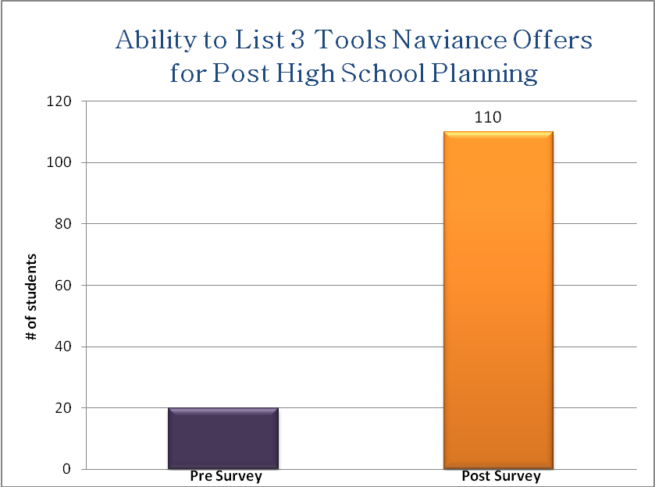

Pre-Survey

1. Have you used Naviance before today? Please circle: Yes No
If yes, what have you done on the site?

2. Can you list 3 tools Naviance has to offer to help with post high school planning?
1.____________________________________________________

2.____________________________________________________

3.____________________________________________________

3. Have you begun planning for after high school? Please circle: Yes No

What resources have you used in college/career planning?
□ Parents/family member
□ Guidance counselor
□ Guidance secretary
□ Internet – college/university website
□ Internet – search engine
□ Other __________________
□ Haven’t done any – N/A

Post-Survey

1. What is Naviance?

2. Can you list 3 tools Naviance has to offer to help with post high school planning?
1.____________________________________________________________

2.____________________________________________________________

3.____________________________________________________________

3. Can you name one tool you used today that you feel has helped you with your post high school plans?

1.____________________________________________________________

4. Did you find this lesson helpful? Please circle: Yes No

