Tara M. Vavruska
March 18, 2012
taravavruska@gmail.com

WORKSHOP LESSON PLAN

ACTIVITY TITLE: Applying for Local Scholarships: After School Workshop
UNIT TOPIC: Senior Year College Preparation
GRADE LEVEL: 12TH
DURATION OF LESSON: 40 minutes
MATERIALS NEEDED: Computer lab, student login IDs and passwords for Naviance’s Family Connection, Pre-Assessment and Post-Assessment worksheets, and handouts.

CURRICULUM LINKS:
National: ASCA National Standards:
A:B2.4 Apply knowledge of aptitudes and interests to goal setting
A:B2:7 Identify post-secondary options consistent with interests, achievement, aptitude and abilities
C:B1.2 Identify personal skills, interests and abilities and relate them to current career choice
C:B1.6 Learn to use the Internet to access career-planning information
PS:A1.10 Identify personal strengths and assets

State: MA CDE Benchmarks:
Academic-Technical: A2-3: Organizational skills for career and life management.
Academic-Technical: A3-2: Skills in researching and evaluating economic and societal
information for career planning and career management.
Personal/Social: PS103: Attitudes and skills, personal responsibility and self-determination.

State: Curriculum Frameworks:
Technology: 3.4 Search for information within an electronic source.
Health: 12.14 Apply planning and management skills to organize tasks and responsibilities.
ELA: 23.14 Organize ideas for emphasis in a way that suits the purpose of the writer.

School Links:
Guidance Department Activities:
The Guidance Department helps students to: understand individual strengths, weakness, needs and attributes that are significant in achieving personal, social, career and academic goals.

STUDENT PERFOMANCE OBJECTIVES:
Cognitive:
- The students will be able to identify where to find local scholarships.
- The students will be able to assess and identify scholarships for which they are eligible.

Affective:
- The students will understand that they are eligible to apply for many scholarships.
- The students will be aware of several sources of scholarship information.
- The students will understand the importance of carefully completing applications, adherence to deadlines, attention to details, and proofreading.

Behavioral:
- The students will research and select scholarships for which they will apply.
- The students will apply for local scholarships.

TEACHER PERFORMANCE OBJECTIVES: The high school administration has asked the school counseling department to increase the number of students applying for local scholarships that are offered through the school. During the lesson, the counselor will help students identify where to find local scholarship and which ones they are eligible for. The counselor will encourage all students to apply for the local scholarships available through the high school in order to increase participation. The counselor will also identify tips and tricks for successful applications.

MODIFICATIONS: All student IEP and 504 modifications and accommodations will be implemented. Students who have difficulty with directions or navigating the computer application will receive individualized assistance from the counselor or a peer as needed. Deaf or ESL students will work with the support of an interpreter or aide as needed. Material will be given in both written and verbal formats to assist both auditory and visual learners. For example, students will be both told and shown where to locate the information and written materials will be reviewed verbally to assist with comprehension. Kinesthetic learners will benefit from the hands-on application of using the computer to access the information through the Family Connection software.

PRE-ASSESSMENT: Students will be given a Pre-Lesson Questionnaire

DESCRIPTION FO THE ACTIVITY/STRUCTURE OF THE LESSON:
Small group classroom instruction:
- Counselor will (CW) give Pre-Lesson Questionnaire.
- CW explain what “local” scholarships are.
- CW explain that local scholarships are those available and awarded through the high school.
- CW explain the basis for selection/eligibility factors and give examples of several, including residency, major/career interest, financial need, high academic achievement, depth of character, leadership, talent, sports achievement, entrepreneurial activity, volunteerism.
- CW give general instructions and tips for scholarship applications.
  - Suggested items: Read scholarship requirements carefully, make note of deadlines, answer all application questions, assemble all supporting documentation ahead of deadline. If an essay is required, it should address the question, adhere to length requirements, and be proofread for errors. A thank you note should follow if a scholarship is awarded.
- CW instruct student to log on to Naviance’s Family Connection http://connection.naviance.com/wbschools
- CW instruct how to navigate the scholarship section of the website.
- CW identify information categorized by selection/eligibility factors.
- CW direct students to select “local” category.
- Students will complete an exercise of selecting local scholarships for which they are eligible. Students will add scholarships to “my scholarship list” where they can be downloaded later.
- CW open up a question and answer session. Students will be allowed to linger and browse through the scholarships.
- CW give out Post-Lesson Questionnaire for student completion.

POST ASSESSMENT: Students will be given a Post-Lesson Questionnaire to evaluate their learning and gather feedback. . Students will be asked for feedback regarding whether the lesson was valuable and useful. Scholarship applications will be recorded. Rates will be analyzed and used to evaluate if student participation has increasedAt the end of the application cycle, the department will evaluate whether the lesson was productive.

WORKSHOP SUPPORT ACTIVITIES/EXTENSION: The information provided in the lesson is extended to all students (not just those who attended the workshop) and reinforced in several ways:
- The bulletin board posted outside the guidance office will reinforce the lesson by connecting the student to the information found on the Family Connection, as well as helpful tips for applying, the workshop information, selected scholarships, previous award information and other useful and pertinent scholarship information.
- Morning and afternoon announcements to the students will include selected lesson information (i.e. previous award amounts, deadline reminders) and new scholarship opportunities.
- Emails will be sent to students and parents with scholarship information and deadline reminders.
- The school counselors and support staff will answer individual student questions.

DATA: POST LESSON ASSESSMENT OF STUDENT PERFORMANCE OBJECTIVES.
Cognitive:
- 100% of students were able to identify where to find local scholarships.
- 100% of students were able to identify scholarships for which they are eligible.
- 100% of students were able to select scholarships they want to apply for after the workshop.

Affective:
- The students understood that they were eligible to apply for many scholarships.
- The students understood the importance of carefully completing applications, adherence to deadlines, attention to details, and proofreading.
- Students feel more confident they are able to apply for scholarships.

Behavioral/Performance:
- 100% of students researched and selected scholarships for which they would apply.
- 75% of students applied for the local scholarships.

Workshop participant data:

 | Pre Workshop | Post Workshop
Knows where to find local scholarships | 25% | 100%
Knows the deadline for local scholarships | 17% | 100%
Selected local scholarships for which to apply | 17% | 100%

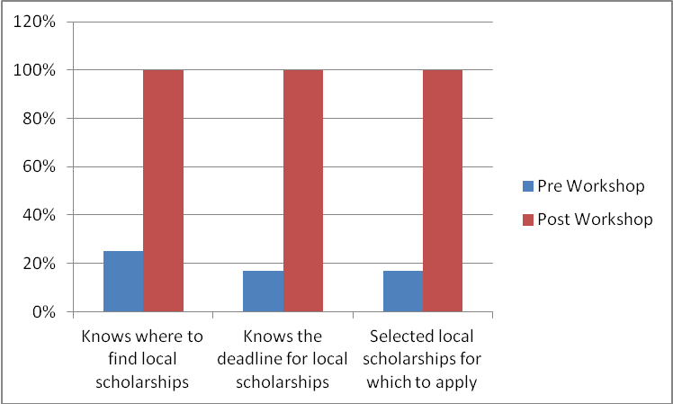

 | Yes | No | Maybe
Plans to apply for local scholarships PRE Workshop | 67 | 0 | 33
Plans to apply for local scholarship POST Workshop | 92 | 0 | 8

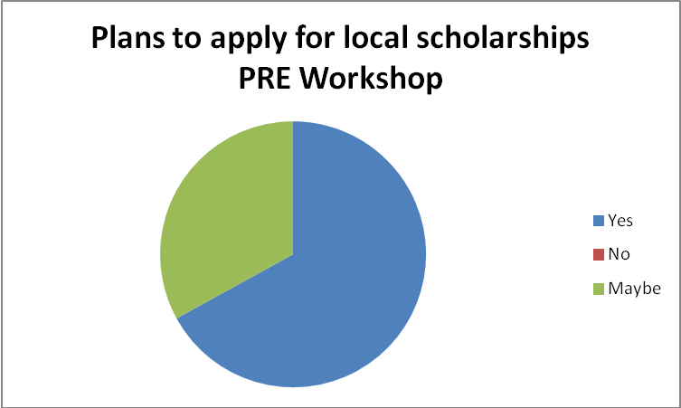

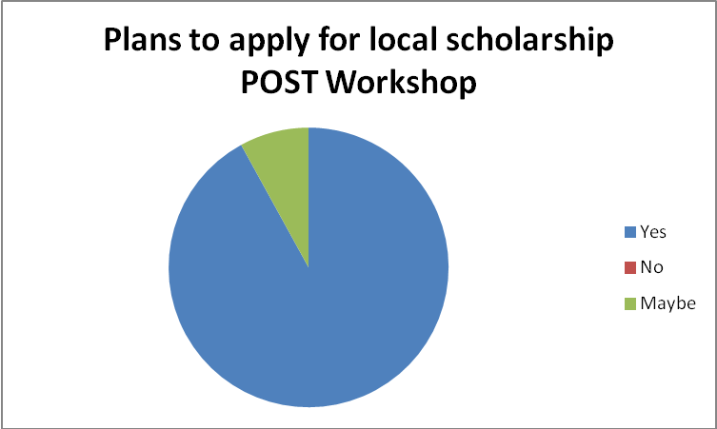

Workshop participants who previously had used Naviance to look for scholarships: 25%

Workshop participants who ultimately applied for local scholarships: 75%

Primary goal: Increase the total number of students who apply for local scholarships by 30%

Result:
 | 2011 | 2012
Students who applied for scholarships (increase of 31%) | 42% | 55%

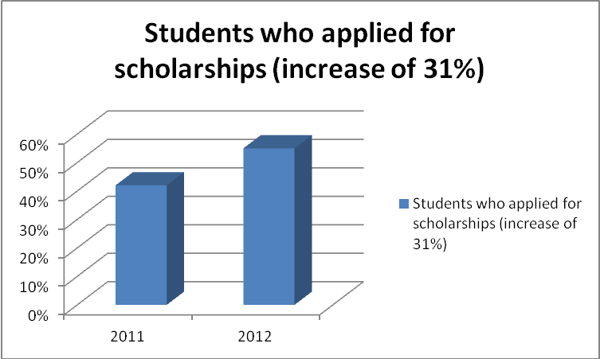

REFLECTION: After conducting this workshop and reinforcing it with the support activities and extension the application rate rose 31%. The students were able to see first hand that they are eligible for many scholarships and also learn where to look for the information that they need.

Data obtained prior to the workshop showed that that the majority of students who attended the workshop had not done any scholarship searches previously (75%). It is hoped that the workshop served to open the door for students to apply for other scholarships as well. This scholarship initiative could be expanded in the future to a second session earlier in the year for (non-local) scholarships in general.

RESOURCES:
The College Board, Scholarship Handbook, 2009. 12th ed., New York
http://connection.naviance.com/wbschools
www.wbschools.com
www.fastweb.com
www.finaid.org
www.collegeboard.com
www.scholarshipworkshop.com
Pre-Lesson Questionnaire

I have used Naviance’s Family Connection to look for scholarships Y N

I know where to find local scholarship information Y N

I have selected local scholarships for which to apply Y N

I plan to apply for local scholarships Y N Maybe

The deadline for local scholarship applications is: _____________________________

Post-Lesson Questionnaire

I know where to find local scholarship information Y N

I have selected local scholarships for which to apply Y N

I plan to apply for local scholarships Y N Maybe

The deadline for local scholarship applications is: _____________________________

Three tips I learned for successful applications are: _____________________________
_____________________________
_____________________________

Feedback:
Did you think today’s lesson was useful and valuable? ___________________________
________________________________________________________________________

Do you have any question that weren’t answered today? If so, what are they? _______________
____________________________________________________________________________________________________________________________________________________________

Do you have a suggestion about what to include in this lesson next time? ___________________
____________________________________________________________________________________________________________________________________________________________

