MARSH School Peer Pressure Unit (2 lessons)

LESSON #1

Unit: Prevention Topic of Lesson: Peer Pressure Lesson # 1
Focus Question: How to recognize and prevent peer pressure
Grade Level: 5 + 6
Time Needed: 20–25 min.
Materials needed:
- Band Aid Chicken by Becky Rangel Henton
- Role plays (attached to lesson)
- Pre/post (attached to lesson) Note: Data also attached to lesson

Curriculum Links:
- ASCA National Standards:
Personal/Social development: PS:A2.6; PS:A1.6; PS:C1.4; PS:C1.6
Academic: A:A2.3; A:A3.1
- MA Curriculum Frameworks
Comprehensive Health
Standard 5: Mental Health: 5.6
Standard 7: Interpersonal Relationship: 7.3
Standard 11: Violence Prevention: 11.9

History and Social Science
5.27; 7.38

English Language Arts
Standard 1: Discussion; 1.3
Standard 2: Questioning, listening, and contributing; 2.4

- MA CDE Benchmarks:
Academic: A1-1
Workplace Readiness Development: W1-3
Personal/Social Development: PS2-1

District/School Links:
Mission Statement: The Marsh strives through teamwork, communication, and shared decision-making to prepare each student to excel in the global community while respecting the other’s individual potential.

Planning Reflection
- I am teaching Attitude, skills and knowledge.
- The baseline data needed for this exercise is the student’s knowledge of peer pressure.
- I will evaluate if students can identify peer pressure, strategies to avoid it, and practice bully management through a multiple choice pre and post test and role plays.
- I will assess student learning through conversation after the lesson and evaluate their knowledge by the post test.

Teacher Performance Objectives: During the lesson the teacher will:
- Read the book, The Band Aid Chicken
- Define peer pressure,
- Discuss the feelings associated with peer pressure,
- Guide students to come up with possible solutions – by what if scenarios,
- Review steps to take to manage peer pressure,
- Explain consequences of bullying
- Encourage students to share their thoughts on peer pressure.

Student Performance Objectives:
Cognitive (knowledge): By the end of the lesson, the students will
- identify the correct definition of peer pressure
- identify ways to manage peer pressure from a list
- list 3 steps you can take against peer pressure

Affective (understand): By the end of the lesson, the students will
- recognize peer pressure in “what if scenarios” by participating in role plays that demonstrate responsible ways to manage peer pressure.

Behavioral/performance (do): By the end of the lesson, the students will be able to
- discuss how to respond to peer pressure, and how to take action when confronted with “traditions” which involve peer pressure.
- explain how ways it feels when you are bullied or pressured
- brain storm a class list of responsible ways to manage bullying and peer pressure, by contributing at least 1 suggestion.

Modifications for Differently Abled Students: Pre and Post test questions will be read aloud. Teacher and Guidance will circulate the room to assist student that needs further explain questions.

Pre Assessment Students will take a multiple choice survey on what is peer pressure? Ways to avoid peer pressure? What is bullying? What does self defense mean? (see attached)

Lesson #1 Activity Summary:
- Students complete pre assessment
Tell the class that you will be reading a story about peer pressure. Ask students if they know what peer pressure is? Explain that lesson will help them develop strategies about how to respond to peer pressure more appropriately, and learn how to take action when confronted with situations that make them uncomfortable.
- Teacher will read the Band-Aid Chicken to the class.
- At varying points in the story, discuss vocabulary words such as “pecking order”,” tradition” etc. At the end of the reading students will be asked to share with the class what tradition means. If a student is willing, he/she will share a tradition that his/her has in their family.

- Class discussion (Note: End of book has other comprehension questions)
How did the band-aid chicken survive?
Why did the band-aid chicken decide not to peck the new chicken?
Ask why students think that people bully.
What are different ways to bully? (teasing, ignoring, just fooling around, physical)
What is the difference between verbal and physical bullying (Explain that words can
hurt as much as physical harassment)
What does it feel like to be picked on and the target of bullies?
What is a bystander? (A bystander in a situation is just as bad as the person
bullying.)
What does self defense mean?
Have there been times when you have felt peer pressure to do something?
What are some ways to say no?
What kind of class would we have if no one picked on anyone?
What can you do to show courage?
- Suggest that student’s take the Band Aid Chicken pledge not to bully. Explain that a pledge is an agreement and reinforced to students he/she would need to try to uphold the pledge.

Assessment:(see attached) Students will take a pre/post test. Analysis of pre/post data will determine if students met the learning objectives of understanding peer pressure.

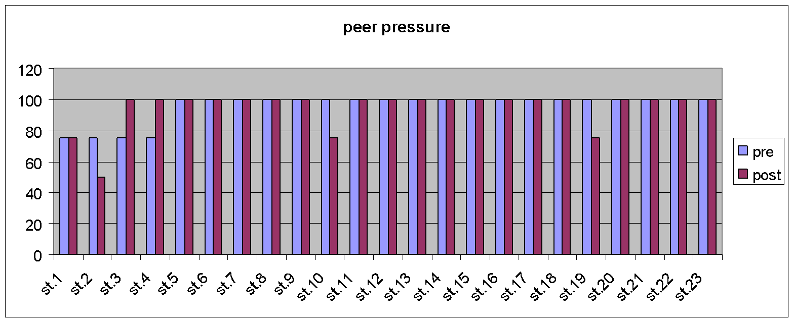

Reflection: This lesson went well and took place during drug and bully free week. It was a bit difficult to do a pre and post test. 95% of the students received 100 on the pre-test. Students provided a copy of the No Bullying pledge certificate to sign if they wished. MARSH had a door decorating contest during the bully prevention week. Some classrooms included the signed pledges as part of the door decorating contest

MARSH School Peer Pressure Unit (2 lessons)
LESSON #2

Unit: Prevention Topic of Lesson: Self defense against peer pressure and bullying Lesson # 2
Focus Question: How students resist peer pressure manage bullying?
Materials needed: Pre test, role- play scenarios Grade Level: 5 and 6
Time Needed: 45 minutes
Planning Reflection:
- I am teaching attitude, skills and knowledge.
- The baseline data needed for this exercise is the student’s knowledge of peer pressure, bullying and “self defense”.
- I will evaluate if students can identify peer pressure, bullying, and resources to avoid bullying and how to mange the behaviors that are witnessed or experienced.
- Students will list ways to manage bullying, recognize a bully behavior through a pre and post test.
- I will assess student learning through conversation after the lesson and evaluate their knowledge by the post test. Students will work with their Teacher and School Counselor to create a display board on ways to manage bullying.

Teacher Performance Objectives: During the lesson the teacher will:
- define peer pressure,
- discuss scenarios of peer pressure,
- break students into groups to organize a role play that includes a bullying behavior, a peer pressure and a management tool for bullying.
- circulate the groups to assist with the role play activity and guide students (as needed) to come up with possible management solutions
- review steps to take to against peer pressure, explain consequences and encourage students to share their thoughts on peer pressure.

Class Objectives: The class will develop and perform role plays that identify a bully situation, how to respond to peer pressure, and how to take action when confronted by a bully. The class will
- Cognitive- list 10 ways to mange bullying
- Affective – recognize a bully behavior in schools and demonstrate responsible management by developing and performing in role plays.
- Behavior- create a bulletin board about managing bullying

Student Performance Objectives: Students will

- Cognitive - contribute 1 suggestion to the managing bullying list.
- Affective – demonstrating a responsible way to manage scenario bullying behavior and peer pressure by participation in the development of their group’s role play performance
- Behavioral – participate in the role play

Modifications for Differently Abled Students: Pre and Post test questions will be read aloud, a teacher can circulate to write down the answers to situations, provisions or role play scenarios. If students would prefer not to perform in a role play, they
- can to draw or write out a situation that describes their resolution to one of the scenarios..
- write a group story if they do not wish to perform their role play to the class.
- create a cartoon with the cells depicting the scenario and solution.

Lesson #2 – Activity Summary
- Administer pre assessment
- Ask students if they remember the story about the band aid chicken. Review Lesson #1 learning objectives: bullying, peer pressure and management of bullies as relayed in the story or from incidents they have been a part of or witnessed.
- Explain that the purpose of this lesson is to come up with ways to manage bullying situations.
- Discussion: Ask students to share a bullying event that they have witnessed. How did they feel watching it and what did they do?
- Divide students into groups of 4-5 and hand out role plays. The scenario should include a victim, bully and bystander-one who stops the bully and the other who watches or laughs.
- Students develop and perform scenarios
- Discussion follows with what self defense really means.
- A word wall (school or classroom) was created for ways to manage bullies.
- Discussion about healthy friendships- that you are judged by the company that you keep. Students were reminded that they are responsible for their own behavior
- Administer the post test.

Assessment (see attached) Students will take a pre/post multiple choice survey on what is peer pressure? What is away to avoid peer pressure? What is bullying? What are ways to manage bullying? Analysis of pre/post data will determine if students met the learning objectives of understanding bully and peer pressure self-defense.

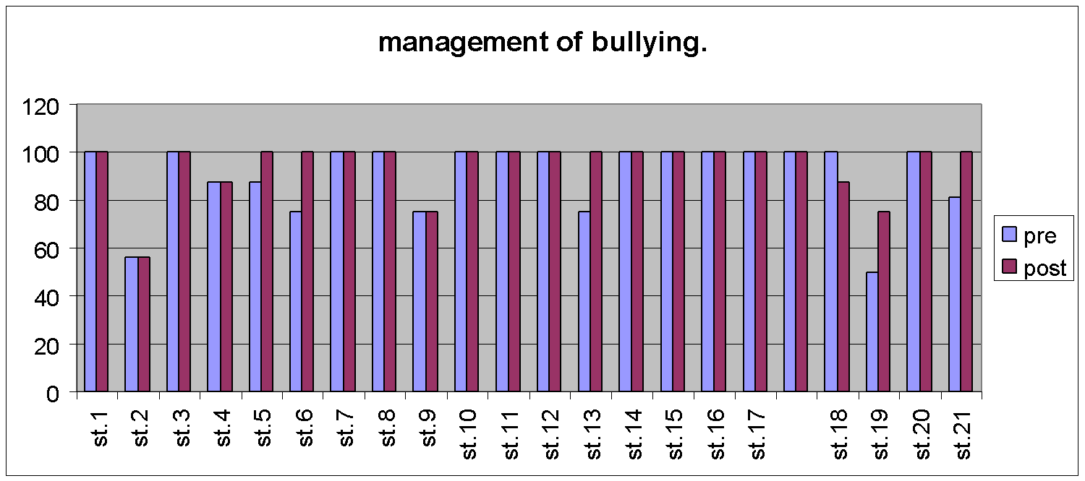

Reflection : The students really enjoyed the role play scenarios. Group discussion was easily facilitated and participation was easy from the students. I would recommend this version of the lesson in the future. Teachers felt that it was a healthy discussion of real life events. The Teachers as well as the students had thoughtful feedback.

Resources: Role play scenarios that were taken from situations that occur in school, on the play ground etc, and as reported by students and witnessed by staff
- American School Counselor Association (ASCA):www.schoolcounselor.org; review of the foundation focus.
- Massachusetts School counselor Association ( MASCA): www.masca.org, review of standards based lesson plans
- Band-Aid Chicken by Becky Rangel Henton, published by Mar-Co products. http://www.amazon.com/The-Band-Aid-Chicken-Resisting-Pressure/dp/1575430576/ref=sr_1_1?ie=UTF8&qid=1361817603&sr=8-1&keywords=band-aid+chicken.
- Conversations and brainstorming with Helen O'Donnell.

2013 Spring MASCA Conference Poster Session Presentation

Recognizing Peer Pressure and Appropriately Managing Bullies
Kelly Shaffer, School Counselor
Marsh Grammar School, Methuen

My poster session will showcase 2 standards-based lessons focused on recognizing peer pressure and appropriately manage bullies. Pre and post data graphs that visually show the impact of the lessons will available for review.

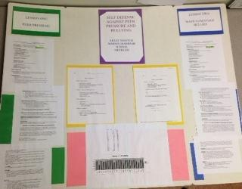

Role Play Scenarios
Role Play #1
You are at recess playing football or another game. A boy grabs the football or ball from you. He says that you are not a good player. He then begins to play keep away with the ball.

Role play the victim/target, the bully, a by stander, and show a way to manage this bully situation.

Role Play #2
You are at lunch. You put your coat on a seat. You go to get lunch. When you return to your seat, your coat is on the floor. Someone tells you that you can’t sit in the seat that you saved. When you ask why you can not sit there, he or she tells you that you don’t have any friends and that you don’t have the right kind of clothing. The other students begin to call you names or laugh.

Role play the victim/target, the bully, a by stander, and show a way to manage this bully situation.

Role Play #3
You are waiting in line to go to specials. The person behind you starts to bump into you on purpose. You turn around to tell the student to stop bumping into you. The student says “make me” and begins to call you names saying that you are not strong enough, or other names.

Role play the victim/target, the bully, a by stander, and show a way to manage this bully situation.

Role Play #4
You are at the Mall with your friends. One of the people that you are with, you do not know very well. He or she is with you in a store. He or she takes something and put it in your pocket to steal it. When you try to take the item out of your pocket the other person says if you don’t keep the thing in your pocket you will get beat up.

Role play the victim/target, the bully/target, a by stander, and show a way to manage this bully situation.

Role Play #5
You are in the bathroom at school. When you walk in a student has written bad words on the wall. When you walk in the student says not to tell anyone. When you begin to walk out you are told that if you say anything, the other student says that you will get blamed. The student then begins to call you names and makes fun of you for some reason.

Role play the victim/target, the bully, a by stander, and show a way to manage this bully situation

Circle one: Pre Assessment Post Assessment

Lesson #1: Band – Aid Chicken
Name ___________________

- What is peer pressure?

  - Saying Hello to a friend
  - Giving in to something that you don’t want to do because everyone else was doing it.
  - Making a new friend

- What is a way to avoid peer pressure?

  - Do it anyway even if you don’t want to.
  - Just do something with one of the people that told you to do something.
  - Walk away or say no.

- What is Bullying?

  - Some teases you
  - Many cows
  - Some physically or emotionally harasses you, and it is repeated and ongoing.

- What is self defense?

  - A kind of Martial Arts
  - Someone hits you and you hit back
  - When you are cornered and you have no other way out of the situation.

Circle one: Pre Assessment Post Assessment

Lesson #2: Self-Defense Against Bullying

Name ___________________

- What is peer pressure? (circle one)

  - Saying Hello to a friend
  - Giving in to something that you don’t want to do because everyone else was doing it.
  - Making a new friend

- List two ways manage/avoid peer pressure and bullying?
- _________________________________________________

- _________________________________________________

- In 3 sentences or less, explain a bully situation that you have witnessed.

- Identify the Victim (the target), the bully and the bystanders in the drawing.

X ___________ X___________ X___________

X ________________

X _________________

