UNIT: 1 TOPIC OF LESSON: Signs of Suicide (SOS) LESSON # 1
GRADE LEVEL: Grade 9 TIME NEEDED: 2 class periods for general population & additional time as needed on an individual basis for those students who scored high on the depression scale.
FOCUS QUESTION: What are the signs (symptoms) of depression/suicide?
MATERIALS NEEDED:
- SOS video (features dramatizations depicting the signs of suicide and depression, recommended ways to react to someone who is depressed and suicidal, as well as interviews with real people whose lives have been touched by suicide);
- Discussion guide;
- Depression screening tool/ BSAD (Brief Screen for Adolescent Depression);
- Instruction sheet on how to score the Screening Form;
- Pencils; projector; laptop; screen; physical space; pre-assessment & post-assessment.
CURRICULUM LINKS:
NATIONAL (ASCA Student Standards): A: A2.3; Use communication skills to know when & how to ask for help when needed C: A2.7; Develop a positive attitude toward work & learning. PS: A1.5 Identify & Express feelings.
STATE: MA Curriculum Frameworks-
- ELA General Standards/ Gather information from a variety of sources, analyze & evaluate the quality of the information obtained, & use it to answer one’s own questions.
- Health & Guiding principles/ (1) Use fundamental health concepts to assess risks, to consider potential consequences and to make health enhancing decisions. (2) Understand & communicate health information clearly for self-management and health promotion
MA CDE Benchmarks: A2-1: Communication & literacy skills for self-advocacy and presentation. W1-2: Knowledge of decision-making process as a complex process. PS1-1: Skills in developing and maintaining a clear and positive self-concept.
District Links Goal #3 – Increase College & Career readiness
School Links Vision statement
Dream! Believe! Achieve!
Mission statement

Old Colony’s High School Counseling Department will:
- Ensure that all students graduate with the necessary academic/technical, workplace readiness and personal/social knowledge and skills for school and future success.
- Support high standards for all students as a means for eliminating the achievement gap by having counselors attend to student’s developmental needs in ways that enable them to achieve success in their endeavors in education, the workplace and society.
- Empower the students to “believe” that they can “achieve” their “dreams”.
PLANNING/ REFLECTION: Students will be given information to increase their knowledge and skills. This will allow them to become aware of their own feelings and those of their peers. With the pre-assessment guidance is able to target those individuals w/ existing or prior mental health issues in order to be sensitive to their individual needs. A pre-assessment, post assessment & BSAD scale will be reviewed. Pre & post- assessment scores will be compared and lesson plan will be adjusted as needed.
TEACHER PERFORMANCE OBJECTIVES: The guidance/school adjustment staff will introduce themselves to the 9th graders, present the video, administer and score the BSAD with the students, meet w/ them on an individual basis if scoring shows concern, familiarize school staff w/ appropriate disclosure guidelines.
STUDENT PERFORMANCE OBJECTIVES:
Cognitive: With 90% accuracy on a written test, students will
- Identify 4 signs of suicide or depression
- List 2 suicide or depression resources available to them.
Affective: The students will demonstrate an understanding of the sign of depression & suicide by
Interpreting their score on the depression scale
Behavioral/Performance: As a result of this lesson, students will
- Summarize the guidelines for getting further help, if necessary.
- Determine fact vs. myth on the true/false post- test with 80 % accuracy.

MODIFICATION FOR DIFFERENTLY ABLED STUDENTS: Audio tape available, individual screening for those students who have past suicide attempts and/or mental health issues. Assist students as necessary with reading & scoring if they are having difficulty.
PRE ASSESSMENT: (see attached)
DESCRIPTION OF THE ACTIVITY/STRUCTURE OF THE LESSON: SOS is a school-based intervention that includes education and screening for depression .Students will be given a pre-assessment re: the symptoms of depression; view a video that teaches them to recognize signs of depression and suicide in themselves & others. Students are taught the appropriate response to these signs. The BSAD is administered and scored.
ASSESSMENT: (see attached)
CITE RESOURCES: ASCA, MA Model, Signs of Suicide (SOS) program, Samaritan website,
American School Counseling Association (ASCA)
www.schoolcounselor.org
Massachusetts School Counselors Association (MASCA)
http://masca.org
Signs of Suicide High School Program (SOS)
http://www.mentalhealthscreening.org/
http://www.mentalhealthscreening.org/programs/youth-prevention-programs/sos/
Samaritans
http://samaritanshope.org/

PRE-TEST Signs of Depression/Suicide
Please circle true or false True False
- Among young people ages 15-24 the rate of suicide is in continually increasing. ___ ___

- Can drinking be a sign of depression? ___ ___

- Suicidal people really want to die, so there’s no way to help them. ___ ___

- Once a person is suicidal, they’re suicidal forever. ___ ___

- Students who use drugs & alcohol may be at higher risk. ___ ___

- “Life stinks, nobody cares if I live or die” may be a verbal sign of suicide. ___ ___

- You should not betray your friend’s trust if they said that they are suicidal. ___ ___

- People always know when they are depressed. ___ ___

- Sudden changes in personality or attitude, appearance, chemical use, or school behavior may be warning signs for depression. ___ ___

- Bullying can sometimes lead to suicide. ___ ___

Comments:___________________________________________________________________________

POST-TEST Signs of Depression/Suicide
Please circle true or false True False
- Among young people ages 15-24 the rate of suicide is in continually increasing. ___ ___

- Can drinking be a sign of depression? ___ ___

- Suicidal people really want to die, so there’s no way to help them. ___ ___

- Once a person is suicidal, they’re suicidal forever. ___ ___

- Students who use drugs & alcohol may be at higher risk. ___ ___

- “Life stinks, nobody cares if I live or die” may be a verbal sign of suicide. ___ ___

- You should not betray your friend’s trust if they said that they are suicidal. ___ ___

- People always know when they are depressed. ___ ___

- Sudden changes in personality or attitude, appearance, chemical use, or school behavior may be warning signs for depression. ___ ___

- Bullying can sometimes lead to suicide. ___ ___

Comments:___________________________________________________________________________\

SOS HS Prevention Program Screening Data
Brief Screen for Adolescent Depression (2012-2013)
- 20 out of total 152 of students indicated high risk level signs of suicide/depression:
  - The criteria to indicate high risk levels include 3 or more “YES” answers or answered YES to the questions “Do you think about seriously killing yourself?” or “Have you tried to kill yourself in the last year?”
- Within these students:
  - 1/20 or 5% students answered yes to “Do you think about seriously killing yourself?” or “Have you tried to kill yourself in the last year?”
  - Students with high level signs of suicide/depression (answered YES 3 or more times): 12/20 or 60%
  - Students with high level signs of suicide/depression (answered YES 4 or more times): 7/20 or 35%

152 students took SOS depression scale. 20 out of 152 scored high & were met on an individual basis.
Graph 1 - # of students @ high risk
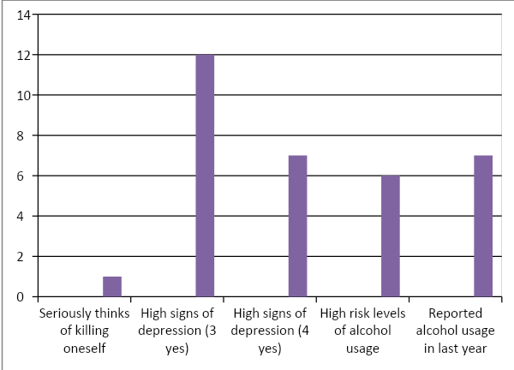

Graph 1: Follow up data on 20 students
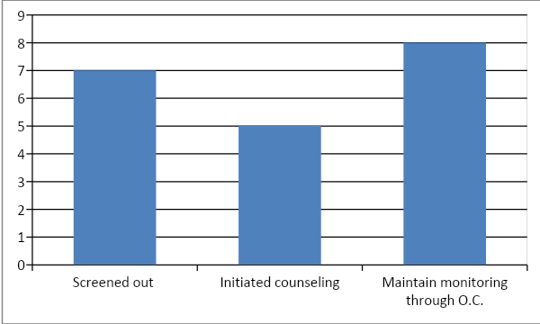
Alcohol Usage
- 6/20 or 30% of students indicated high risk levels of alcohol use:
  - The criteria to indicate high risk levels are answering YES, ALWAYS, USUALLY or SOMETIMES to using alcohol as a coping skills or binge drinking.
- Out of the 20 students screened 7/20 reported some alcohol use within the past year – 35%

Follow Up/Reflection
- After individual screening each of the high risk students 5/20 or 25% received outside counseling.
- 7/20 or 35% of the students were spoken to and screened out of being high risk.
- The remaining 8/20 students will be monitored by OC guidance staff.
Plan for the future –design & implement a depression psycho-education curriculum; collect data; review & adjust as necessary.

