Christina Smith Algonquin Regional High School, Northborough, Ma
Skills for Success
UNIT: Study Skills/Improving Learning  Topic of Lesson: Exploring skills necessary to experience success in high school  Lesson # 1  Grade Level: 9  Time Needed: 45 minute class period  FOCUS QUESTION:  What academic skills are necessary for you to experience success in your classes? |  |  | MATERIALS NEEDED:  - Computers to administer pre and post-test survey or paper copies for pre and post-test survey  - LCD projector to show PowerPoint  - Handout for students to complete and take notes on
CURRICULUM LINKS:
National ASCA Standards:
A:A1 Improve Academic Self-concept
- A:A1.5 Identify attitudes and behaviors that lead to successful learning
MA State Frameworks:
Arts Core Concept: Expressing ideas and emotions that [one] cannot express in language along. In order to understand the range and depth of the human imagination, one must have knowledge of the arts. (PS1-1)
ELA Guiding Principles: (1) Building on the language, experiences, and interests that students bring to school; (2) developing each student’s distinctive writing or speaking voice; (3) Attaining independence in learning (students articulate their own learning strategies, evaluate their effectiveness, and use those that work best for them.) (PS1-1, PS1-2)
Health Guiding Principles: (1) Healthy habits and behaviors for the individual and others; (2) Skills that assist students in understanding and communicating health information clearly for self-management and health promotion. (PS 1-1. PS1-3)
Foreign Language Technology Competencies: (1) Identify ethical and legal behaviors when using technology and describe personal consequences of inappropriate use; (2) Practice responsible use of technology systems and sftware (3) Analyze advantages and disadvantages of widespread use and reliance on technology in the workplace and in society (PS1-4)
Mathematics Guiding Principles: Mathematical ideas should be explored in ways that stimulate curiosity, create enjoyment of mathematics, and develop depth of understanding. (PS1-2)

Career Development Education Benchmarks:
PS1: attitudes, behaviors, knowledge and skills that promote identity formation, personal responsibility and self-direction
- PS1-3: Attitudes and skills, personal responsibility and self-determination
DISTRICT/SCHOOL LINKS:
Algonquin Regional High School Social Core Value, Beliefs, and Learning Expectations
S.E.2 Students at Algonquin Regional High School will take responsibility for their actions.

PLANNING REFLECTION:
- This lesson involves teaching an attitude and content which is helping students form a definition and idea of success.
- There is no baseline data needed prior to instruction.
- The pre and post assessment would take place using Naviance. The assessments will be used to see if student knowledge of study skills increased over the course of the unit.
Performance Objectives
COUNSELOR/TEACHER PERFORMANCE OBJECTIVES
Through the use of brainstorming, and discussion, the school counselor will demonstrate ways that attitudes and behaviors can lead to success in school.
STUDENT PERFORMANCE OBJECTIVES
Cognitive (knowledge):  - Students will define success.  - Students will evaluate suggestions for academic success. | Affective (understanding):  Students will prioritize habits that will lead to academic success. |  |  | Behavioral/Performance (be able to do):  Students will list at least three things they need to do to be academically successful.
DESCRIPTION OF THE ACTIVITY/STRUCTURE OF THE LESSON
PRE-ASSESSMENT  Students will take a pre-assessment survey. It is attached to this document. The pre-assessment survey will be given through students’ Naviance account. They will be asked to take the survey before the first lesson. Counselors can monitor the completion of the pre-assessment and the answers to the pre-assessment through Naviance. Students will take the same assessment for the post-assessment. |  | POST-ASSESSMENT  Students will take a post-assessment survey. It is the same as the pre-assessment survey. The pre and post data can be compared to see if the presentation was effective. It can also identify areas that may need follow up in another presentation. Naviance will be utilized to deliver the post-assessment.
THE LESSON
- Make sure the pre-assessment has been administered. Examine the information gathered from the pre-assessment

- Explain to students that today, together, you will be exploring ways they can increase their academic success. Let them know that this is the first of a series of lessons on skills for success

- Have this question written on easel paper or on the board: What does success mean and how can you achieve success?

- Pass out the handout for students to record information on.

- Begin going through the PowerPoint with the corresponding information on the handout. In the notes section, the PowerPoint contains information you can say to students while going through the PPT. The information is listed below.

- Welcome. Today we will be discussing what it takes to be academically successful. This will be the first of a series of lesson designed to help you refine your study skills. Before we begin, I want to thank you all for taking the pre-assessment on Naviance. That information will be used to see if my work with you makes a difference in your knowledge, skills, and behavior. At the end of this unit on study skills, I will ask you to take a post-assessment and then I will compare the results of both assessments. The pre and post assessments do not affect your grade, but they are important to our counseling program and will help us make improvements. Okay, let’s begin.

- Our goals for today are to define academic success. I also want you to think about what success is, what skills you already have to help you meet with success, and I want you to think about skills you might want to develop to become even more successful. I gave you a handout when you came into class. You will use the handout to record information from today’s class.

- To begin, think about yourself now and ten years from now. In ten years, how will you know if you are successful? You’ll be about 24. Take a moment and record your thoughts on your handout under #1. (give students a few minutes) Does anyone want to share what they wrote?

- Let’s move on to number 2 on your handout. What is academic success and do you think it differs from success. Please take a moment and record your thoughts. (give students a minute or two) Can a few of you share how you defined academic success and whether you think it differs from success?

- Now we are going to look at pictures. We will look at six pictures. After looking at each picture, record your thoughts about how the picture communicates a message of success to you. Think about what you can use from the message in your own quest for success. VARIATIONS: Counselor—the pictures can be shown by PPT or by printing them out. You can post them around the room in stations or you can print them and have them available at each table. For “differently-abled” students, you can set the activity up by having students look at the pictures from the PPT, printing them out for groups, or posting them around the room at stations. You could also make stations that students would move through.

- Keeping the pictures that you just looked in mind and what you just wrote down, think about the habits you already possess that help you achieve success. Write those down under the habits I already have. Next, keeping the pictures in mind and what you wrote down about them, write down the habits that you would like to develop or put in place so you can be even more successful than you are now. (If time, talk with students about what they have recorded and learned from the activity.)

- Thank you very much for your participation. Next time we meet, we will discuss strategies for taking tests.

MODIFICATIONS FOR DIFFERENTLY ABLED STUDENTS  - Students can be paired or work in groups. The classroom teacher can help with pairings or creating groups.  - Some students may need you to write the definition of success on the board and/or you can provide a definition for students to comment on.  - You can go through a few of the pictures with  - The PowerPoint can be used to create a skeletal outline for notes for students to write on and/or the completed PowerPoint could be handed out or posted on the web after the presentation. |  | LEARNING STYLES ADDRESSED  - Learners with a visual preference will benefit from the projected PowerPoint and the word success listed on the board as well as you recording the brainstorming.  - Learners with an auditory preference will benefit from the discussion component of the lesson as well as from the oral presentation of the material.  The kinesthetic modality can be addressed by having students move to different stations with the pictures.
Data Analysis and Summary:
I was unable to deliver this lesson. The guidance counselors have limited time in the classroom. I did prepare materials for another lesson that I will send to you.

REFLECTION  This lesson might be better served in a two period division rather than an 80 minute period. Make sure that either you are recording the brainstorming or have the classroom teacher assist by recording information. |  | RESOURCES  http://www.rrcc.edu/success/tips/StudySkillsQuestionnaire.pdf
SUPPLEMENTAL MATERIAL: PowerPoint and handouts

- Pages 6-10 is an exported PowerPoint in word format that corresponds with this lesson. The actual PowerPoint is available on the MASCA website.

- Pages 12-17 of this document contains the pre and post assessments. The answers can be collected by paper and pen, through Naviance survey, or Google Docs.

- Pages 19-20 contain the handouts for this lesson

Christina Smith Algonquin Regional High School, Northborough, Ma
Planning and Using Time Effectively
UNIT: Study Skills/Improving Learning  Topic of Lesson: Exploring skills necessary to experience success in high school  Lesson # 2  Grade Level: 9  Time Needed: 55 minute class period  FOCUS QUESTION:  How can you use the skill of planning to use your time more effectively? |  |  | MATERIALS NEEDED:  - Pen/pencil  - Planning activity sheets.  - Chart paper and markers  - Tape or magnets
CURRICULUM LINKS:
National ASCA Standards:
A:A1 Improve Academic Self-concept
- A:A1.5 Identify attitudes and behaviors that lead to successful learning

MA State Frameworks:
ELA Guiding Principles: (1) Building on the language, experiences, and interests that students bring to school; (2) developing each student’s distinctive writing or speaking voice; (3) Attaining independence in learning (students articulate their own learning strategies, evaluate their effectiveness, and use those that work best for them.) (PS1-1, PS1-2)

Career Development Education Benchmarks:
PS1: attitudes, behaviors, knowledge and skills that promote identity formation, personal responsibility and self-direction
- PS1-3: Attitudes and skills, personal responsibility and self-determination
DISTRICT/SCHOOL LINKS:
Algonquin Regional High School Social Core Value, Beliefs, and Learning Expectations
S.E.2 Students at Algonquin Regional High School will take responsibility for their actions.

PLANNING REFLECTION:
- This lesson is imparting knowledge and also helping students form attitudes about good study habits and effective time management skills.
- No baseline data is necessary before instruction.
Performance Objectives
COUNSELOR/TEACHER PERFORMANCE OBJECTIVES
Through the use discussion the school counselor will demonstrate ways that planning and effective time management can lead to success in school.
STUDENT PERFORMANCE OBJECTIVES
Cognitive (knowledge):  - Students will define success.  - Students will identify obstacles to using their time effectively. | Affective (understanding):  Students will prioritize habits that will lead to academic success. |  |  | Behavioral/Performance (be able to do):  - Students will generate ideas for removing obstacles to using their time effectively.  - Students will plan a party and then apply the idea of planning to an assignment.  - Students will evaluate suggestions for academic success.
DESCRIPTION OF THE ACTIVITY/STRUCTURE OF THE LESSON
PRE-ASSESSMENT  . No pre-test was given. Students were asked to come to the seminar having filled in their Keeping Track sheet (see PDF with handouts). |  | POST-ASSESSMENT  Students were asked to fill in the Managing Your Time handout (see PDF with handouts).
THE LESSON
- Planning (35 minutes)
  - Have students get in groups by teacher. Groups can be 4-6 students depending on the needs in the class.
  - Pass out the Planning a Party handout and go over the directions. Remind students to brainstorm first. Brainstorming can be recorded on the bottom portion of the handout. Ask them to record their plan on the large chart paper and encourage them to use the calendar and or agenda materials each group has available. Let them know they will be sharing their plans with the class. Also let them know how much time they have to do this portion of the activity. (10 minutes)
  - Before the groups present their plans, read through the questions that are on the back of the planning a party sheet. As the groups go through their plans, tell students to think about answers to the questions on the sheet.
  - Give students time to answer the questions and then discuss similarities between planning for a party and planning for assignment as you transition to the planning out a real assignment. (5-10 minutes)
  - Reference the assignments that have been provided by each teacher and ask groups to plan out their school assignment. They can share out with the group if there is time. (5-10 minutes)

- Using time effectively (15-20 minutes)
  - Have students look at the information they recorded on their Keeping Track sheet.
  - Have students fill in the Tackling Time Management sheet with their group.
  - Lead a discussion using the students’ answers to the Tackling Time Management sheet.
  - Have students complete the Managing You Time sheet by themselves.

- Closing Remarks
- Summarize what students learned about today (see goals above)
- Let them know what is coming up for the December session.
MODIFICATIONS FOR DIFFERENTLY ABLED STUDENTS  - Students can be paired or work in groups. The classroom teacher can help with pairings or creating groups. |  | LEARNING STYLES ADDRESSED  - Learners with a visual preference will benefit from the questions projected on PowerPoint and by recording information from the discussion on the board.  - Learners with an auditory preference will benefit from the discussion component of the lesson as well as from the oral presentation of the material.  - The kinesthetic modality can be addressed by having students stand to share answers. The whip around technique would work well.
Data Analysis and Summary:
Through discussion of answers to the question that were given throughout the lesson, counselors were checking for understanding and adjusting instruction.
REFLECTION  This lesson might be better served in a two period division rather than an 55 minute period. Make sure that either you are recording the brainstorming or have the classroom teacher assist by recording information. |  | RESOURCES
SUPPLEMENTAL MATERIAL: Handouts are on pages 20-24 of this document.
PowerPoint for Skills for Success Lesson (PowerPoint is available on the MASCA website)

Slide 1 |  | Welcome. Today we will be discussing what it takes to be academically successful. This will be the first of a series of lesson designed to help you refine your study skills. Before we begin, I want to thank you all for taking the pre-assessment on Naviance. That information will be used to see if my work with you makes a difference in your knowledge, skills, and behavior. At the end of this unit on study skills, I will ask you to take a post-assessment and then I will compare the results of both assessments. The pre and post assessments do not affect your grade, but they are important to our counseling program and will help us make improvements. Okay, let’s begin.
Slide 2 |  | Our goals for today are to define academic success. I also want you to think about what success is, what skills you already have to help you meet with success, and I want you to think about skills you might want to develop to become even more successful. I gave you a handout when you came into class. You will use the handout to record information from today’s class.
Slide 3 |  | To begin, think about yourself now and ten years from now. In ten years, how will you know if you are successful? You’ll be about 24. Take a moment and record your thoughts on your handout under #1. (give students a few minutes) Does anyone want to share what they wrote?
Slide 4 |  | Let’s move on to number 2 on your handout. What is academic success and do you think it differs from success. Please take a moment and record your thoughts. (give students a minute or two) Can a few of you share how you defined academic success and whether you think it differs from success.
Slide 5 |  | Now we are going to look at pictures. We will look at six pictures. After looking at each picture, record your thoughts about how the picture communicates a message of success to you. Think about what you can use from the message in your own quest for success. VARIATIONS: Counselor—the pictures can be shown by PPT or by printing them out. You can post them around the room in stations or you can print them and have them available at each table. For “differently-abled” students, you can set the activity up by having students look at the pictures from the PPT, printing them out for groups, or posting them around the room at stations. You could also make stations that students would move through.
Slide 6
Slide 7
Slide 8
Slide 9
Slide 10
Slide 11
Slide 12 |  | Keeping the pictures that you just looked in mind and what you just wrote down, think about the habits you already posses that help you achieve success. Write those down under the habits I already have. Next, keeping the pictures in mind and what you wrote down about them, write down the habits that you would like to develop or put in place so you can be even more successful than you are now. (If time, talk with students about what they have recorded and learned from the activity.)
Slide 13 |  | Thank you very much for your participation. Next time we meet, we will discuss strategies for taking tests.

Pre and Post
Assessments

Skills for Success
&
Planning and Using Time Effectively

Pre-Assessment of Study Skills
Directions: Please take this survey. You will not be graded, but this survey will allow you and your counselor to see areas that you can work on to help you perform better academically. The survey questions were taken from http://www.rrcc.edu/success/tips/StudySkillsQuestionnaire.pdf

*1. | When reading a textbook, I browse the headings, pictures, charts, questions and summaries before I start reading the chapter.
Rarely
Sometimes
Often

*2. | I make questions from a textbook chapter before, during, and after reading it.
Rarely
Sometimes
Often

*3. | I try to understand the meaning of new words as I see them for the first time
Rarely
Often
Sometimes

*4. | I look for familiar concepts as well as ideas that spark my interest as I read.
Rarely
Sometimes
Often

*5. | I look for the main ideas as I read.
Rarely
Sometimes
Often

*6. | I take notes as I read my text books.
Rarely
Sometimes
Often

*7. | I take notes during class lectures.
Rarely
Sometimes
Often

*8. | I rework, rewrite, or type up my notes.
Rarely
Sometimes
Often

*9. | I compare my notes with a classmate.
Rarely
Sometimes
Often

*10. | I study where it is quiet and has few distractions.
Rarely
Sometimes
Often

*11. | I study for a length of time then take a short break before returning to studying
Rarely
Sometimes
Often

*12. | I have all my supplies handy when I study, such as pens, paper, calculator, etc.
Rarely
Sometimes
Often

*13. | I set study goals, such as the number of problems I will do or pages I will read.
Rarely
Sometimes
Often

*14. | I quiz myself over material that could appear on future exams and quizzes.
Rarely
Sometimes
Often

*15. | I summarize my notes into my own words, for better understanding.
Rarely
Sometimes
Often

*16. | I try to create associations between new material I am trying to learn and information I already know.
Rarely
Sometimes
Often

*17. | I study with a classmate or group
Rarely
Sometimes
Often

*18. | When I don’t understand something, I get help from classmates and/or my teachers.
Rarely
Sometimes
Often

*19. | I do all homework assignments and turn them in on time.
Rarely
Sometimes
Often

*20. | I anticipate what possible questions may be asked on my tests and make sure I know the answers.
Rarely
Sometimes
Often

*21. | I use a planner (or other method) to write down upcoming academic and personal activities.
Rarely
Sometimes
Often

*22. | I start studying for quizzes and tests at least several days before I take them.
Rarely
Sometimes
Often

*23. | I start papers and projects as soon as they are assigned.
Rarely
Sometimes
Often

Post-Assessment of Study Skills
Directions: Please take this survey. You will not be graded, but this survey will allow you and your counselor to see areas that you can work on to help you perform better academically. The survey questions were taken from http://www.rrcc.edu/success/tips/StudySkillsQuestionnaire.pdf

*1. | When reading a textbook, I browse the headings, pictures, charts, questions and summaries before I start reading the chapter.
Rarely
Sometimes
Often

*2. | I make questions from a textbook chapter before, during, and after reading it.
Rarely
Sometimes
Often

*3. | I try to understand the meaning of new words as I see them for the first time
Rarely
Often
Sometimes

*4. | I look for familiar concepts as well as ideas that spark my interest as I read.
Rarely
Sometimes
Often

*5. | I look for the main ideas as I read.
Rarely
Sometimes
Often

*6. | I take notes as I read my text books.
Rarely
Sometimes
Often

*7. | I take notes during class lectures.
Rarely
Sometimes
Often

*8. | I rework, rewrite, or type up my notes.
Rarely
Sometimes
Often

*9. | I compare my notes with a classmate.
Rarely
Sometimes
Often

*10. | I study where it is quiet and has few distractions.
Rarely
Sometimes
Often

*11. | I study for a length of time then take a short break before returning to studying
Rarely
Sometimes
Often

*12. | I have all my supplies handy when I study, such as pens, paper, calculator, etc.
Rarely
Sometimes
Often

*13. | I set study goals, such as the number of problems I will do or pages I will read.
Rarely
Sometimes
Often

*14. | I quiz myself over material that could appear on future exams and quizzes.
Rarely
Sometimes
Often

*15. | I summarize my notes into my own words, for better understanding.
Rarely
Sometimes
Often

*16. | I try to create associations between new material I am trying to learn and information I already know.
Rarely
Sometimes
Often

*17. | I study with a classmate or group
Rarely
Sometimes
Often

*18. | When I don’t understand something, I get help from classmates and/or my teachers.
Rarely
Sometimes
Often

*19. | I do all homework assignments and turn them in on time.
Rarely
Sometimes
Often

*20. | I anticipate what possible questions may be asked on my tests and make sure I know the answers.
Rarely
Sometimes
Often

*21. | I use a planner (or other method) to write down upcoming academic and personal activities.
Rarely
Sometimes
Often

*22. | I start studying for quizzes and tests at least several days before I take them.
Rarely
Sometimes
Often

*23. | I start papers and projects as soon as they are assigned.
Rarely
Sometimes
Often

Handouts

Skills for Success
&
Planning and Using Time Effectively

Name______________________________________ Date________ Counselor_____________

On the Road to Success:
Learning what it takes to be academically successful

- When you think about yourself ten years from now, how will you judge whether or not you are successful?

- Define academic success. Do you think it is different from success?

- Record your thoughts about the pictures you see. All of the pictures have SUCCESS as a theme.
Picture # | My thoughts related to success and what I see in the picture.
1
2
3
4
5
6

Haves and Have-Nots

Habits I already have that help me be successful with my school work | Habits I would like to have to help me be successful with my school work

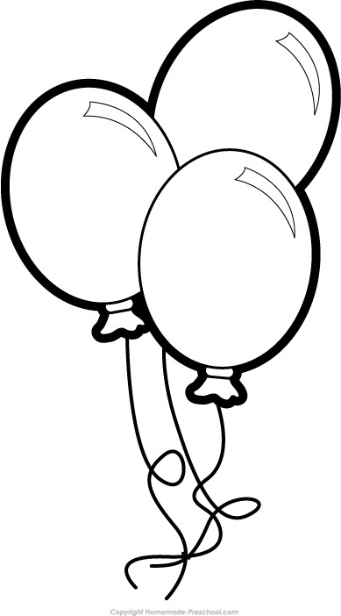

Planning a Party

You have just been asked to plan a party. You can plan any type of party you would like to. For example you may plan a graduation party, birthday party, a holiday party, etc. Think about what you would need to make this party a success! Your party will be on November 30, 2013.

- Brainstorm
- What kind of party are you going to host?
- What do you need for the party? (Record this on a piece of paper.)

- Create your plan.
  - When is the party? (see above)
  - Plan what you need to do by the party’s date. Your plan should be realistic.
  - Record your plan on the chart paper. Be prepared to share the main points of your plan with the class.

- Share the plan for your party.
- We’ll post the chart paper around the room for others to see.
- Remember to make eye contact and use a loud voice when presenting.

Planning

- As you listened to your classmates present the plans for their parties, what are some elements that the plans had in common?

- When you had to determine what you needed to get ready for your party, what were some of the factors that determined when you planned to do certain tasks?

- List three ways that planning a party like planning for a project, test, paper, presentation, or other assignment?

- Describe how you might use this ‘party planning’ lesson to plan for an assignment in any of your classes. Write two to three sentences to show what you have learned from this activity.

- List three ways that using an agenda book, assignment notebook, or using the calendar on a phone could help you achieve academic success in your classes.

- Now, it’s your turn to plan out the events to reach success with an assignment in your U.S. History I class.

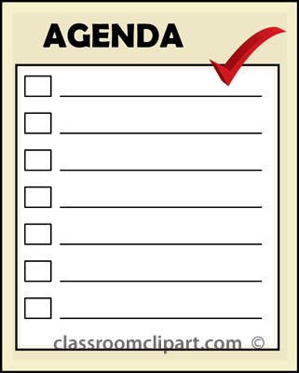
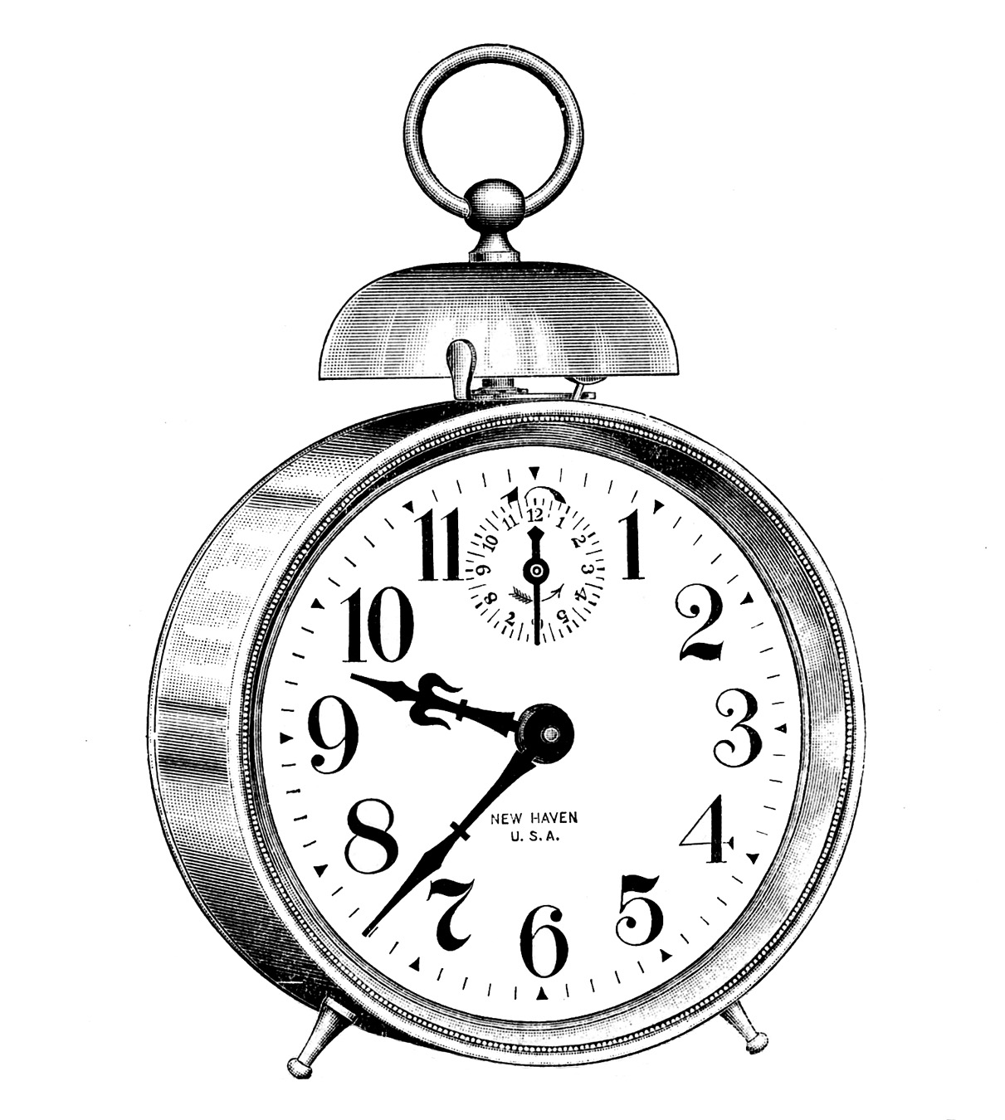

Tackling Time Management

With your group, you are going to discuss ways you can use your time more effectively. Before you can do that, you’ll need to identify some of the obstacles that may get in your way as you prepare to study and complete assignments.

Obstacles | Tackling Obstacles
List at least three obstacles that may get in your way of completing assignments. | For each obstacle that you listed, come up with a way you can tackle that obstacle so that you can complete your assignments.
List at least three obstacles that may get in your way of having an environment that is conducive (good for) studying. | For each obstacle you listed, describe a way that you can improve the environment you study in.

Managing your TIME

You may delay, but time will not. --Benjamin Franklin
Time is what we want most, but what we use worst. --William Penn
I must govern the clock, not be governed by it. --Golda Meir

Wisdom is the power to put our time and our knowledge to the proper use. --Thomas J. Watson

DIRECTIONS: Look over the data that you brought about your schedule over the last week. Answer the questions that follow.

- Looking at your data, list out any time periods or days when you can see that you are not using your time effectively. What is ‘eating’ up your time?

- Looking at your data, have you provided yourself with breaks and stress relieving activities? What are they? If you don’t have any, what could you add to your schedule?

- Looking at your data, what changes do you think you can make to your schedule to use your time more effectively?

Keeping Track
DIRECTIONS: Choose 2 weekdays and 1 weekend day and write down your activities. Provide details related to what you are doing with your time. The first day is filled in so you would have an example to follow.

TIME | Monday | _____________ day | _________________day | _________________day
5:00 a.m. | Woke up and got ready for school
6:00 a.m. | Breakfast and checked Facebook
7:00 a.m. | Got to school
8:00 a.m. | School
9:00 a.m. | School
10:00 a.m. | School
11:00 a.m. | Study/played game on phone
12:00 p.m. | School
1:00 p.m. | School
2:00 p.m. | Stayed after for U.S. History
3:00 p.m. | Basketball practice
4:00 p.m. | Hung out with friends
5:00 p.m. | Dinner at Chipotle
6:00 p.m. | Watched T.V.
7:00 p.m. | Showered
8:00 p.m. | Homework
9:00 p.m. | Watched Netflix
10:00 p.m. | Watched Netflix
11:00 p.m. | Went to bed
12:00 a.m.

