Stress Management in the Middle School

UNIT: Guidance TOPIC OF LESSON: Stress Triggers LESSON# 1
FOCUS QUESTION: How to deal with stress

MATERIALS NEEDED: Note book paper, white board, stress handouts GRADE LEVEL: Middle/High School TIME needed: 60mins

CURRICULUM LINKS:
- National: (ASCA National Student Standards):
  - Please align with ASCA Mindsets and Behaviors
- State: MA Curriculum Frameworks
  - English Language Arts & Literacy:
    - Initiate and participate effectively in a range of collaborative discussions (one-on-one, in groups and teacher-led) with diverse partners
  - Comprehensive Health
    - 5.1 Identify the various feelings that most people experience and describe the physical and emotional reactions of the body to intense positive and negative feelings
  - History
    - Grades 8-12 concepts and skills
      - 5. Explain how cause and effect relationship is different from a sequence or correlation of events.
- State: MA CDE Benchmarks
  - Academic-Technical Development: A2-3: Organizational skills for career and life management
  - Workplace readiness: W4-3: Skills in managing competing life roles at home, school, work and in the community
  - Personal/Social Development: PS2-4: Knowledge of how positive behaviors and attitudes contribute to educational achievement and workplace success
  - Personal/Social Development: PS3-1: Knowledge and skills for maintaining personal and psychological well-being
- National Common Core
  - CCSS.ELA-Literacy.SL.7.1 Engage effectively in a range of collaborative discussions (one-on-one, in groups, and teacher-led) with diverse partners on grade 7 topics, texts, and issues, building on others’ ideas and expressing their own clearly.
- District/School links: Mission Statement:
  - “West Boylston Middle/High School has a commitment to the pursuit and attainment of excellence. The school’s primary objective is to guide students to be self-directed life-long learners and critical thinkers who have the skills and knowledge to succeed in life. It is the responsibility of the entire school community to provide for the growth and the development of the student in a positive atmosphere of mutual respect. We recognize that the complete education of the student includes opportunities that promote creativity and self-expression both within and beyond the classroom. We at West Boylston Middle/High School strive to help each student realize his or her potential in order to become a contributing member of society.”

PLANNING REFLECTION:
- Students will learn ways to manage stress
- Students will be able to recognize what gives them stress
- Pre and post data handouts; other relevant handouts
- There will be a post lesson (month later) focus group, followed by a follow up questionnaire.

TEACHER PERFORMANCE OBJECTIVES: During the lesson the teacher will engage the students in discussions on stress, what it is and how it makes them feel. We will talk about ways to deal with stress, how being more organized, not procrastinating, and living a healthy lifestyle can lead to less stress.

STUDENT PERFORMANCE OBJECTIVES:
- Cognitive: By the end of the lesson, the students will know techniques for managing stress. They will be able to:
-list 2 ways to cope with stress
-identify 2 ways their body reacts to stress
- Affective: By the end of the lesson, the students will understand that everyone has different “Stress triggers”, and it is not the event that causes stress, but what they think of the event that causes stress as evidenced by reflected in their journal entries.

- Behavioral/Performance: By the end of the lesson, the students will know ways to cope with managing life events that may cause them stress, by successfully completing the post test with 80% accuracy and their personal journal entries.
PRE ASSESSMENT: 1 Page pre-test (attached)

POST ASSESSMENT: 1 page post-test (attached); one month later conduct a focus group with a few members of the class, as well as have the entire class take a second post assessment test

DESCRIPTION OF THE ACTIVITY/SEQUENCE OF THE LESSON
- Start with a name ice breaker/game. Have students say their name and one fun fact about them.
- Ask the students if they feel stress. What areas of their day to day life give them stress? Give example. (Picking out my clothes in the morning stresses me out…so I do it the night before;)
- Ask the students to come up with 1 highly stressful event (generalize) that have happened to them (1 per student). (having a huge argument with a friend or parent; failing a test; going to class without having done your homework; dealing with peer pressure; riding a roller coast; watching a sporting event, etc.). Write list on the board.
- Have students write down the stressful events on a piece of paper by ranking the events in the order that they are most stressful to you (most stressful at the top and least at the bottom).
- After the ranking the events, tabulate the students results and write it on the board
  - Why is a particular event really stressful and another not so stressful?
  - Are there any big differences in what stresses out the class?
- “Everyone reacts to stressful situations differently. One event may be stressful to me but not to you. This is because it is not the event that causes the stress, but what we think about that event that bothers us.”
- Select a listed stressful situation and find a student who reacted strongly to it and someone who didn’t react as strongly and ask them why the same event caused them to react in such different ways. Ask what they were thinking during the particular event.
- Give example: Event Thought Reaction:
  - Person A roller coaster ride: I’m going to die! Terrified
  - Person B Roller coaster ride: This is great! Exhilaration
- It isn’t the roller coaster ride that caused person A to be terrified; it was his/her thoughts about what might happen to him/her that caused his/her reaction
- Have students look at the list on the board of stressful events and share with the group what about the event is stressful to them.
- It is the student’s thoughts, not the actual event that creates stress. Give example of when they were little and they thought that monsters lived in their closets.
  - How did you react?
  - Were their monsters? No there weren’t, but your thoughts about monsters had your convinced that you were in danger if the closet opened.
  - What finally made you realize there were no monsters in your closet?
  - Does opening your closet now give your stress? Probably not, because you know there are no monsters in there!
  - What are your “monsters” now? Friends, peer pressure, school, sports, grades, parents, siblings, etc.
  - Are these “monsters” causing you stress or is it your thoughts about them causing the stress?
  - How can we change the thoughts we have to help us change our stress levels?
- Look again at how your ranked the stressors we listed on the board. On a piece of paper, write the first fearful thought you have about your top three. Then write a change-of-thought statement that may help you reduce the stress surrounding the event. Have the students share if they are comfortable.
  - Example:
    - Peer pressure stress thought: They’re not going to accept me.
    - Change of thought: I’m OK just the way I am. If they don’t accept me, that’s their problem.
    - Adolescence stress thought: I’ll never grow up and get out of here. I’ll be a kid forever.
    - Change of thought: In five years, I’ll look back on this and laugh. This, too, shall pass.
    - School stress thought: I have no idea what is going on, I am going to fail!
    - Change of thought: I need to stay after with my teacher to get caught up.
- Have students talk about what they do to relieve stress. Have them look at the “coping with stress” handout and discuss if they do any of these things or may try to in the future when they face stress. Ask for examples.
MODIFICATIONS FOR DIFFERENTLY ABLED STUDENTS:
If the lesson were done with high school students the stressful situations would be different. They could be work stress, relationship stress, money stress, car stress, applying to college stress, etc.

DATA ANALYSIS and SUMMARY:
The students came away with knowledge and helpful tools for dealing with stress. They were able to identify areas in their life that may cause them stress, and some ways to make those events less stressful. Many of them didn’t realize that some of the things they enjoyed doing (working out, playing sports, listening to music, etc.) were also ways to relieve stress. A lot of the stress the students felt was from having a lack of time to do everything they needed to in a day. We worked on their time management throughout the day, to try and find time to everything they had to complete on any given day. This seemed to help the students feel more in control and also organized about their days. This particular group of students is in a special program that required a recommendation and an application and interview process to get into, so they are high achieving students.

After participating in the lesson and taking the post-test the students were all able to correctly define what stress was.

The students seemed to struggle with the concept of “coping” and some were unable to think of examples of ways that they coped with stressed on the pre-test. Many students even asked me to define what “cope” meant while they were taking the pre-test. After the lesson was presented and they took the pre-test, more students were able to think of ways they cope with stress. On the pre and post-test the students were asked to list two ways they coped with stress. On the pre-test 18 of the 24 students were able to come up with two, while on the post-test 22 out of the 24 students were able to come up with examples.

REFLECTION and NEXT STEPS: The lesson went really well. I got a lot of positive feedback from the students, especially through the post-test. I will follow up with a few focus groups in one month, as well as a follow up questionnaire.

CITE RESOURCES: Catherine Taintor. (n.d.). Retrieved from http://www.counselorsroom.com/SC_CR_MS_Academic.php;

SUPPLEMENTAL MATERIAL: Handouts

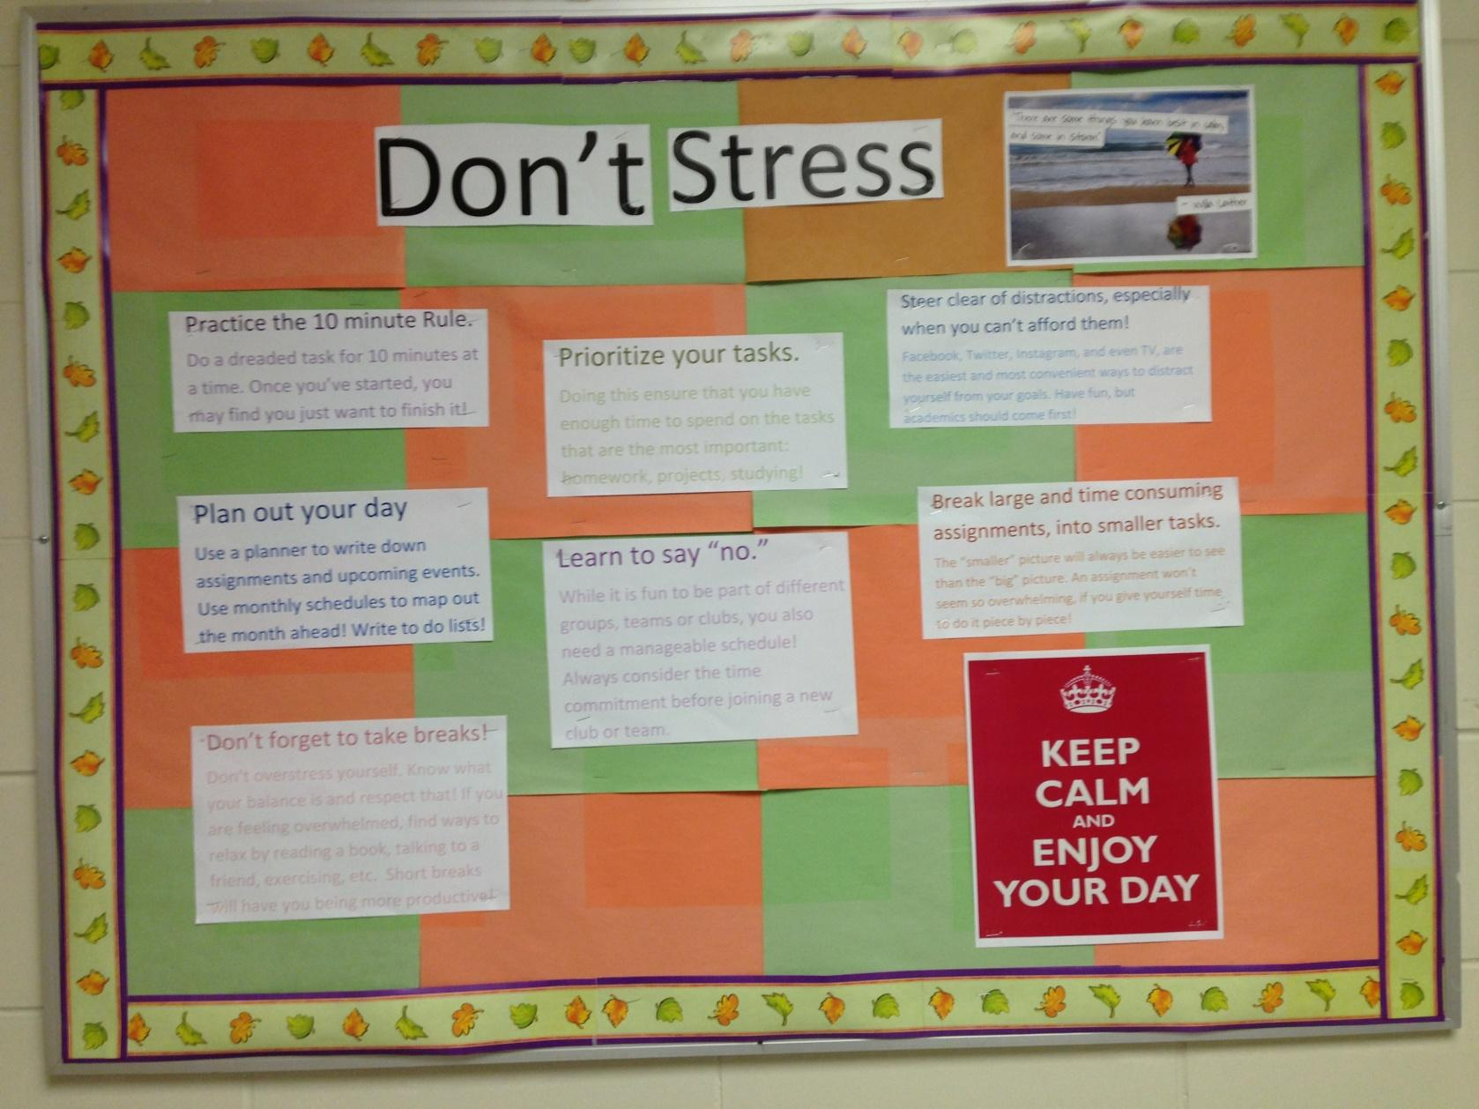

Name: _________________________________________

Stress pre-test

- Define stress in your own words:
_________________________________________________________________________________________________________________________________________________________________________________________________________________________________________________________________________________________________________________________________________________________________________________________________________________________________________

- What areas of your life do you feel the most stress (i.e. school, family, sports, etc.):
_________________________________________________________________________________________________________________________________________________________________________________________________________________________________________________________________________________________________________________________________________________________________________________________________________________________________________

- How does stress make your body feel? _________________________________________________________________________________________________________________________________________________________________________________________________________________________________________________________________________________________________________________________________________________________________________________________________________________________________________

- What are 2 ways you cope with stress?

____________________________________________________________________________________________________________________________________________________________________________________________________________________________________________________________________________________________________________________________________________________

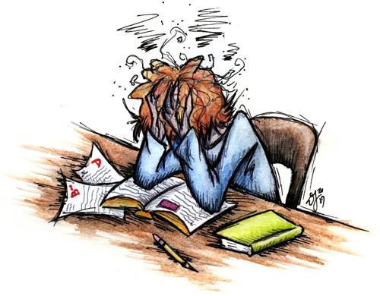

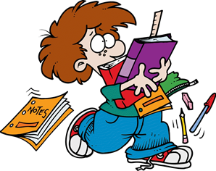
Name: _________________________________________

Stress triggers post-test

- Define Stress in your own words:
_________________________________________________________________________________________________________________________________________________________________________________________________________________________________________________________________________________________________________________________________________________________________________________________________________________________________________

- What are 2 ways you can cope with stress? _________________________________________________________________________________________________________________________________________________________________________________________________________________________________________________________________________________________________________________________________________________________________________________________________________________________________________

- Is it a particular event that causes stress, or how we think of the event that causes stress? ______________________________________________________________________________________________________________________________________________________________________________________________________________________________________________________

- Everyone reacts differently to stressful situations: Yes/No

- How was this lesson:(not helpful) 1----------------5----------------10 (very helpful)

- What could I (Ms. Giobellina) do differently next time I present this lesson? _________________________________________________________________________________________________________________________________________________________________________________________________________________________________________________________________________________________________________________________________________________________________________________________________________________________________________

- What should I (Ms. Giobellina) keep the same the next time I present this lesson? ______________________________________________________________________________________________________________________________________________________________________________________________________________________________________________________________________________________________________________________________________________________________________________________________________________________________________________________________________________________________________________________________

Stress lesson follow up test:

- How stressed are you currently? (1 being not stressed, 10 being very stressed)
1---------------------------5-------------------------10
- Where do you feel the most stress? School, home/life, friendships/relationships: _____________________________
- What are some things you are doing now to cope with your stress?
  - ______________________________________
  - ______________________________________
  - ______________________________________
  - ______________________________________
- What is one goal you can give yourself right now, to help you better deal with your stress?
________________________________________________________________________________________________________________________________________________________________________________________________________________________________________________________________________________________________________________________________________________________________________________________________________________

Coping with Stress

Everyone feels stress at times- but there are things you can do to minimize stress and manage stress that is unavoidable.

Healthy Living:
Exercise on a regular basis (try for 30 min/day about 3-4 days per week to start)
Eat well balanced meals, 3 times per day
Get enough sleep and set up a regular sleep routine- adolescents need 9-10 hours of sleep per night
Avoid illegal drugs, alcohol, tobacco and excess caffeine
Healthy Thinking:
Don’t worry about things you can’t control- ex. Weather
Look at change as a positive challenge
Positive thoughts and positive self-talk
Set realistic goals
Meditate

Healthy Actions:
Prepare well in advance for events that may be stressful- ex. Test/Project
Ask for help from friends, family, teachers, and professionals
Take breaks for daily stress with time with friends, fun activities and/or group sports
Work to resolve conflicts without anger and losing temper
Solve problems one at a time- take one task at a time
Avoid overscheduling- prioritize activities

Identify stressful situations:
Ex. Preparing for an exam, test taking, doing homework, writing papers, working on a project, making a public presentation, talking to other peers, asking question in class

Stress reducing exercises:
Two exercises you can do to alleviate stress: deep breathing and muscle relaxation. These take a little practice, but are exercises you can use anywhere to try to relax and reduce stress.
Deep breathing: Lie down on flat surface or sit in comfortable chair with arms by side and feet on floor. Breathe in slowly through your nose over 3 seconds feeling your stomach rise and your chest expand. Breathe out slowly through your nose and/or mouth over 3 seconds feeling your stomach go down and your chest contract. Repeat until you feel relaxed and tension drain out of your body.
Muscle relaxation: Start with one group of muscles (usually your feet), hold it tight for a few seconds and then release. Then move to the next group of muscles (ex. Lower legs) and do the same thing. Work your way up through your legs, abdomen, chest, hands, arms, shoulders, neck and face muscles. You should feel the tension drain out of your body and leaving you feel heavy and relaxed.

Fact Sheet on Stress/Anxiety

Stress is a state of tension related to your body attempting to cope with its environment; it’s the body’s way of preparing to meet a tough situation. Anxiety is a sense of apprehension, dread and/or uneasiness. We tend to perceive anxiety and stress as negative, but in fact both are normal and can be adaptive. The stress response involves the nervous system and specific hormones in the body, and it enhances the ability to perform under pressure as well as avoid danger. It is when stress is excessive or ongoing and interfering with functioning that anxiety and stress become a problem. This can lead to wearing out the body’s reserves and leaving a person feeling depleted or overwhelmed, weakening the immune system and making it harder to cope with daily demands. There are effective treatments available for anxiety and stress management. The first step is to learn to recognize when you are stressed, the next is to find a way to deal with stress.

Common symptoms of stress and/or anxiety:
- Trouble catching your breath
- Butterflies in your stomach
- Sweaty and/or trembling hands
- Feeling lightheaded
- Feeling nervous or jumpy
- Feeling overwhelmed
- Feeling tired all the time
- Having trouble concentrating
- Irritability and moodiness
- Headaches
- Problems sleeping
- Feeling sad or depressed

Problems related to anxiety and stresses are among the most common reasons for people to see health professionals.

Any sort of change- good or bad, can make you feel stressed out.

You are more likely to experience difficulties with anxiety if someone in your family has an anxiety disorder.

Chronic stress lasting a month or more can put you more at risk of medical problems such as frequent headaches, viral illnesses and ulcers.

Avoiding situations that cause anxiety can make the anxiety worse.

Test taking anxiety is very common among students and there are strategies to help.

Physical exercise, eating a healthy balanced diet and a good sleep routine help reduce stress and anxiety.

Anxiety can put you more at risk of developing depression.

Three Kinds of Thinking

Basically there are three kinds of thinking that go on in a stressful situation.

- Irrational thinking:
  - Catastrophic thinking: “What if…I’ll just die…”
  - Absolutistic thinking: “I must…I need to…I have to…I should…”
- Rationalization:
  - Involves an attempt to brush off the importance of an event
    - “so what…who cares…doesn’t bother me… big deal…”
- Rational thinking:
  - Involves making preferences based on rational thought:
    - “I would like to…It would be good if…I prefer…”

- Irrational thinking results in greater worry because the person images what is going to happen.
- Rationalization results in procrastination because the person denies the importance of the situation. This also interferes with decision making and increases avoidance behavior.
- Rational thinking means that you are using your thinking and decision making skills in a calm way to maximize your chances of reducing stress and making good decisions.

