UNIT: 1 TOPIC OF LESSONS: Taking perspective LESSONS: 1-3

GRADE LEVEL: 4th TIME needed: 45-60 mins

FOCUS QUESTION: Are Grade 4 students able to demonstrate the ability to use self-control and take perspective?
Lesson 1- Are the students able to understand feelings and opinions of others?
Lesson 2- Are students able to identify feelings of others and role play taking other’s perspectives?
Lesson 3- Are students able to identify and role play respectful perspective taking, calming down strategies, and apologizing?

MATERIALS NEEDED:
Activity/Lesson 1- Optical illusions, calming down poster (Attached)
Activity/Lesson 2- Worksheet (Attached)
Activity/ Lesson 3- Worksheet (Attached)
CURRICULUM LINKS: (Identify standard source, standard and #)
National:
- Common Core: CCSS.ELA-Literacy.W.4.1.b, CCSS.ELA-Literacy.SL.4.1, CCSS.ELA-Literacy.RI.4.1
- ASCA student standards: A:A3.2, PS:A1.5, PS:A2.2, PS:A2.6,
- ASCA Mindsets and Behaviors
Behavior: Learning Styles 9- Gather evidence and consider multiple perspectives to make informed decisions
Behavior: Management skills 1- Demonstrate ability to assume responsibility, 2- Demonstrate ability to work independently, 3- Develop effective coping skills when faced with a problem, 10- Demonstrate ability to manage transitions and ability to adapt to changing situations and responsibilities
Behavior: Social skills 1- Use of effective oral and written communication skills and listening skills
2- Create positive and supportive relationships with other students, 4- Demonstrate empathy, 6- Use effective collaboration and cooperation skills, 8- Demonstrate advocacy skills and ability to assert self, when necessary, 9- Demonstrate social maturity and behaviors appropriate to the situation and environment

State:
- State: MA Curriculum Frameworks – Comprehensive Health 1.2, 2.4, 5.2, 5.6, 5.7, 7.1, 7.2, 7.3, 7.5
- State: MA CDE benchmarks- A1-1, W1-2, PS2-1

District/School links:
- The Crisafulli community is committed to developing lifelong learners who are confident, caring, curious, and respectful citizens. We work hard to create a rich learning environment where all students can grow academically, socially, and emotionally. It is a strong home/school connection that ensures our students' success. Each day we are asking our community members to 'PAWS' as they come in to school to remember that we strive to be a peaceful community by paying attention to the Power of our words, being Accepting of others, being Willing to help others, and demonstrating Self-control.

PLANNING REFLECTION:
- These lessons teach skills on how to demonstrate self-control, perspective taking and being accepting, and willing to help others
- The baseline data that will need to be collected is how much students know about perspective taking, self-control and calming down strategies using observations of how many students raised their hands
- Pre-data will be observations of how much they know about taking perspective, and post data will be an informal assessment (worksheet) on taking perspective, observing others feelings, calming down strategies, apologizing, and observing role plays
- To assess the impact of the instruction/intervention, the teacher will observe and collect data from the students which will demonstrate the lesson’s effectiveness

TEACHER PERFORMANCE OBJECTIVES (TPO): During the lesson the counselor will:
- Facilitate engaging activities to teach
- Guide instruction to help develop student understanding
- Link instruction to district learning goals and competencies
- Introduce new vocabulary and have students respond if they know
- Teach student calming down strategies, conversation skills, and ways to apologize

STUDENT PERFORMANCE OBJECTIVES (SPO):
Cognitive: By the end of the lesson, the students will know…
- Identify the correct definitions of perspective and impulse control – they will fill out a quick multiple choice assessment
- When given a scenario, students were able to correctly identify:
1. Feelings of other’s
2. Acceptable reasons for other’s feelings
3. Calming down strategies
4. How to write an apology

Affective: By the end of the lesson, the students will understand…
- While participating in activities, student will demonstrate: active listening skills (attentive body language, looking at the teacher, quiet voices etc.), being accepting of others opinions and having self-control by using calming down strategies when others do not agree

Behavioral/Performance: By the end of the lesson, the students will be able to (do)….
- In one sentence each, write the correct definitions of perspective and impulse control
- Demonstrate their ability to take another’s perspective, being accepting of others, and calming down strategies by filling out a worksheet and role playing the scenarios

PRE-ASSESSMENT: At the beginning of Lesson 1: Students will be asked to write down the definitions of perspective and impulse control. Appropriate responses for perspective are “point of view”, “how another person sees something”, “the way someone views a situation” etc. Appropriate responses for impulse control are “controlling your first thought”, “Controlling your body’s reaction” etc.

POST-ASSESSMENT:
Activity/ Lesson 1- Observations of how many students raised their hands to interpret vocabulary (Perspective and Impulse control)
Activity/ Lesson 2- Worksheet on perspective taking and communication skills and observing role plays
Activity/ Lesson 3- Worksheet on identifying other’s feelings, calming down strategies and observing role plays

DESCRIPTION OF THE ACTIVITY/SEQUENCE OF THE LESSON-
Start off each lesson with yoga breathing, and remind students that yoga breathing is to help relax and refocus the mind and body to make you ready to learn. Ask the students before each class if they can remember what we have learned in previous classes to link to the next lesson.
Activity/Lesson 1-
Split up class into groups of four, show students optical illusions (attached), ask them to find at least 2 different images when looking at the optical illusions and write down what everyone in the group says. Give them five minutes to do that. Allow each group to share what they found in each optical illusion. If they didn’t find the two images in the picture, point them out. Introduce the words perspective and impulse control. After that, ask them to write down what perspective means, and then have them write down what impulse control means. Relate the words to the activity. For instance, perspective means your point of view. In the activity one person could potentially see one image in the optical illusion, and another person could see something else. Talk about what could happen if two people have different perspectives such as, there could be a fight if one person thinks he is “right” and the other person thinks he is “right”. Relate those instances to impulse control. Impulse control is when you control the first thing that comes to your mind. If you get upset about someone having a different opinion or perspective, impulse control would mean that you would control your urge to say something negative to that person. Show the “Calming down poster” and talk about calming down strategies including deep breathing, positive self-talk, counting down from ten etc. Ask students what makes them upset and angry at home or at school, and relate that to how they can use the calming down strategies. Ask the students if they can think of any other strategies to help them calm down. They should come up with answers such as reading, playing a sport, talking to a friend/teacher/parent/sibling, listening to music etc. Wrap up the lesson by explaining to students that they should be using these calming down strategies when they start to get angry.

If students need a movement break in between, give them an opportunity to do jumping jacks, wall push-ups, etc.

Activity/ Lesson 2-
Go over what the students learned during the last lesson. Ask the students to identify the two words they learned about (Perspective and impulse control). Identify ways in which students could misinterpret another one’s actions. For instance, if students are playing a game of four-square at recess, and one student thinks he gets another student “out”, but that other student thinks that he is still “in”, there could be a misinterpretation and therefor there could be a fight. Go over the correct way to handle the situation by modeling an appropriate conversation. Ask one of the students to help you show the class the appropriate way to handle the situation. For example: Person 1: “You’re out!” Person 2: “No, I was still in!” Person 1: “Oh okay, I couldn’t see it that well, let’s just start over.” Person 2: “Ok, good idea. Thank you for understanding my point of view.” Give each student the worksheet (attached) and read the scenario about a misinterpretation of two friends to the class. Ask the students to fill out the worksheet about the scenario that you just read. Circulate around the room and answer any questions they might have about the worksheet. After that, go over the answers that the students wrote down with the entire class. Then, demonstrate having a respectful conversation after a misinterpretation. Model the conversation that should happen between the two friends that is located on the back sheet of the worksheet. Have a student help you. If you have time, create scenarios that happen at school in which students get into fights. For instance, over a game at recess, saving a seat at lunch, saving a seat on the bus, gossiping, etc. Give each group a scenario and have them role play the appropriate way to handle the situation.

If students need a movement break in between, give them an opportunity to do jumping jacks, wall push-ups, etc.

Activity/Lesson 3- At this point, students should really understand the concepts that you have continued to go over in the other lessons. This lesson is for the teacher to gather what they have learned from the prior lessons. The students will be given the worksheet and asked to answer each questions on their own. Give them five to ten minutes to complete the worksheet. Once each student is done, go over all the answers with them. At the end there is a section on apologizing. Out students in pairs and give them five minutes to practice role playing an apology. When they are ready, each student will do their role play in front of the class. Give them an alternative scenario, and ask them how they could have prevented having to apologize in the first place. Give them time to role play that scenario as well. Collect worksheets for data.

If students need a movement break in between, give them an opportunity to do jumping jacks, wall push-ups, etc.

MODIFICATIONS FOR DIFFERENTLY ABLED STUDENTS:
Lesson will be modified for any student with an IEP or 504. For instance, if a student needs to have directions repeated to stay on task, you will go over to that students and touch base with him and make sure he is on task. Take movement breaks whenever the students seem to be unfocused. If there are any ELL students who cannot understand the worksheets or the vocabulary, there will be extra help (teachers) in the classroom for more support.

DATA ANALYSIS and SUMMARY: Discussion of student learning. Did the students meet the learning objectives: perception data, results data? What was the impact of your lesson/intervention? What does data suggest for next steps/future lessons?
Baseline data: Student feedback (by hand raising) showed that a significant percentage of each class did not know the meaning to the new vocabulary words.

Post data:
Students were able to actively participate in the activities, role play and complete worksheets on perspective taking, calming down strategies and self-control.
When given a scenario, students were able to correctly identify:
1. Feelings of other’s
2. Acceptable reasons for other’s feelings
3. Calming down strategies
4. How to write an apology

POST DATA OF 1ST LESSON:
How many students know definition of perspective: 102 out of 117: 87%
How many students knew the definition of impulse control: 93/117: 80%

POST TEST OF 2nd LESSON:
How many students could role play perspective taking, and apologizing: 112 out of 117 students: 96%

POST DATA OF 3RD LESSON:

Process Data: Number of students who participated in the lesson in the fourth grade: 117 students
Perception Data: Teacher will observe students role play and collect Post Test assessment
Results Data: To see if the number of reported conflict referrals is reduced throughout the school year as a result of these lessons

REFLECTION/NEXT STEPS:
After reviewing the data:
- I noticed that the for the most part, the students were able to correctly identify other’s feelings. In some cases the students left the question blank or wrote something inappropriate.
- Almost all the students were able to identify acceptable reason’s for others feelings.
- Most students could identify at least 2 calming down strategies, but some could only think of one appropriate calming down strategy and would repeat the same answer, such as writing “taking deep breaths” twice. Some inappropriate responses included writing down what they would say to themselves instead of writing “positive self-talk”, or writing down “try not to say anything” instead of writing “walk away and think about the situation before getting upset.” In future lessons, I would discuss the calming down strategies more in depth, and give the students a chance to fill out a chart of the different strategies.
- Many of the students could write a correct apology. Some of the students had trouble with the appropriate way to accept an apology. Some students knew how to accept an apology by writing “It’s okay, I understand.” A few students had trouble with accepting an apology, and wrote “sorry” back to the apologizer. In future lessons, I will discuss the correct way to accept an apology while emphasizing that the person who is receiving the apology does not have to say sorry for anything, if he did not do anything wrong. I will give each student the chance to role play the apology.
- These lessons went really well. The students are really able to identify how to identify the react in scenarios. The best way for the students to understand the material is to have the student’s role play as much as possible. It is easy for students to write down an answer on a sheet of paper, but to actually role play the scenario, shows that the students understand the material in a different, more in depth way.

CITE RESOURCES: Optical illusions, calming down strategy images on google images, Worksheets created by Sara Leef– Crisafulli Elementary School

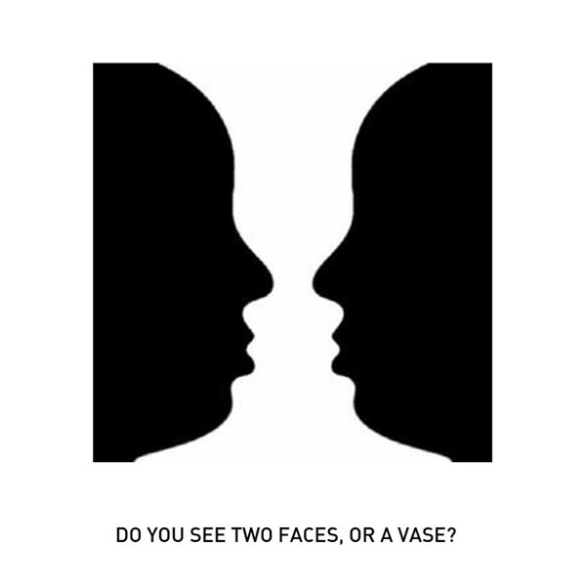

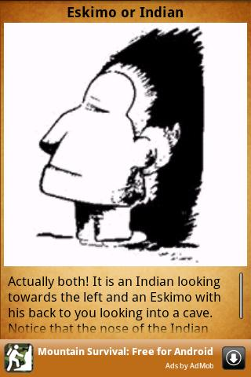

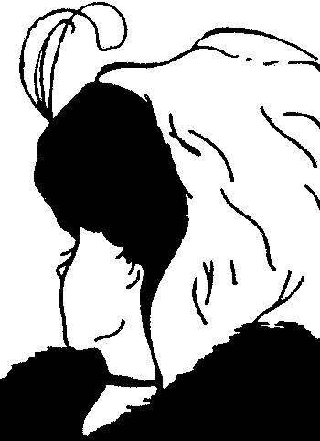

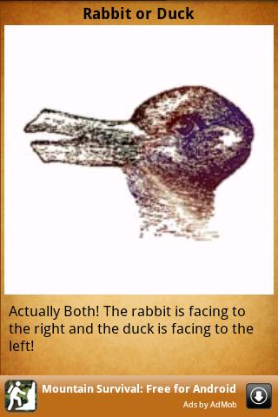

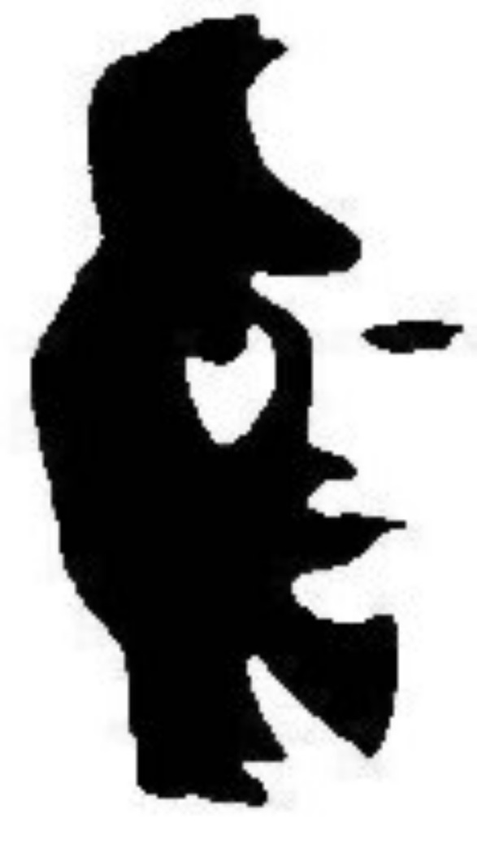
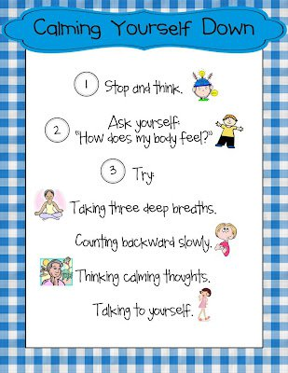
WORKSHEET FOR LESSSON 2-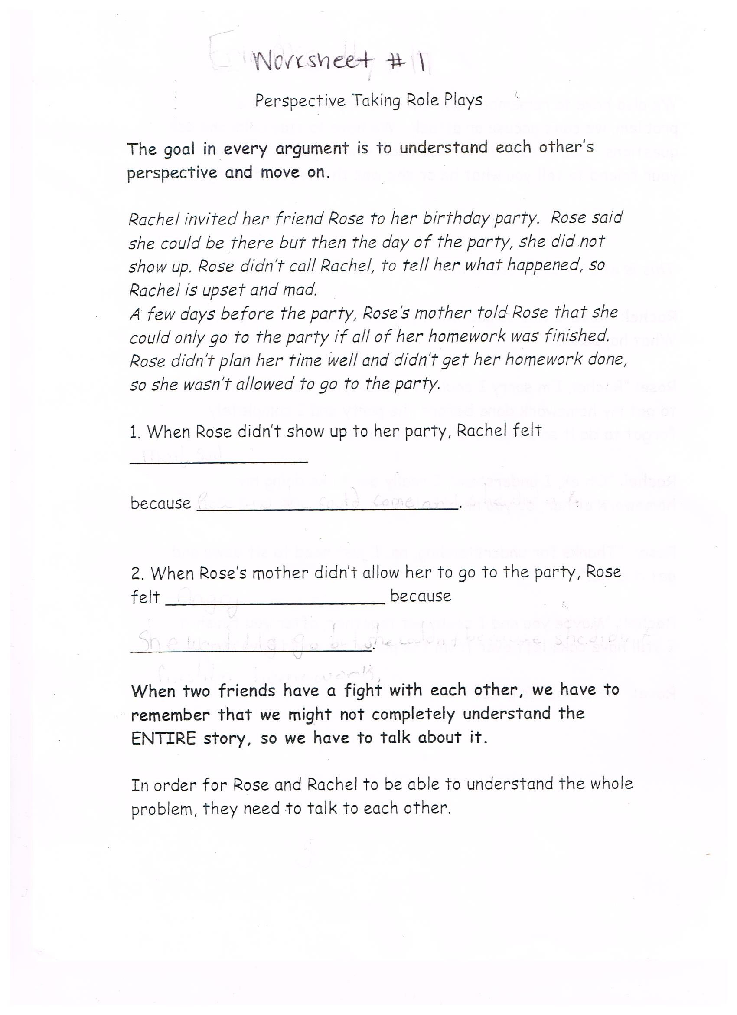
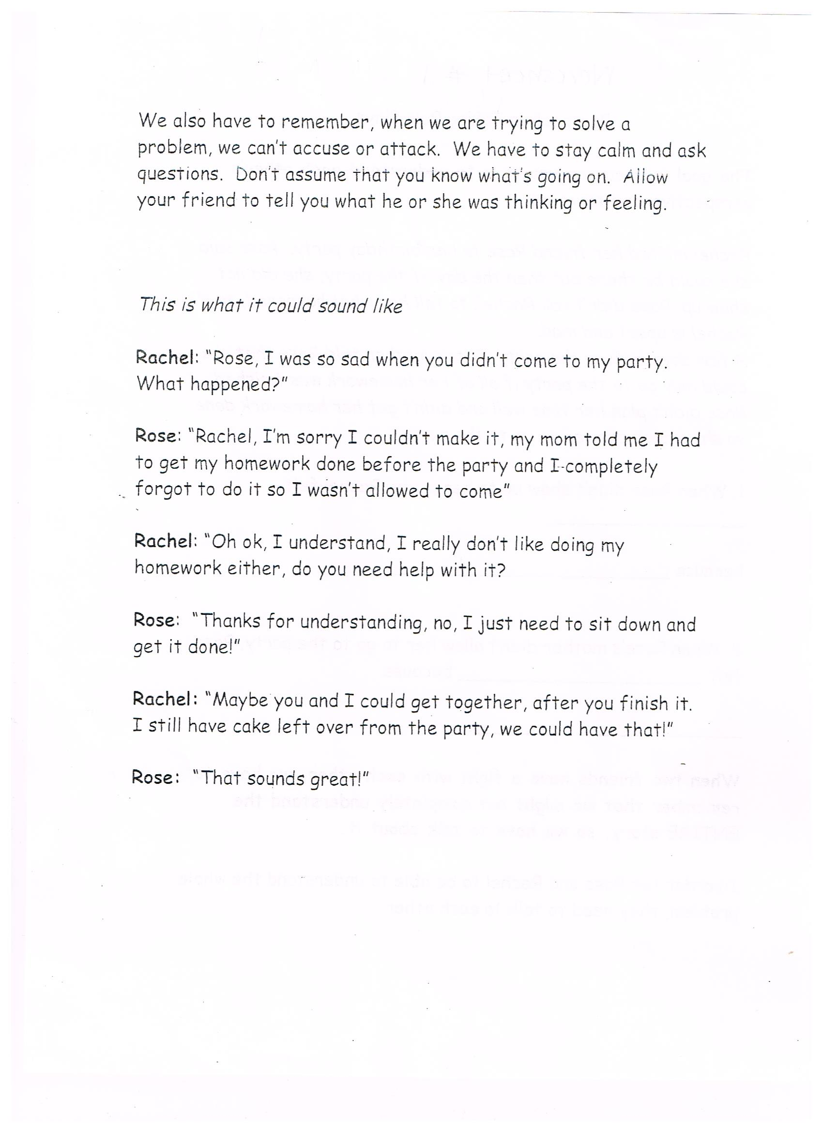WORKSHEET FOR LESSON 3-
